MULTIMEDIA DEVELOPMENT USING WHITEBOARD ANIMATION TECHNIQUE AS A SUPPLEMENT TO SCIENTIFIC WORKS COURSES NON-BASIC EDUCATION STUDENTS

Sri Sumiyati¹, Aini Indriasih², Mohamad Hariyono³, Edi Prayitno⁴, Sumaji⁵
^{1,2,3,4,5}Universitas Terbuka Indonesia
email: sumi@ecampus.ut.ac.id

Abstract
This research presents an experiment for developing scientific works with whiteboard techniques. Data collection in the field was carried out using a questionnaire given to non-basic education students at the Faculty of Economics who took the Scientific Work course. The data were analysed descriptively, giving meaning to each data collected and presented in percentages and graphs. The results of the analysis and interpretation of the data show that the whiteboard animation technique is very effective in making supplements in the student's Scientific Work course. This is evidenced by students’ perception that this technique can make it easier for them to compose a chart and encourage them to compile a chart. Illustration’s pictures/videos in teaching media can clarify the material, with whiteboard animation making it easier to understand Karil material. However, there are still inhibiting factors in implementing the whiteboard animation techniques, including the use of language.

Keywords: Karil, whiteboard animation, effectiveness, valid.

INTRODUCTION
Teaching media is an important learning aid in tutorial activities. Teaching media encourages the emergence of student activities. Activeness encourages and requires students to express opinions and listen to the opinions of others (Moss & Ross, 2003). Communication in the form of interactions between students and tutors is what drives the emergence of independent learning demands before the face-to-face process occurs. Students are required to study and look for materials as a modal to interact during the tutorial.
Teaching media has a considerable influence on the effective tutorial process. Education experts conclude that teaching media tutor can affect the development of interests, attitudes, social, emotions and reasoning. This result will be even more maximal when accompanied by tutor skills in managing communication interactions (Usman, 2001). The success of the tutorial depends on the smooth communication interaction between students and tutors. Disrupted interactions will result in the emergence of misunderstandings, and the message received is not fully as intended by the message giver. The tutorial is intended only to function as a learning aid, as a forum for students to communicate learning difficulties.
Students feel satisfied in obtaining information from the learning media displayed by the teacher. Student satisfaction will create a sense of certainty about the benefits of the media they use, thereby creating a need for the presence of the media (Parrish, 2015, IPHS, 2020). Student satisfaction will be suspected by the teacher so that the teacher's need for the presence of the media appears.
The individual user and user activity determine the level of dependency. From the user's point of view, the level of dependence is measured by the ability of the media to satisfy user needs. If the media succeeds in satisfying the user's needs, the user will become more dependent on the learning media; on the contrary, if the media does not satisfy the user's needs, the dependence on the media will decrease.
The process of creating a sense of dependence starts from the interest of media users. The media displays processes and content that can meet user needs, both from understanding, entertainment, and information fulfilment. Cognitive and affective motivation encourage an increase in the level of satisfaction, which encourages involvement in the learning process (IPHS, 2020). The main learning process is the learning process that students must do in an independent study. However, in scientific work, the tutorial process becomes the main forum for students to gain field experience from their supervisors in making scientific work as a final project. The guidance process cannot be done particularly without an overview of the cycle as a whole, nor can it be carried out with the dominance of the tutor during the guidance process without paying attention to the level of student work progress. Emphasis on concepts without student work processes will not result in students' ability to carry out scientific writing. Writing scientific papers requires skills, knowledge, attitudes (behavior), and values ​​so that learning is the result of various kinds of behavior (Triyanto, 2010). Visualization of a series of processes can be clarified by using the media. The right media is the media used to describe the process as a whole and can also describe each step of the process in detail (UT's Karil Writing Guide). Guidance for each meeting is formulated specifically and clearly to achieve the main goal, namely students are able to carry out and compile reports. Media is the right solution to visualize the main goals achieved through the goals of each meeting. In reality, there are still tutors who teach karil courses who do not use the right media. Some tutors still rely on the method of exposing the core of teaching materials and some others use projectors to convey the essence of teaching materials. Karil's tutoring is done individually. Tutors rarely reveal students' mistakes in carrying out work and the class’s corrective steps. The tutors have not combined a variety of teaching media to stimulate active interaction during the tutorial, so it is necessary to initiate an initiative that encourages tutors to create or use various teaching media, one of which is Video Animation. Video animation with product specifications for learning media based on Video Scribe Whiteboard Animation is expected to increase the effectiveness, efficiency and attractiveness of developing multimedia-based learning media products through Video Scribe Whiteboard Animation for tutors and students. So it is hoped that there will be an increase in the ability of students to carry out karil making. Based on this, this research was made to find out how the specifications of the Video-based learning media products Scribe Whiteboard Animation will be developed and to assess the effectiveness, efficiency and attractiveness of the product development of multimedia-based scientific work guidance media through Video Scribe Whiteboard Animation for tutors and students.
This study aims to produce guidance media that can support the tutorial process in the classroom. In this study, researchers will develop a product in the form of media based on Video scribe whiteboard animation. This product will be developed into a medium for non-Pendas student scientific work tutorials. Testing the effectiveness of whiteboard animation as a learning medium in tutorials to increase students' understanding in compiling scientific works as a final project, applying themethod pre-experimental designs in the form of one-group pretest-posttest design, which compares understanding of scientific works before and after treatment. The reason for using the method is one-group pretest-posttest design because this study compares the conditions before and after treatment without using a comparison group (control group). Sugiyono (2007) suggests that the one-group pretest-posttest design can compare the conditions before and after treatment. This method is research and development (R&D) using combined data analysis, namely qualitative and quantitative data analysis.

One-group pretest-posttest design is visualised in the following figure:
0₁
0₂
X

Figure: 3.1
Testing the Effectiveness of Media

Description:
0₁ Conditions before treatment
0₂ Conditions after treatment
X Treatment The
Data obtained from the questionnaire was processed by descriptive analysis to prove that the media Whiteboard Animation was valid. The device is said to be valid if the assessment of the validators reaches an average above the specified criteria of 80% of the highest score. The analysis was carried out by comparing the data obtained with the established criteria, namely valid, practical and effective. If the data obtained shows that the success criteria have not been achieved, the researcher will revise. The developed whiteboard animation media meets the effective criteria if as many as 80% of the subject students understand the material. Studentsents can easily do it and increase their understanding after using Whiteboard Animation.
At this stage, the final important result is a change that brings improvement (what works better) and is not to be generalised. That means the enforceability of the program (workable), which has been developed in the research, is more concerned with the benefit of the media in practice in the field to implement the tutorial guidance manufacture of scientific work for students non-basic education in Open University.
RESULTS AND EVALUATION
Validity Media Whiteboard Animation
The validity of Whiteboard Animation media done in this study is based on expert perception. This test is carried out to test the validity of each statement item in measuring the variables. Validity testing in this study was carried out by correlating the score of each item statement addressed to the respondent with the total score for all question items in Table 1. Data analysis was used to conclude the data obtained. Data processing is carried out using percentages (%). The data analysis will be described to provide an overview of research results globally. Based on data from questionnaires filled out by experts, in general, can be seen in

Table 1 Material Expert Assessment Response Results
No. | Kesusaian Topics | Score | Average | Achievement | Criteria
1 | Compliance is a topic in media development Whiteboard Animation | 141 | 3.44 | 85, 98% | either
2 | Suitability of the material presented in the media development Whiteboard Animation | 140 | 3.41 | 85.37% | fine
3 | Suitability KI KD | 138 | 3.37 | 84.15% | fine
4 | Compliance with K13 | 138 | 3.37 | 84.15% | fine
5 | Conformance picture with material | 141 | 3.44 | 85.98% | good
6 | Appropriateness of the scope of material in the media Whiteboard Animation | 138 | 3.37 | 84.15% | good
 | Feasibility of illustration material |  |  | 92.68%
7 | Material can provide motivation | 152 | 3.71 | 87.80% | good
8 | Ease of understanding language | 144 | 3.51 | 86.59% | good
9 | Evaluation success rate | 142 | 3.46 | 85.98% | good
10 | Attractiveness  of content writing format | 141 | 3.44 | 85.98% | Good
Average |  |  | 3.45 |  | Good
Source: data processed, 2021

Based on table 1 above, the mini value obtained is 3.41 on the questionnaire from the question of Conformity of KI KD. The highest score of the questionnaire is 3.71 on the question. The material can provide motivation. The average of the 1questionnaire’s 0 (ten) questions is 3.45, so the Whiteboard Animation developed is in a good category.
From Figure 4.1 above, the result is a range of 84.00% - 93.00% indicates that respondents’ perceptions about course content are valid.

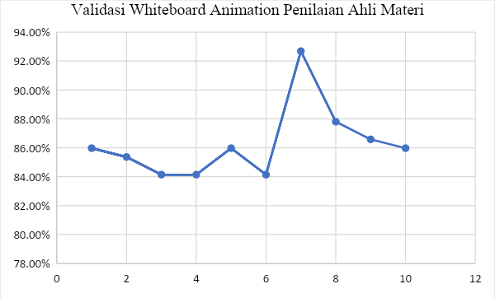
1. FigureUser Answers Matter Expert Assessment / Contents Subject

Test Field Trial of MK Karil's VideoscribeKaril Court's Videoscribe
Learning Media Field Trial of Learning Media was small to students as respondents. This test is carried out to test the validity of each statement item in measuring the variables. Field testing in this study was carried out by correlating the score of each item statement addressed to the respondent with the total score for all question items in Table 2. Data analysis was used to conclude the data obtained. Data processing is carried out using percentages (%). The data will be described as an overview of research results globally. Based on the students’ questionnaire data, the outline of several experiments can be explained in Table 2.

Table 2. Results of the Answers to the Test Response Questionnaire
No | Statement of | Score | Average | Achievement | Criterion
1 | This teaching media can facilitate you in compiling karil | 140 | 3.41 | 85.37% | fine
2 | Use of the media can encourage you in preparing Karil | 150 | 3.66 | 91.46% | fine
3 | you easily understand the lesson material in this medium | 144 | 3.51 | 87.80% | both
4 | Are material conformity presented in the development of this teaching media to compose karil | 142 | 3.46 | 86.59% | good
5 | Illustration’s pictures/videos in teaching media can clarify the material | 141 | 3.44 | 85.98% | good
6 The | display of this media is interesting and easy to understand | 141 | 3 ,44 | 85.98% | good
7 | media makes it easy to understand the material Karil | 143 | 3.49 | 87.20% | good
8 | the language used in teaching media is easy to understand | 136 | 3.32 | 82.93% | fine
9 | media helps me in assembling karil | 158 | 3.85 | 96.34% | b aik
10 | This teaching media is very clear because there are writings, pictures and sound | 146 | 3.56 | 89.02% | good
 |  |  | 3.51
Source: processed data, 2021

Based on table 2 above, the minimum score is 3.32 on the questionnaire from the question. The language used in this teaching media is easy to understand. The highest score for the questionnaire is 3.85 for questions. This media helped me in compiling karil. The average of the 10 (ten) questionnaire questions is 3.51, then the media Whiteboard Animation developed is in a good category. student) is valid.

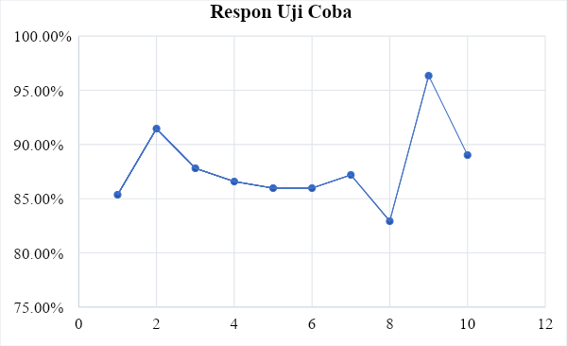
Figure 2. Diagram of the Testing Result

Effectiveness of the Media. The Whiteboard Animation
Evaluation of the effectiveness of the media Whiteboard Animation carried out in this study was based on students' perceptions. This test is carried out to test the validity of each statement item in measuring the variables. Validity testing in this study was carried out by correlating the scores of each item statement addressed to the respondent with the total score for all question items in Table 3. Data analysis was used to conclude the data obtained. Data processing is carried out using percentages (%). The data will be described to provide an overview of research results globally. Based on the questionnaire data filled in by students, an outline of several experiments can be explained as follows in Table 3.

Table 3. Results of User Response Questionnaire (Student) Answers
No | Statement of | Score | Average | Achievement of | Criteria
Whiteboard Animation QuestionnaireValidation of Media Design Test
1 | Media attractiveness to students | 143 | 3.49 | 87.20% | good
2 | Clarity of display | 151 | 3.68 | 92.07% | good
3 | Suitability of pictures/videos to material | 154 | 3.76 | 93.90% | good
4 | Clarity of illustration of pictures to material | 154 | 3.76 | 93 , 90% | good
5 | Media video scribe capable of facilitating the students' understanding of | 148 | 3.61 | 90.24% | either
6 | layout images/videos are arranged systematically | 150 | 3.66 | 91.46% | either
7 | Compatibility font with students understanding | 144 | 3 ,51 | 87.80% | good
8 | Conformity duration consistent | 139 | 3.39 | 84.76% | good
9 | PM images following the content of the material | 149 | 3.63 | 90.85% | good
10 | Conformity evaluation instruments | 143 | 3.49 | 87.20% | good
Whiteboard Animation Vali Questionnaire TTM Media Test tie
1 | Interesting material | 142 | 3,46 | 86,59% | good
2 | Ease of use of media | 152 | 3,71 | 92,68% | good
3 | Image suitability Basic competence | 145 | 3,54 | 88,41% | good
4 | Image suitability with material | 151 | 3 ,68 | 92.07% | good
5 | conformity of the example with the material | 151 | 3.68 | 92.07% | good
6 | Conformity of Front with student understanding | 145 | 3.54 | 88.41%composer | good
7 | Conformity of media | 151 | 3.68 | 92.07% | good
8 | The suitability of the sample images in understanding the material | 146 | 3.56 | 89.02% | good
9 | The level of language understanding | 151 | 3.68 | 92.07% | good
10 | The evaluation success rate | 144 | 3.51 | 87.80% | Good
 | Average |  | 3.60 |  | good
Source: data processed, 2021
Based on table 3 above, the minimum score is 3.46 on the questionnaire from material interest. The highest score of the questionnaire is 3.76 for the two questions. The suitability of the image/video to the material and the clarity of the illustration of the image to the material. The average of the 20 (twenty) questions in the questionnaire is 3.60, so the Whiteboard Animation developed is in a good category. From Figure 3 above, scatter can be seen that the result is a range of 84.00% - 94.00% indicates that the perception of the user (student) is valid

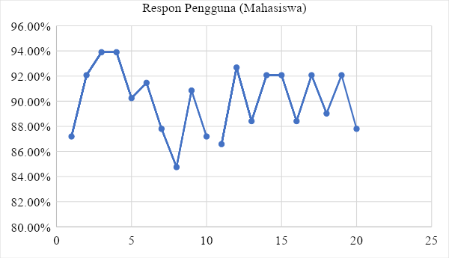
Figure 3. User Response (Student)

CONCLUSION:
This study aims to determine the Multimedia Development Technique Whiteboard Animation as a Supplement to Scientific Work Courses for Non-Basic Education Students. Based on the results of this study, it can be concluded that the technique is whiteboard animation very effective in making supplements in the student's Scientific Work course. This is evidenced by students’ perception that this technique can make it easier for them to compose a chart and encourage them to compile a chart. Illustration’s pictures/videos in teaching media can clarify the material, with media whiteboard animation making it easier to understand the Karil material.
The results of this study are related to development. Multimedia Using Whiteboard Animation Techniques as a Supplement to Scientific Paper Courses, Non-Basic Education Students must consider limitations that may affect the results of the study, namely this study uses a questionnaire measurement that may cause a perception bias on the questions in the questionnaire even though the researcher has tried to reduce bias by using Scientific work material experts, media experts and tutors in Scientific Work courses, further research can use experimental methods to avoid perceptual bias. The number of respondents from one economics faculty does not guarantee that the results of this study can be generalised to other students so that further studies of this type can increase the number of respondents and the number of experiments. The use of language in the preparation of whiteboard animation should be easier for students to understand so that there is no bias in student perceptions.

REFERENCES
Usman,Basyirudin A. 2002. Media Pembelajaran. Jakarta: Ciputat Press.
Badan Standar Nasional Pendidikan. 2007. Panduan Penilaian kelompok mata pelajaran Ilmu dan Teknologi. Departemen Pendidikan Nasional.
Suprihadi, Saputro. 2006. Strategi Pembelajaran. Malang: Laboratorium Teknologi Pendidikan.
Suharsimi, Arikanto. 1998. Prosedur Pengembangan: Suatu Pengembangan Praktek. Jakarta: P.T.Rineka Cipta.
Triyanto. 2010. mendesain model pembelajaran inovatif-progresif. Jakarta: Prenanda Media.
Daryanto. 2010.Media pembelajaran. Yogyakarta: Gava Medi.
Arsyad, Azhar .2012. Media Pengajaran. Jakarta : PT Raja Grafindo Persada. Tirtamedia.co.id/apa-ituivideoscribe. 121
Susilana R dan Riana C. 2008. Media pembelajaran. Bandung: CV Wacana Prima.
Kustandi C dan Sutjipto B. 2011. Media Pembelajaran Manual Dan Digital. Bogor: Ghalia Indonesia.
Purwanto. 2008. Evaluasi Hasil Belajar, Yogyakarta: Pustaka Belajar.
Sudjana Nana. 2005. Hasil Proses Belajar Mengajar. Bandung: Remaja Rosdakarya.
Sukmadinata Syaodih N. 2011. metode penelitian pendidikan. Bandung : PT Remaja Rosdakarya.
Sugiyono. 2011. metode penelitian kuantitatif, kualitatif dan R & D. Bandung : Alfabeta.
Asep Jihad dan Abdul Haris, Evaluasi Pembelajaran, Yogyakarta: Multi Persindo, 2010. Hlm. 19.
Kusumah, Dwitagama.2007.Buku PTK. Labschool Jakarta Indonesia
Sukmadinata, Nana Syaodih. 2006. Metode Penelitian Pendidikan. Bandung: PT Remaja Rosdakarya
Sugiyono. 2011. Statistika Untuk Penelitian. Bandung : Alfabeta.
-------------- 2012.Metode Penelitian Kombinasi. Bandung: Alfabeta.
Sujana. 2012 Metode Statistik Bandung : Tarsito
Sudjana, Nana., & Rivai,. Ahmad. 2011. Media Pengajaran. Bandung:Sinar Baru Algesindo
Mohommad Ashori (2007), Penelitian Tindakan Kelas, Bandung : CV Wacana Prima.
Nana Sudjana. Penilaian Hasil Proses Belajar Mengajar. Bandung: Remaja Rosdakarya. 2005. Hlm. 138.
Ditjen PMPTK.(2010). Membimbing Guru Dalam Penelitian Tindakan Kelas Materi Pelatihan Penguatan Pengawas Sekolah. Jakarta : Kemendiknas.
Rudi Susilana dan Cepi Riana, 2008. Media Pembelajara, bandung: CV. Wacana Prima.
http://www.scribd.com/doc/59705852/Kreatif-Mengembangkan-MediaPembelajaran. diakses pada 13 April 2014. jam 13.10
http://atikatikaaziz.blogspot.com/2010/09/4-pilar-pendidikan-menurut-unesco.html. diunduh tanggal 13 April 2016

