3R-Based Teaching Module for Biology Education Students: A Research Development
Suryanti ¹ , Nurkhairo Hidayati², Laili Rahmi³, Sepita Ferazona⁴, Rendra Cahyana⁵
Universitas Islam Riau; yantibio@edu.uir.ac.id
Universitas Islam Riau; khairobio@edu.uir.ac.id
Universitas Islam Riau; rahmi_emybio@edu.uir.ac.id
Universitas Islam Riau; sepitabio@edu.uir.ac.id
Universitas Islam Riau; rendra cahyana@student.uir.ac.id

INFO PASAL |  | ABTRACT
Kata kunci:  Modul Ajar berbasis 3R,  Penelitian Pengembangan |  | The current of globalization is getting unstoppable. Now as it has entered the era of the industrial revolution 4.0 and continued the era of society 5.0 requires students to be more critical. Education is an important thing to balancing, it is expected to have skills in life to compete in facing life that continues to move forward rapidly in various fields. Modules used are learning packages that have the content of the concept of lesson units. The teaching module is a learning design based on the semester learning plan (RPS) applied with the aim of achieving predetermined competency standards. The study aims to find out the 3R-Based Teaching Module for Biology Education Students: A Research Development. Methodology of R & D Development (Research and Development) ADDIE Model, consists of 3 stages, namely analysis (Analisys), design (Design), development (Development). Carried out at the Biology Education Study Program, Riau Islamic University, Muhammadiyah University, Lancang Kuning University. Conducted from July to December 2023. Sampling validators in the development of this teaching module, namely material experts, learning experts, media experts, readability tests to 15 students as respondents in semester 3 have received Environmental Science courses at 3 universities with Purposive Sampling techniques. Validator data retrieval techniques Questionnaires are used with a grid of validation sheets. For students with Google Forms. The results obtained for media expert validation 94.44 categories are very valid, learning expert validation 96.59 categories are very valid, material expert validation 100 categories are very valid, recapitulation of all validators 96.67 is very valid, student readability 91.16 categories are very valid. It can be concluded that the 3R-Based Teaching Module that has been developed has proven to be valid and practical for biology study program students.
Sejarah artikel:
Diterima 14-08-2021
Revisi 2021-11-12
Diterima 17-01-2022
 |  | Ini adalah artikel akses terbuka di bawah lisensi CC BY-NC-SA .
Suryanti¹
Universitas Islam Riau ; yantibio@edu.uir.ac.id

- INTRODUCTION
The tide of globalization is getting unstoppable. Now we have entered the era of the industrial revolution 4.0 and further, the era of society 5.0 requires students to be more critical because they are prepared as more advanced human resources so as not to be defeated by robots. To deal with this phenomenon, education in universities should be required to produce qualified graduates in order to compete in the national and even international arena (Prasetya (Wibawa & Agustina, 2019). (Wit & Altbach, 2021). The lecturers are expected to be able to develop the quality of learning and also be able to develop teaching modules so that graduate resources (HR) can become a milestone in Indonesia's development. Become qualified and competently play a very important role in the present and also for the future. The Indonesian are required to be able to compete with other countries, so it is very important for the government and policy makers in this case to formulate education rules that are in accordance with existing developments so that they can be applied to any condition.
Education is an important thing in human life, which can be balanced through education is expected to have skills in life to compete in facing life that continues to move forward rapidly in various fields. Education should also at this time form students who can face the era of globalization, environmental problems, technological advances, knowledge-based economy, the rise of creative industries, and culture (Rafi’y et al., 2022), (Taufan et al., 2023). The shift in world economic power, as well as the influence and impact of science-based technology. Learning in general still emphasizes aspects of knowledge and understanding of the material only. This leads to lack of training in developing thinking skills in solving problems and applying concepts learned on campus into the real world (Mubarak et al., 2021).
The module used is a learning package that has the content of the concept of lesson units that are applied by utilizing the internet and are interactive, some research is evidence that the use of modules can be used as one of the teaching materials (Jannah & Fathuddi, 2023), (Sidiq & Najuah, 2020). Can spur creativity, motivation to student learning outcomes. This developed module fulfills the elements of triggering student motivation and is effective in improving student learning outcomes in accordance with the expected competencies that have been proclaimed in the learning objectives. In order for the resulting module to be able to stimulate learning motivation, it is expected that the module developed has certain essences such as the use of varied colors, placement of mind mapping, supporting images and many others that are tailored to the characteristics of students (Kaswar & Nurjannah, 2021)(Sidiq & Najuah, 2020).
The teaching module is a learning tool or learning design based on the semester learning plan (RPS) which is applied with the aim of achieving predetermined competency standards. Teaching modules have a major role to support lecturers in design the learning process. In the preparation of learning tools that play an important role are lecturers, honed thinking skills to be able to innovate in teaching modules. Therefore, making teaching modules is a competency that needs to be developed, it is hoped that teaching techniques in the lecture process are more effective, efficient, and so that the lecture process can run as it should (Maulida, 2022). (Logan et al., 2021).
Environmental problems today are not the responsibility of the government alone, but all elements of society have the same role and responsibility. One element of society that plays an important role in this is educational institutions, because education is the right means to build a community that has concern for the environment. Higher education in general and students in particular are one of the educational institutions that accommodate students to be equipped with science, one of which is biology education on plastic pollution materials, aiming to instill a sense of environmental care. One of the efforts to overcome these problems is to improve learning strategies and models. (Khoirunnisa & Kadarohman, 2022), stated that the use of plastic-based goods has now become a necessity in human life and has become a culture among the community. This is because plastic materials have various functions and can meet the needs of the community. Especially with the support of the latest technology that has produced many plastics with various variations ranging from interesting shapes, sizes, colors, and motifs. Plastic is familiar in human life, so it seems as if the world without this material would have a hard time.

People of all ages have indirectly been educated to use all forms of plastic to meet their needs and of course this will lead to a decline in the culture of plastic use to future generations. Initially, plastic is a material that has many advantages that can be formed as desired with the help of heat and or pressure. However, over time, it turns out that plastic has a long-term impact because of its strong and difficult to decompose nature, of course, it can have an impact on the environment, both on land and sea in the environment for a long time.
For this reason, students in a university, must be sensitive to differences in activities, interests, and social status that someone has, making the lifestyle that everyone has different. This lifestyle is formed to preserve the environment (Escario et al., 2020), Reducing environmental pollution can include many things, including 3R (reduce, reuse and recycle). Referring to the Regulation of the Minister of Environment (Peraturan Menteri Negara Lingkungan Hidup Republik Indonesia Nomor 13 Tahun 2012 Tentang Pedoman Pelaksanaan Reduce, Reuse, Dan Recycle Melalui Bank Sampah, 2012), reduce, reuse, and recycle activities are all activities that are able to reduce everything that can cause waste, waste reuse activities that are suitable for use for the same or different functions, and activities to process waste into new products. The trend of municipal waste management that prioritizes 3Rs needs to be supported, so that the amount of waste disposed of is reduced, and future waste management patterns are organized (Juliandi, 2023). According to the opinion (Junaidi & Utama, 2023), in this case it is guided by the 3R principle, namely Recycle, Reduce and Reuse. Supported (Ratri et al., 2022). Reduce, improving environmental impact by reducing resources used. Reuse, utilization of resources, but not with the same purpose. Recycle, processing plastic into new products. (Mohammed et al., 2021).
As for the problems in the field that were found to have no material enrichment about plastic pollution, the teaching modules provided were in the form of handout so that the desire to learn for students had not been achieved properly, had not been developed optimally learning about 3R-based on plastic pollution for students. So that the creation of modules will rejuvenate the understanding of the material, more interesting and equipped with pictures that add enthusiasm to the learning process. To overcome this, it is necessary to make teaching modules so that the lecture process can run in accordance with the goals to be achieved.
The results of previous research that the science module of 3R-based waste handling materials (reduce, reuse, recycle) towards zero waste for grade X students is suitable for use in the learning process based on quality assessment according to education expert lecturers, science teachers and students. And students' responses after using the science module on 3R-based waste handling materials (reduce, reuse, recycle) towards zero waste towards caring for the environment have the potential to be effective in increasing concern for the environment (Marsolina & Anggreini, 2022). Furthermore, the 5R waste management module based on Problem Based Learning is suitable for high school / MA students. The feasibility of the module is based on the assessment of the Problem Based Learning based waste management module by validators and obtained the final results and field test results that are declared suitable for use. As for the suggestions from this research for the development of the next module. First, more in-depth research to reduce the impact of pollution due to waste management activities on the people of Malang city. Second, more in-depth research needs to be carried out related to the development of other teaching materials, especially those integrated with critical thinking, environmental knowledge, and environmental concern to increase awareness and love for the environment (Demokratis et al., 2021). The research aims to develop a 3R-Based Teaching Module for Biology Education Students: A Development Research. The conclusion that the 3R-Based Teaching Module that has been developed has proven to be valid and practical for biology study program students.
METHOD
The research was carried out at the Biology Education Study Program, Riau Islamic University, Muhammadiyah University, Lancang Kuning University. Conducted from July to December 2023. Validators in the development of this teaching material are material expert validators, learning expert validators, media expert validators, and readability tests to 15 students as 3rd semester respondents who have received environmental science courses at 3 universities. The object in this study is a 3R-Based Teaching Module for Biology Education Students: A Development Research. The method used is the development method (Research and Development) with the ADDIE model, which consists of 5 stages, namely Analysis, Design, Development, Implementation, and Evaluation. The ADDIE learning model was developed by Reiser and Mollanda in 1967 (Nisa et al., 2022). ADDIE development research steps from the analysis stage (Analyze, Design, Development). As for the explanation of the development design, the steps are briefly explained as follows:
- Analisys
The analysis stage is a process of defining the requirements needed in the development of teaching modules, where the steps are curriculum analysis, material analysis and student analysis.
- Design
The purpose of this stage is to develop 3R-based teaching modules on plastic pollution in accordance with the curriculum. At this stage, it is determined how the module is designed as a whole in accordance with the subject matter and then compiles indicators for learning objectives that will be designed into teaching modules. Includes cover and module design design with the Canva Application program, images on modules are sourced from various sources and arranged according to user wishes.
- Development
The development phase aims to produce teaching modules in the form of 3R-based modules on plastic pollution and in accordance with the curriculum. Modules that have been compiled are validated by the vaidator. The purpose of validation is to examine concepts and grammar in modules that are adapted to the curriculum and RPS in the study program.
- Validators
Biology education experts and competencies in their fields as many as three experts are listed in Table 1 as follows; Table 1. List of Validator Names
No. | Validator Name | Expert Field | Information
1. | Dr. Nurkahiroh  Hidayati S. Pd. M.Pd | Material Expert | Lecturer in Biology, Faculty of Teacher Training and Education, Universitas Islam Riau
2. | Sepita Ferazona S.Pd.M.Pd. | Leaarning Expert | Lecturer in Biology, Faculty of Teacher Training and Education, Universitas Islam Riau
3. | Nurul Fauziah M.Pd. | Media Expert | Lecturer in Biology, Faculty of Teacher Training and Education, Universitas Islam Riau
Source: Researcher Data 2023
A questionnaire was used with a grid of validation sheets for material experts containing details of 3 aspects assessed were content feasibility (8 statements), feasibility of presentation (3 statements), and language (4 statements). The benefits of learning experts are module structure (4 statements), writing organization (3 statements), language (3 statements), module presentation (11 statements), and benefits (1 statement). While the Media Expert Module assessed aspects are, cover (3 statements), content (3 statements), and media benefits (1 statement) (Noviola, 2020).

b. Eligibility Trial Limited to students.
After the teaching module is developed and validated by validators, the module will be tested for limited feasibility to biology students at 3 universities. The sample used is 15 people for semester 3 which has been determined as in table 2 below;
Table 2. List of Semesters in Biology Students for Trials
Semester (Level) | Address | Number of students
Semester 3 | Univeristas Islam Riau | 15
Semester 3 | Universitas Muhammadiyah | 15
Semester 3 | Univeristas Lancang Kuning | 15
Source: Data by Researchers 2023
The sampling technique uses Purposive Sampling technique. According to (Sugiyono, 2019) Purposive Sampling is a sampling technique with certain considerations. From 3 universities 15 students each. Data collection through primary data using student readability questionnaires has 4 aspects, namely material (4 statements), language (2 statements), presentation (4 statements) and display (2 statements) with Google Form, while for secondary data literature studies from journals and related sites.
The analysis technique used is causative descriptive analysis that describes the service of 3R-based teaching modules on plastic pollution. The respondent's response was the number 4,3,2,1 which shows the Likert Scale, expressed in the form of an answer range starting from 1= if no descriptors appear, 2= if only one descriptor appears, 3= if only two descriptors appear, 4= if all three descriptors appear. This scale can be simplified to 4 answer scales only so that respondents' responses are clearer. . Instruments in the form of limited eligibility questionnaires submitted to validators are first validated. Construct validation will be validated by peers.
The percentage of module validity will be calculated for five different validators. First: material experts, second: learning experts, third: media experts, fourth: students as respondents. For the level of validity, the feasibility level analysis is descriptively qualitative. The validity results of each (experts and lecturers), the percentage level can be matched or confirmed with the criteria in Table 3 below.

Table 3. Validity criteria according to validator assessment
No. | Validity criteria | Validity Level
1. | 85,01% - 100% | Very valid, or can be used without revision
2. | 70,01% - 85% | Quite valid, or usable but needs minor revisions
3. | 50,01% – 70% | Less valid, it is recommended not to be used because it needs major revisions
4. | 01,00% - 50% | Invalid, or may not be used.
Source; (Sugiyono, 2019)

- FINDINGS AND DISCUSSION
3R-Based Teaching Module for Biology Education Students: A Development Research, in this study using Research and Development (R & D) developed with the ADDIE Model which has steps with 5 stages, namely analysis (Analisys), design (Design), development (Development) at this stage several validations are carried out by validators including media expert validators, learning expert validators, material expert validators, student readability, while for the stage (Implementation), and evaluation (Evaluation) has not been carried out. The ADDIE model is very effectively used as one of the module development models. The stages of ADDIE are also very systematic so that products that are ready to use and meet product development testing standards (Firmansah, 2021). The steps of Research and Development (R&D) developed with the ADDIE Model can be described in the figure below as follows;
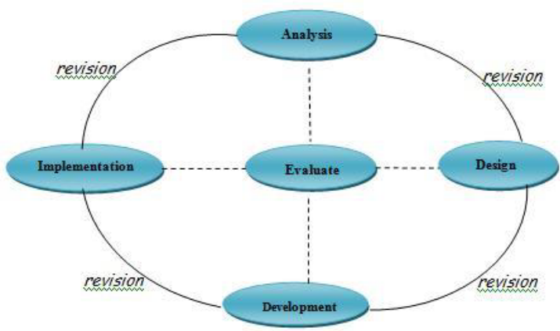
Figure 1. ADDIE Development Model Chart
Source: (Sugiyono, 2019)
3.1 Analysis
This analysis is used in determining learning needs, who want to be taught, as well as competencies that are expected to be mastered by students after the learning process. At this stage perform;
- Analysis of the existing curriculum to determine the direction of module development on target and indicators of achievement of existing competencies in accordance with the curriculum.
- Analysis of student needs as students This activity observes the student learning environment, identifies educational problems faced and to improve the quality of education. Seeing what students need is less varied using learning modules in other forms, mostly in the form of books. Likewise with tasks, identifying material, selecting relevant material and arranged systematically. To help the student learning process and will support student independent learning.
- Material analysis, discussions conducted to discuss the materials presented in the modules to be developed which still refer to the course RPS. With consideration of the discussion, it was decided that the material to be described into modules must be integrated with learning applications that are able to make students more motivated in learning and lead to better learning outcomes later.

3.2 Design
After doing the analysis, the next step is to carry out the design process. Aims to facilitate the process of making covers from teaching modules. Then the design projects include the preparation of teaching materials, practice questions and other additional features. Learning materials are sequentially arranged based on RPS which is adjusted to references related to integrated learning courses which are then compiled into Microsoft Word and converted into Pdf. The next step is to prepare practice questions, where there are 10 (ten) multiple-choice questions, 5 (five) essay questions. For the problem, it complements and triggers student learning motivation because it is packaged attractively. The images presented in the module are developed from various sources which are then imported into the module. The background is made based on the normal design of Microsoft Word. The design raised by the researcher is made attractive with a combination of colors that make students feel at home in reading this teaching module. The instruments prepared consist of 3 (three), namely assessment instruments on media feasibility by media experts, material feasibility instruments by material experts and assessments on learning feasibility of learning experts, materials and media for student readability. The instrument is arranged in the form of a questionnaire with 4 alternative answers, namely the score 1 = if no descriptors appear, 2 = if only 1 descriptor appears, 3 = if only 2 descriptors appear, 4 = if all three descriptors appear. The determination of module eligibility categories consists of 4 categories, namely very valid, valid, quite valid, and invalid.

3.3 Development
After the design is complete, this teaching module is made using Microsoft Word which is converted into Pdf form using the Canva Application. The whole pre-designed parts are put together. At this stage the researcher tests all functions whether they can run properly. In addition, this stage aims to see whether the predetermined concepts are in accordance with the modules developed. The validation test aims to measure the feasibility of the module before it is used in the learning process. In the validation test process, you will get suggestions and input for improvements so that they are ready to use. One of the stages in the development of modules feasible or not to be used in the learning process is an expert validation test (Ramadhani & Fitri, 2022). Module development at this stage is a process to realize a design that has been designed to be in accordance with the lecture unit plan and material including;

3.3.1 Assessment Aspects of Media Expert Validator Module
Research data on 3R-Based Teaching Modules for Biology Education Students: A Development Research, aspects of assessing the media expert validator module to determine the feasibility of the teaching modules developed are selected in accordance with competence and understanding in their fields assessment and suggestions are given into material for revision to be better, which can be seen in graph 1 as follows;

Graph 1. Assessment Aspects of Media Expert Validator Module

Data from Graph 1 above, for the module cover aspect, a value of 91.67 is obtained with a very valid category, because the madul cover is the first display that will be seen before entering the contents. For this reason, Cover is the main imformation that is closely related to writing, both title, author name, identity. Then the cover also allows other readers to identify the material at a glance. Where the module cover must be attractive by combining colors and illustration images, the shape and size of the font must be harmonious so that it looks more attractive. Furthermore, the validation results of the cover image validator are clarified, the title of the subchapter forn 14, image consistency, image position must have a source, the results of this suggestion can be improved as a whole.
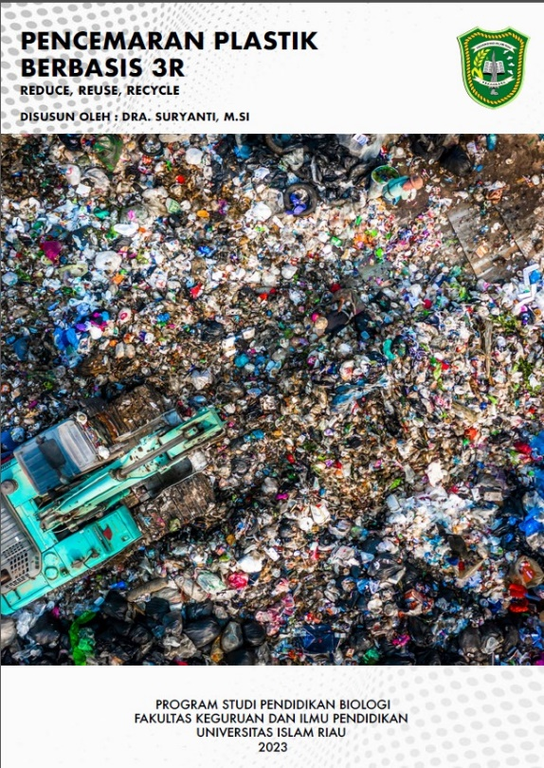
Figure 1. 3R-Based Module Development Cover
Source: Research Data 2023
The aspect of the module content is obtained a value of 91.67 with a very valid category, it can be understood in the content section of the module to place stimuli in the form of images or illustrations, containing sequences that are considered to represent the material of the entire module content including starting from the table of contents, concept maps, learning objectives, plastic materials, various types of plastic, plastic waste, the function of plastic waste, plastic waste problems, other facts about plastic waste and the environment, pollution due to plastic waste, how to prevent 3R-based plastic waste pollution (Reduce, Reuse, Recycle), a way of processing modern plastic waste. Assignments and exercises are packaged in such a way as not to be boring and interesting to read and do according to the characteristics of students. Everything presented by media validator experts is considered feasible, especially in terms of material enrichment for lecture modules for students. Learners' need for media can be based on curriculum demands, so that the preparation of material in a learning media must be guided by Basic Competencies and Core Competencies or in accordance with learning objectives (I. P. D. P. Putra et al., 2021). A clearer description of the preface, table of contents and concept map can be seen in figure 2 as follows;
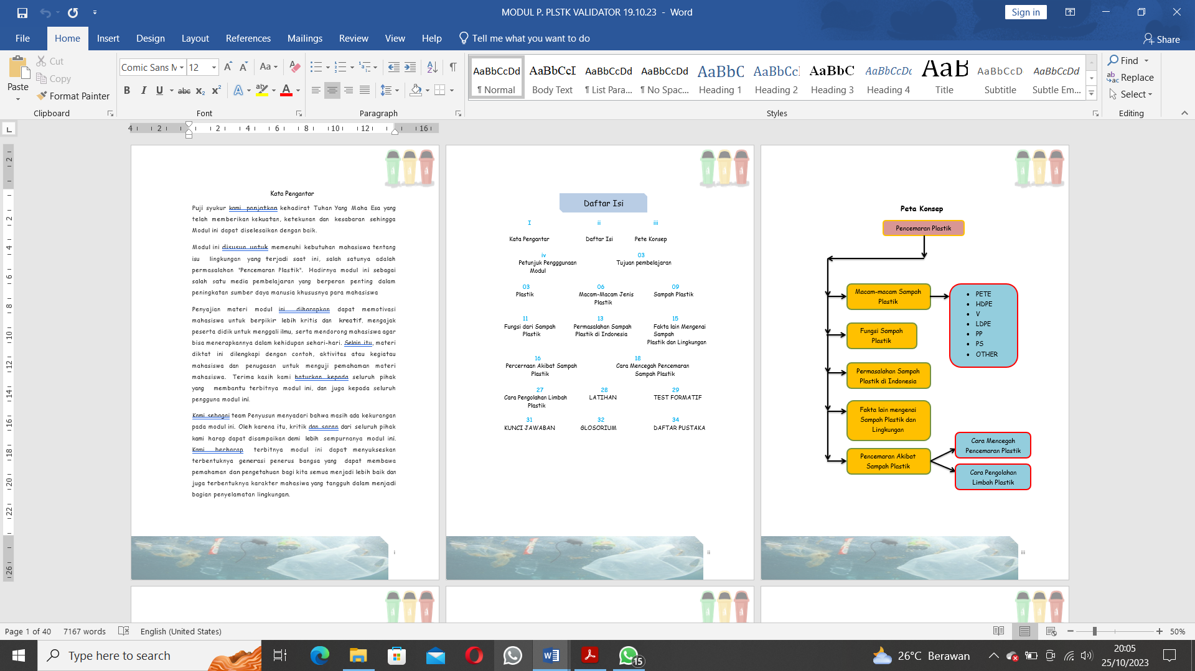
Figure 2. Module Content (preface, table of contents and concept map)

Furthermore, the description of the Module Content (glossary and bibliography) can be seen in figure 3 as follows;

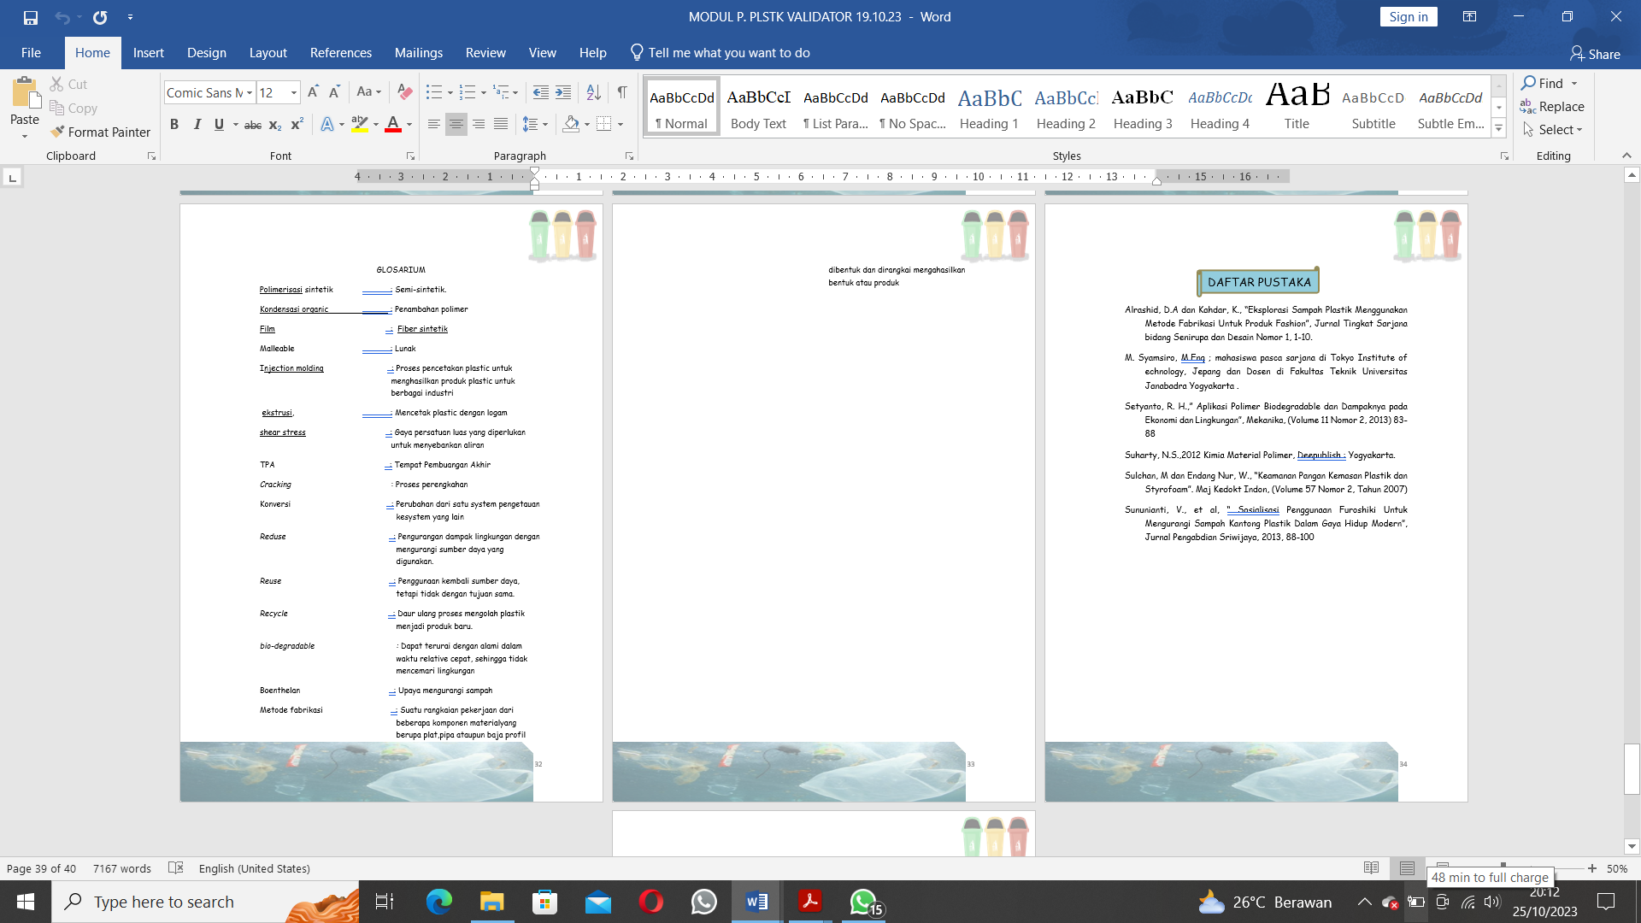
Figure 3. Module Contents (glossary and bibliography)
Source: Research Data 2023

The benefits of media obtained by 100 data with categories are very valid, because the module is one of the tools used as a guide in lecture activities in the form of designs according to needs. Considered as a determinant of a learning objective and consideration of the material to be delivered. This is so that later the learning process is more interesting and not monotonous. Because in the module itself there are important components, these components will be used as a reference. According to (Angriani et al., 2020). Media and learning resources have an important role in the learning process, this is because the media can help students understand the information to be conveyed. Next (Faizzah et al., 2023). Media is one of the learning tools that can provide stimulus, provide experience to students and help make the same observations in students, So that students have the same understanding of the information conveyed.
The module display obtained 92.86 data with very valid categories, is expected to be interesting for those who see, meaningful and challenging so as to foster student interest in learning, understand the fun, involve all students actively so that they can interact and participate so that lecture goals can be achieved properly. The display of the Teaching module can use a simple organizing system and color combinations so that the filter is more impressive to make students' reading desires better (Rahmayanti, 2023). The overall average result of module validation from media experts obtained a value of 94.44 with a very valid category, because the display of media in the module for the learning process is more representative so that it is suitable for use in the lecture process for students. Supported by research results (Haristah et al., 2019). The overall percentage results carried out by media expert validators were obtained at 86.25% with very good criteria. If it represents all aspects of the media, the learning media is valid or suitable for use in the learning process.

3.3.2 Assessment Aspects of the Learning Expert Validator Module
3R-Based Teaching Module Data for Biology Education Students: A Development Research, next is the Assessment Aspects of the Learning Expert Validator Module can be seen in graph 2 below;

Graph 2. Assessment Aspects of the Learning Expert Validator Module

Aspects of Module Assessment Learning Expert Validators obtained data about the module structure with a value of 93.75 categories is very valid, because One that must be considered in making and preparing modules is the module structure. Because they are things or components or arrangements that must be present in the printed module used, they must be complete and suitable for use in the lecture process further make it easier for lecturers to deliver material and make it easier for students to understand the material and follow lectures.
The organizational aspect of writing obtained 100 data with very valid categories, as a whole in the module writing organization must be considered so that the modules made have good feasibility including; the use of letters, the writing of words, the use of punctuation and the writing of absorption elements. If this has been approved then the module is considered suitable for use in lectures.
The language aspect of the learning aspect of the value of 91.67 with a very valid category, preferably the language used in accordance with the situation or writing conditions in the module, must be in accordance with applicable rules such as in accordance with spelling, punctuation, terms and grammar methods, this is very necessary in compiling the module so that the resulting language is easy to understand and interesting for students to read. And more importantly to note the sentences we write and compose can fulfill as correct sentences. According to (Wanabuliandari et al., 2021). To mentioning the use of good and correct language according to the EYD is very important. Remembering by using language that will make it easier for students to understand the material and feel comfortable in the learning process. Therefore, in the preparation of modules also need to be validated first in the use of the language.
The aspect of presentation obtained with a value of 97.73 with categories is very valid, because it is necessary to adjust the appearance so that the making of this module can be understood and analyzed in accordance with the expected purpose, where in the presentation of the material must be simple, clear and easy to read and understand by students. Validator suggestions should be before the material adds learning objectives, this has also been changed according to the suggestions.
The aspect of benefits obtained with a value of 100 with a very valid category, the implementation of learning using modules can be used individually where students learn to have different abilities so they must be able to independently understand it. Meanwhile, classically students will study in lectures simultaneously, discussion and easier to understand with material enrichment. Then an evaluation is carried out which is done individually and classically.
Furthermore, the average aspect of data learning expert validators obtained 96.59 with very valid categories, it can be understood that if all aspects needed in module development have been fulfilled in the applicable tenure, the module is considered suitable for use. (Harahap et al., 2022) suggests that preparatory learning prepared by lecturers is to attract and inform students, so that the preparation designed can help students achieve the expected goals in the process.

3.3.3 Assessment Aspects of Material Expert Validator Module
Data on 3R-Based Teaching Modules for Biology Education Students: A Development Research, from the aspect of assessing material expert validator modules can be seen in graph 3 below;

Graph 3. Assessment Aspects of Material Expert Validator Module

From the results of module development on the feasibility aspect of content with a value of 100 categories are very valid, it is very understandable that the material provides imformation, simplifies and clarifies the material so that it is not too verbal, has been compiled in detail, has complete competition, overcomes the limitations of space, time and sensory power of students and lecturers, and can be used appropriately and varied. Especially very helpful in the lecture process. Furthermore, a module must pay attention to the content feasibility component.
The feasibility aspect of presentation is obtained a value of 100 with a very valid category, interpreted as a whole this aspect has met the existing provisions, contains concepts presented interestingly, interactively and is able to encourage the process of critical, creative, innovative and deep thinking, as well as metacognition and self-evaluation. Thus a textbook must pay attention to the presentation component, which contains presentation techniques, supports the presentation of the material, its presentation supports learning. Suggestions from material validators at the beginning of the material add theories about pollution. This has also been fixed as per the suggestions.
The language aspect obtained data with a value of 100 categories is very valid, because the language used in the module contains imformations, messages, and knowledge that is expressed in written form and can be communicated with readers. It must be in accordance with its function, the situation then has a truth value, the value that is expected to give a feeling of pleasure and happiness that cannot be separated must refer to good and correct Indonesian methods, meaning that a module must pay attention to its language component. This is in line with (Sidiq & Najuah, 2020) one of the characteristics of a good teaching module is using communicative language so that students more easily understand the content of teaching materials. Polite or positive language will help the teacher to understand the characteristics of students.
Average for Assessment Aspects of the Material Expert Validator Module with a value of 100 Very Valid categories. This can be understood because with interesting material containing challenging things, especially the problem of plastic pollution to be studied so as to get a good understanding and students can apply it to everyday life about the importance of 3R. In accordance with the research (Sariyah, 2023) : (Haristah et al., 2019) The results state that the teaching module is a collection of imformations that provide a description of the material needs needed must be seen as good material aspects and suitable for use as learning materials and learning processes.

3.3.4 Recapitulation of All Aspects of Module Assessment Validators Media Experts, Learning Experts and Material Experts
Data recapitulation of 3R-Based Teaching Modules for Biology Education Students: A Development Research, from the aspect of module assessment validators material experts, learning experts and media experts to be clearer can be seen in graph 4 below;

Graph 4. Recapitulation of All Aspects of Module Assessment Validators Media Experts, Learning Experts and Material Experts
The results of the reapitulation of the three validator experts, the aspect for media experts with a value of 99.44 categories is very valid, where the caver, content, media benefits and visual presentation as a whole have met the existing rules in making module development on 3R-based plastic pollution material (Reduce, Reuse, Recycle). Recapitulation for aspects for learning experts assessment module validator learning experts obtained 95.59 with categories is very valid, because the module structure, writing organization, language, presentation and benefits are considered good when carried out in the teaching process. The recapitulation for the assessment aspect of the expert material validator module obtained by 100 categories is very valid, because the feasibility of content, feasibility of presentation and language have met existing and applicable provisions so that the material presented in the module can be interesting to students because of the variety of images that represent the material. The Teaching Module is a learning resource that contains materials, methods, and limitations as well as ways of evaluating that are designed systematically and interestingly to achieve the curriculum and predetermined goals. The teaching module is arranged in such a way that it will contain fragments with interactive questions to make it easier for users to understand the material (Taufan et al., 2023).
3.3.5 Recapitulation of Assessment Aspects of Student Readability Teaching Modules
Data on 3R-Based Teaching Modules for Biology Education Students: A Development Research, a recapitulation of the assessment aspects of student readability teaching modules from 3 universities with 4 aspects for more clarity can be seen in chart 5 below;

Graph 5. Recapitulation of Assessment Aspects of Student Readability Module

The data obtained from the average recapitulation results of student readability teaching modules from 3 universities, from the aspect of material with a value of 91.10 categories are very valid, it is hoped that the selection of material must be essential where it is important to be mastered and understood by students and is sustainable. The material must attract interest so that learning time does not become bored, it must be meaningful in the sense that students are able to relate new imformations or lecture materials with concepts or other things that already exist in the cognitive structure. In addition, the material must also be clear about the existence of content, presentation and language so as to develop an attitude of challenge. Must be relevant according to the type according to the type of course learning outcomes. It must be contextual where the material emphasizes the relationship between the material and real-life conditions, especially where in the material page with words, pages with titles must be connected.
The linguistic aspect with a value of 93.01 categories is very valid, because language is an important key and the main for making modules, because the language of students can and is able to interact with each other and language is also a resource for the lecture process to be understood correctly. Language is also a vehicle for understanding each other's purpose for the module to be used. Strengthened must listen well so that communication runs smoothly.
The presentation aspect obtained a value of 94.87 categories is very valid, because this aspect itself must be considered in the module, regarding 1. Systematic presentation, sequence of concepts, and continuity between chapters 2. Presentation of lectures which include student centering to stimulate metacognition, imagination and creative thinking, 3. The presentation consists of an introduction, a content section and a concluding part. The presentation is also interactive and participatory which motivates students to engage mentally and emotionally
The display aspect obtained a value of 93.73 categories is very valid, this must be able to choose colors that are calm and not flashy because of the accuracy in determining the background so that it can be assessed properly. Color harmony also greatly affects creativity, color compatibility with images, neatness, imagination and cleanliness. The clarity of the image is very decisive and balanced followed by sufficient detail but not excessive, the lines must be clean and firm so that they can draw as a whole what is expected. Furthermore, it has to do with conformity with instruction or decryption and using appropriate techniques and in accordance with neatness and proportional form.
The average recapitulation of 4 aspects for student readability teaching module obtained a value of 93.73 categories is very valid, if the material, language, presentation and appearance in the development of teaching modules are considered properly, then at the end of the process all in accordance with existing provisions specifically and generally. The results of interviews conducted with students that this module seen in terms of cover is interesting, the color is not monotonous and not too crowded, the content of the module is clear, because the material is not too long and uses language that is easy to understand so that it is easy to understand and can help in the learning process. This value indicates that students can accept the modules that have been created and the modules get a positive response from students. Based on validation tests and student responses, Modules can also be disseminated in a wider context so that students can use them to increase their insight and knowledge related to the material in the module. According to (Agnestia et al., 2021), for readability, which means that the teaching module is easy to read and understand in terms of pollution, plastic pollution and 3R material by biology students who are concerned with reducing and maintaining the environment so that it is not more polluted. This is in accordance with the basic assumptions of researchers regarding the readability of teaching modules that have met the criteria in making teaching modules. Furthermore, the results of research (B. P. Putra et al., 2022) on teaching moadul amengajar the material presented is more interesting, the presentation of material associated with the real world is able to encourage students to make connections between the knowledge they have and their application in everyday life. Using this teaching module, lecturers can make one of the practical learning media when learning. Supported by research (Wilujeng et al., 2020), the teaching module involves students fully in understanding, explaining from the material obtained so that the learning process is dominated by students in finding and conveying concepts and training to be able to be more independent, active, think creatively in the learning process.
CONCLUSION
From the results of research and discussion, it can be concluded that the 3R-Based Teaching Module that has been developed has proven to be valid and practical for biology study program students. Furthermore, it is necessary to test the effectiveness of the development of this teaching module combined with the appropriate learning model.
Acknowledgments:
The researchers' gratitude to the DPPM Universitas Islam Riau Pekanbaru for the assistance of research funds within UIR in 2022 and the research team who provided a lot of thoughts and energy so that they finished writing this journal article.

Conflict of Interest:
That this research has been approved by DPPM and in data collection does not violate applicable ethics.

REFERENCE
Agnestia, S., Kasrina, K., & Yani, A. P. (2021). Pocket Book Keanekaragaman Mangrove Di Kawasan Teluk Sepang Sebagai Media Belajar Taksonomi Tumbuhan. Diklabio: Jurnal Pendidikan Dan Pembelajaran Biologi, 5(1), 121–127. https://doi.org/10.33369/diklabio.5.1.121-127
Angriani, A. D., Kusumayanti, A., & Nur, F. (2020). Pengembangan Media Pembelajaran MATHSC Berbasis Android Menggunakan App Inventor 2 Pada Materi Barisan dan Deret Aritmatika. Jurnal Cendekia: Jurnal Pendidikan Matematika, 4, 926–938.
Demokratis, Sueb, & Amin, M. (2021). Pengembangan Modul Pengelolaan Sampah 5RC (Reduce, Reuse, Recycle, Replace, Repair, Composting) Berbasis Problem-Based Learning. Jurnal Pendidikan: Teori, Penelitian, Dan Pengembangan, 6, 35–42. http://journal.um.ac.id/index.php/jptpp/
Escario, J. J., Rodriguez-Sanchez, C., & Casaló, L. V. (2020). The Influence Of Environmental Attitudes And Perceived Effectiveness On Recycling, Reducing, And Reusing Packaging Materials In Spain. Waste Management, 113, 251–260. https://doi.org/10.1016/j.wasman.2020.05.043
Faizzah, Q. N., Wilujeng, B. Y., Maspiyah, & Pritasari, O. K. (2023). Pengembangan Media Pembelajaran Berbasis Video Tutorial Menggunakan Aplikasi Adobe Premiere Pada Materi Pelurusan Rambut di SMK Negeri 6 Surabaya. Jurnal Tata Rias, 12, 349–355.
Firmansah. (2021). Pengembangan Media Pembelajaran Biologi Melalui Pemanfaatan Barang Bekas di SMA Negeri 1 Madapangga. Jurnal PIPA: Pendidikan Ilmu Pengetahuan Alam, 02(01), 7–12. https://doi.org/10.36312
Harahap, S. A., Laila, Hardiansyah, F., Yulianti, Rambe, S. A., Rahmayanti, D., Konaidi, H., Sudiadharma, Fitria, U., Heriansyah, Mendoza, W. D., & Haryanto, P. P. P. (2022). BELAJAR DAN PEMBELAJARAN (S. N. I. Trisnawati, Ed.; Pertama). Tahta Media Group.
Haristah, H., Azka, A., Setyawati, R. D., & Albab, I. U. (2019). Pengembangan Modul Pembelajaran. Imajiner: Jurnal Matematika Dan Pendidikan Matematika, 1(5), 224–236.
Jannah, F., & Fathuddi, T. I. (2023). Penerapan Modul Ajar Berbasis Kurikulum Merdeka II UPT SD Negeri 323 Gresik. SOKO GURU: Jurnal Ilmu Pendidikan, 3(1), 131–143. https://doi.org/10.55606/sokoguru.v3i1.2099
Juliandi. (2023). Model Pengelolaan Sampah Berbasis Sumber Dengan Sistem Reduce-Reuse-Recycle (3R) di TPS 3R Desa Baktiseraga. Jurnal Pendidikan Geografi Undiksha, 10(3), 301–307. https://doi.org/10.23887/jjpg.v10i3.50529
Junaidi, & Utama, A. A. (2023). Analisis Pengelolaan Sampah Dengan Prinsip 3R (Reduce, Reuse, Recycle) (Studi Kasus di Desa Mamak Kabupaten Sumbawa). Jurnal Ilmu Sosial Dan Pendidikan (JISIP), 7(1), 2598–9944. https://doi.org/10.58258/jisip.v7i1.4509/http
Kaswar, A. B., & Nurjannah. (2021). Pengembangan Modul Pembelajaran Interaktif (MOBELIN) Untuk Meningkatkan Mutu Pembelajaran Algoritma dan Pemrograman. Jurnal Pejaminan Mutu, 7, 143–153. http://ejournal.ihdn.ac.id/index.php/JPM
Khoirunnisa, F., & Kadarohman, A. (2022). Dilema Penggunaan Plastik: Kebutuhan dan Keberlanjutan Lingkungan (Tinjauan Aspek Etika dalam Perspektif Aksiologi). Jurnal Filsafat Indonesia, 5.
Logan, R. M., Worsham, J. W., & Johnson, C. E. (2021). Development Of An E-Learning Module To Facilitate Student Learning And Outcomes. Teaching and Learning in Nursing, 16, 139–142.
Marsolina, N., & Anggreini, E. (2022). Development of Science Module for 3R Based Waste Management Materials (Reduce, Reuse, and Recycle) Towards Zero Waste (Vol. 11, Issue 1).
Maulida, U. (2022). Pengembangan Modul Ajar Berbasis Kurikulum Merdeka. Tarbawi : Jurnal Pemikiran Dan Pendidikan Islam, 5(2), 130–138. https://stai-binamadani.e-journal.id/Tarbawi
Mohammed, M., Shafiq, N., Elmansoury, A., Al-Mekhlafi, A. B. A., Rached, E. F., Zawawi, N. A., Haruna, A., Rafindadi, A. D., & Ibrahim, M. B. (2021). Modeling Of 3R (Reduce, Reuse And Recycle) For Sustainable Construction Waste Reduction: A Partial Least Squares Structural Equation Modeling (PLS-SEM). Sustainability (Switzerland), 13(19). https://doi.org/10.3390/su131910660
Mubarak, S., Ansharullah, & Dewi, H. I. (2021). Pengembangan Modul Pembelajaran Tematik Melalui Problem Based Learning. Jurnal Instruksional, 3, 57–65.
Nisa, E. M., Bahar, A., Purwidiani, N., & Romadhoni, I. F. (2022). Pengembangan Media Pembelajaran Interaktif Berbasis Web Pada Kompetensi Dasar Personal Hygiene di SMK Negeri 2 Ponorogo. JURNAL TATA BOGA, 11(2), 89–97. https://ejournal.unesa.ac.id/index.php/jurnal-tata-boga/
Noviola, C. (2020). Keanekaragaman Hayati Buah Lokal di Kabupaten Indragiri Hilir Provinsi Riau Sebagai Modul Bahan Ajar Biologi Kelas X SMA Skripsi.
Peraturan Menteri Negara Lingkungan Hidup Republik Indonesia Nomor 13 Tahun 2012 Tentang Pedoman Pelaksanaan Reduce, Reuse, Dan Recycle Melalui Bank Sampah. (2012).
Putra, B. P., Purwanto, A., & Risdianto, E. (2022). Respon Peserta Didik Terhadap Keterbacaan E-Modul Berbasis SSCS (Search, Solve, Create, Share)Untuk Melatihkan Kemampuan Berpikir Kreatif Peserta Didik Pada Materi Gelombang di SMA. Amplitudo : Jurnal Ilmu Pembelajaran Fisika, 2, 75–82.
Putra, I. P. D. P., Priantini, D. A. M. M. O., & Winaya, I. M. A. (2021). Pengembangan Video Animasi Pembelajaran Interaktif Berbasis Tri Hita Karana Untuk Meningkatkan Hasil Belajar Siswa SD. Jurnal Ilmiah Pendidikan Citra Bakti, 8(2), 325–338. https://doi.org/10.38048/jipcb.v8i2.344
Rafi’y, M., Normalita De Lima, C., Siti, W. O., Day, H., Welerubun, P., & Merauke, U. M. (2022). Pengembangan Modul Pembelajaran Terpadu Untuk Mahasiswa PG-PAUD Universitas Musamus. Jurnal Pendiidkan Indonesia:Teori, Penelitian Dan Inovasi, 2(6), 218–228.
Rahmayanti, M. N. (2023). Pengembangan E-Modul Pembelajaran Berbasis Flipbook Pada Kompetensi Dasar Menerapkan Teknik Kerja Aseptis Di SMKN 1 Kuningan. Jurnal Pendidikan, 14(1). https://jp.ejournal.unri.ac.id/index.php/JP/index
Ramadhani, N., & Fitri, R. (2022). Pengembangan Media Pembelajaran E- Learning Berbasis Edmodo pada Mata Pelajaran Biologi. Spizaetus: Jurnal Biologi Dan Pendidikan Biologi, 3(3), 56. https://doi.org/10.55241/spibio.v3i3.71
Ratri, I. S., Meidiana, C., Eka, K., Jurusan, S., Wilayah, P., & Kota, D. (2022). Peran TPST Dan TPS 3R Dalam Mereduksi Sampah Di Kota Batu. Planning for Urban Regionand Environment Journal (PURE), 11(1), 121–132.
Sariyah, W. P. L. M. S. (2023). Waste Recycling Education As An Effort To Prevent Environmental Pollution Caused By Plastic Waste At Sdi Wolotopo. 1(2), 104–113. https://doi.org/10.54066/jkb-itb.v1i2.655
Sidiq, R., & Najuah. (2020). Pengembangan E-Modul Interaktif Berbasis Android pada Mata Kuliah Strategi Belajar Mengajar. Jurnal Pendidikan Sejarah, 9(1), 1–14. https://doi.org/10.21009/jps.091.01
Sugiyono. (2019). Metode Penelitian Kuantitatif, Kualitatif, dan R&D (A. Nuryanto, Ed.; 3rd ed.). Alphabet.
Taufan, A., Astutik, S., Muhammad Asyroful Mujib, Elan Artono Nurdin, & Bejo Apriyanto. (2023). Pengembangan E-Modul Interaktif Berbasis Aplikasi Canva Pada Materi Pengelolaan Sumber Daya Alam Indonesia Siswa SMA. Jurnal Pendidikan Geografi Undiksha, 11(2), 133–143. https://doi.org/10.23887/jjpg.v11i2.61947
Wanabuliandari, S., Ristiyani, R., & Kurniasih, N. (2021). E-Modul Matematika Berbasis Santun Berbahasa Bagi Siswa Slow Learner. AKSIOMA: Jurnal Program Studi Pendidikan Matematika, 10(2), 1260. https://doi.org/10.24127/ajpm.v10i2.3574
Wibawa, R. P., & Agustina, D. R. (2019). Peran Pendidikan Berbasis Higher Order Thinking Skills (HOTS) Pada Tingkat Sekolah Menengah Pertama di Era Society 5.0 Sebagai Penentu Kemajuan Bangsa Indonesia. EQUILIBRIUM : Jurnal Ilmiah Dan Pembelajarannya, 7, 137–141.
Wilujeng, I., Suci, T., & Putri, Y. (2020). Development of SETS E-Module Integrated with POE Model for Science Learning. Journal of Educational Science and Technology, 6, 252–264. https://doi.org/10.26858/est.v1i1.144735
Wit, H. de, & Altbach, P. (2021). Internationalization In Higher Education: Global Trends And Recommendations For Its Future. Policy Reviews in Higher Education, 5, 303–325.

