Effectiveness and Practicality of Consortium Collaboration between Electrical Engineering Departments and Industrial Practitioners in Electrical Power Engineering Learning in North Sumatra
Agus Junaidi¹, Marwan Afandi², Wanapri Pangaribuan³, Abd Hamid K⁴, Rahmaniar⁵
¹ Department of Electrical Engineering, Faculty of Engineering Universitas Negeri Medan, Indonesia; agusjunaidi@unimed.ac.id
² Department of Electrical Engineering, Faculty of Engineering Universitas Negeri Medan, Indonesia; marwanelektro@unimed.ac.id
² Department of Electrical Engineering, Faculty of Engineering Universitas Negeri Medan, Indonesia; marwanelektro@unimed.ac.id.
₄ Postgraduate Technology and Vocational Education, Universitas Negeri Medan, Indonesia; abdulhamid@unimed.ac.id
⁵ Department of Electrical Engineering, Faculty of Engineering Universitas Pembangunan Panca Budi;
rahmaniar@dosen.pancabudi.ac.id

ARTICLE INFO |  | ABSTRACT
Keywords:  keyword 1; Collaboration  keyword 2; Instructional Media  keyword 3; Electric-Power  keyword 4: Teaching-learning  (List three to five pertinent keywords specific to the article; yet reasonably common within the subject discipline; use lower case except for names). |  | Simulations using computer technology are currently an important part of supporting learning outcomes for students in higher education. Computers as media and tools are used to improve learning outcomes and facilitate students' practical and innovative learning. Development of simulation media in the field of electric power transmission. Media development is carried out using the ADDIE model. The media products developed began with a needs analysis through focus group discussions involving industry practitioners and academics in the form of a collaborative consortium to build the media needed by undergraduate students of the Electrical Engineering Study Program in North Sumatra. The media effectiveness and practicality trial was applied to 21 students in each control class and experimental class. In the experimental class the pretest results were 65.5 and post-test 83.38 in the experimental class, indicating that there was an increase in learning outcomes from media users. Practicality tests were also carried out and obtained practicality results of > 80% which were very practical for users to use.
Article history:
Received
Revised
Accepted
Article history:  Received  Revised  Accepted |  | This is an open access article under the CC BY-NC-SA license.
Corresponding Author:
Agus Junaidi
Department of Electrical Engineering, Faculty of Engineering Universitas Negeri Medan, Indonesia;
agusjunaidi@unimed.ac.id

- INTRODUCTION
Electrical engineering students need learning products for simulation programs in the field of electrical power systems in line with the need for learning using computer and information technology (ICT) as a learning aid (Junaidi A, 2022). Simulation technology is a practical and effective medium in helping students understand complex fields of study (rahmaniar, 2022). The field of energy distribution systems studies is one of the interesting topics in research regarding the application of ICT in learning, because it has the characteristics of material that has many mathematical formulations and modeling, so that ICT is needed to complete student learning. Physically, a platform for learning digital protection operations is implemented to provide students with the opportunity to practice electrical power protection systems. Equipment for testing three-phase distribution network systems, disturbances in electrical power plants, monitoring systems, and digital relay protection systems. The protection scheme platform with communication technology which is included in practical activities in learning provides students with competency content in increasing their understanding of the operation of automation and electric power protection (Q. Wang, 2016).
The role of technology in learning has a practical impact on students. Simulation-based educational perspectives and strategies provide freedom for students to explore new ideas that relate to real needs. The teaching and learning process using simulation technology with an integrated model with information technology tools is applied in an effort to resolve the tendency for students' weaknesses who have not maximized critical thinking skills to become obstacles in learning electrical engineering. The integration of computer simulation technology in learning and teaching skills needs to be optimized, this is related to efforts to strengthen learning implementation strategies to produce learning outcomes with critical skills through analytical abilities and skills to solve problems in learning in line with the 4C competencies needed in today's world of work. (Report Rekomendasi Rakernas Kemenristekdikti, 2019; Ayu, 2023).
Strategic program to improve the quality of graduates in the provision of higher education through strengthening quality education and teaching in universities as producers of science and technology-innovation and centers of excellence which includes strengthening the focus in the field of science. Internalizing collaboration in learning between academics, practitioners and experts is now a necessity in efforts to improve the quality of Human Resources (HR) in Indonesia. The role of collaboration between institutions in implementing strengthening research and learning collaboration both between universities and with industry has been formulated based on the policy direction of the Medium Term Development Plan (RPJM-2020-2024). The implementation of HEIs as producers in developing competitive and innovative human resources then becomes a challenge for universities to continuously increase cooperation in an effort to support the quality of graduates. The teaching and learning process involving cooperation between units and institutions/industry shows beneficial effects for educational institutions and students (Considine, 2023), including those in the field of electrical engineering who have creative skills, critical and innovative thinking skills through learning independence into the urgency of cooperation in the form of a consortium is needed to improve learning outcomes.
Learning in the field of electrical engineering with various characteristics of electrical engineering study programs in the fields of electric power systems, electrical energy conversion and electrical power engineering is available in 23 universities that have Electrical Engineering Study Programs in North Sumatra. Currently, they have not yet optimized cooperation in the form of specific agreements in preparing profiles. graduates based on user needs. The electrical engineering study program in North Sumatra has a culture and sociography that has the same users as graduates, namely the Medan Industrial Area, Agriculture, Plantation and Tourism where graduates work. The distribution of graduate competencies for each study program in each university is expected to be identical, even though each study program has its own uniqueness in scientific development which characterizes the study program. However, equal distribution of graduate competencies is intended as an effort to create quality human resources whose quality is truly felt by users, which is a challenge in itself for each electrical engineering study program, so that the realization of cooperation between study programs through agreement with academics, practitioners and experts in contributing input to the profile, strategies, media and modules taught in universities are an alternative to overcome the problem of competency inequality between study programs in North Sumatra. This empirical study evaluating survey results related to the role of industry in the higher education environment shows that the participation of industry practitioners in academic engagement activities encourages the quality of learning and elaborates on the motivation for university-industry collaboration at the individual level. There is a relationship between creativity and learning innovation in the tendency of positive values ​​to encourage efforts to improve quality (Michal Hrivnák, 2022).
The collaboration that is being built certainly intersects with the Merdeka Belajar Kampus Merdeka (MBKM) policy which is currently the government's policy to strengthen the quality of tertiary graduates, listed in the “Indikator Kinerja Utama” (IKU) in the study program partnership aspect which includes the number of collaborations between graduate study programs at IKU 6 is the achievement target, apart from that there is IKU 2 application of case-methods and team based projects in learning which is part of efforts to improve the quality of graduates (Kepmendikbud-Ristek No. 210/M/2023), so that the development of learning products for simulation programs in the field of systems studies Tripartite Collaborative (Academics, Experts and Practitioners) based electricity distribution is proposed to be tested for its level of effectiveness and practicality in producing quality human resources and supporting MBKM policies. In the field of electrical engineering, tripartite cooperation is needed in an effort to improve the quality of teaching for educators in various study programs in higher education, currently faced with the challenge of producing competitive graduates who can enter the new job market of the 21st century, including in electrical engineering study programs. strata one (S1) sector of the 150 KV High Voltage Overhead Line (SUTT) system. Studies in SUTT courses have complexity because the study material is analytical, it becomes complex when the presentation in learning does not pay attention to aspects of using technology as a learning aid with simulation programs. The application of computer and information technology in learning by building a 150KV high voltage overhead line simulation program requires a tripartite cooperation/collaborative model (academics, experts and practitioners). The collaboration model has more benefits in improving skills through training programs (Sonhadji A, 2015; Arwenni, 2023).
The tripartite collaboration method was chosen to develop simulation products that will be used by students as learning aids. Digital media experts from industry practitioners collaborate with a team of researchers to produce SUTT simulation program products for undergraduate level learning that are validated by experts. Paktisi are involved in providing input on the learning process and plans for cooperation in developing Independent Learning Campus (MBKM), through the Team Based Project and Case Methods models in higher education. , influences the quality of human resources in global competition. Strategic programs contained in the implementation of higher education in an effort to produce Human Resources (HR), through strengthening quality higher education as producers of science and technology-innovation and centers of excellence which include strengthening the focus of scientific fields according to local regional potential. The internalization of collaboration in learning between academics, practitioners and experts currently needs to be increased in an effort to strengthen research consortium collaboration between universities and industry based on the policy direction of the Rencana Pembangunan Jangka Menengah (RPJM-2020-2024).
- METHODS

2.1. Strategy/Approach
In an effort to optimize research achievement targets, the concept of research direction developed in determining the targets is arranged in the block diagram in figure 1.
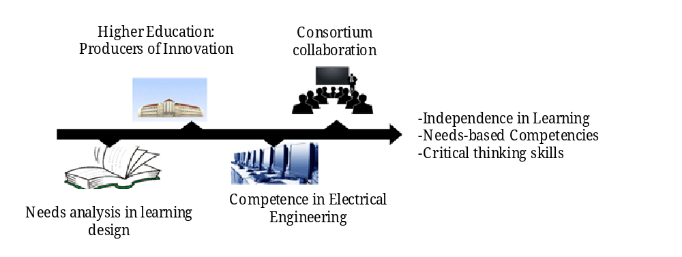
Figure 1. Tripartite Collaboration Model Strategy in Learning
In Figure 1, the block diagram shows the strategies determined in an effort to achieve collaboration goals, namely, Independence in Learning, -Needs-based Competencies and Critical thinking skills. The intended achievement target is to support the optimization of the Independent Campus policy in the Electrical Engineering Study Program in the North Sumatra region. There are 4 main blocks contained in the chart to realize the target of a digital learning home, student learning independence and recognition of the activities carried out by students through the involvement of Colleges that have electrical engineering study programs. Tripartite collaboration, RPS document with collective agreement standards that meets the minimum components contained in PERMENDIKBUD No. 3 of 2020 Article 12 paragraph 3, as well as enrichment of e-Modules which are jointly prepared and implemented in a virtual learning environment.
The main activity in optimizing the independent learning policy is through a tripartite consortium, which involves collaboration between lecturers in the field of electrical expertise between universities that cover the field of electrical engineering, as the Main Driving Force (MDF) as the main driving force. MDF works within the MoU to actualize student learning needs. MDF became the formulating team in compiling the MBKM needs-based learning process business with complete RPS and standard teaching materials/e-Modules based on mutual agreement. MDF in preparing programs for student learning needs will involve expertise/experts from study program associations and professional community groups as well as the World of Business and Industry (DUDI). Mapping of study program associations and professional community groups in the North Sumatra region that can create a tripartite consortium, namely the Association Forum in the field of Electrical Engineering and the involvement of industry practitioners in compiling a standard that will become a guideline for the consortium. in building the needs for optimizing the tripartite consortium of independent campuses for electrical engineering study programs in the North Sumatra region.

2.2. Media Development Stage.
Collaboration is also implemented in the field of electrical engineering. Applied to learning Electric Power Transmission, a core course on electrical power systems in the electrical engineering study program. Media development through a disturbance simulation program on High Voltage Air Lines is one part of the research activities carried out. The simulation program development stage begins by modeling the high voltage network with the Phi-Nominal model because medium distance high voltage overhead lines are selected.
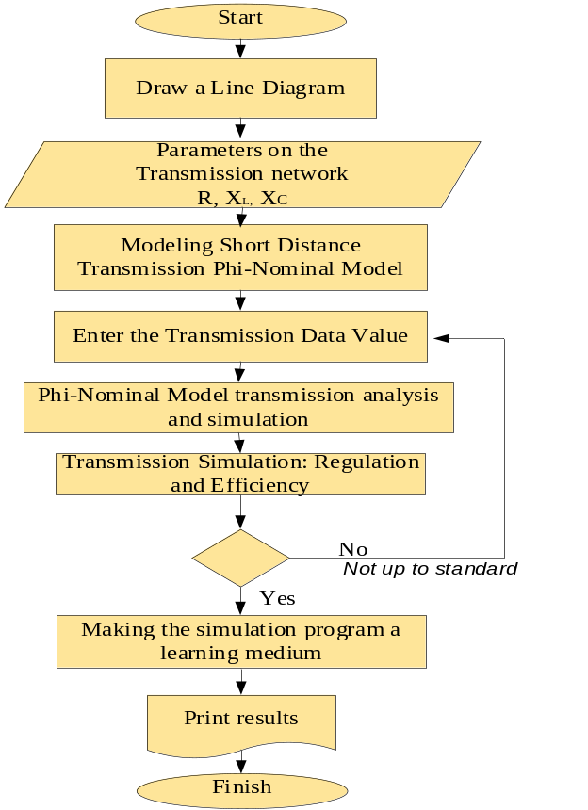
Figure 2. Simulation Program Preparation Stage

Figure 2 shows the stages of creating a simulation program starting from system data on a line diagram with the sending side and receiving side of the high voltage overhead line, then forming a phi-nominal model, then carrying out resistance analysis and Geometric Mean Radius and Geometric Mean Distance to obtain impedance through calculation of transmission line reactance due to XL and XC. From this calculation, the Volatage Regulation (VR) value and transmission line efficiency will be determined. Analysis and simulation of voltage regulation and efficiency in the medium range SUTT Analysis Formulation Model. Classification of medium distance transmission between 80 km to 250 km, using the phi-nominla model as shown in figure 3.
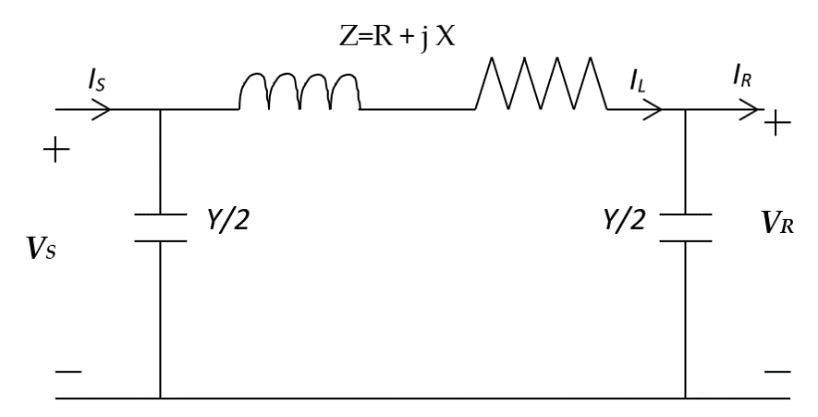

Figure 3. Nominal Phi Transmission Line Model
Information
I_{S} = Sending Current (Current from the Sending Side)
I_{R} = Receiving Current (Receiver side current)
V_{S} = Sending Voltage (Sending Side Voltage)
V_{R} = Receiving Voltage (Receiver side voltage)
Y = Transmission Line Shunt Admittance
Z = Transmission Line Series Impedance
Figure 3 shows the Nominal phi Model for the medium distance channel used in the simulation program used in the study.
From the Khircoff Current Law (KCL) the current in series impedance with I_{L} notation is:
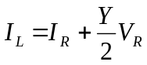 (1)
From Kirchoff's Voltage Law (KVL) the sender side voltage is written as:
V_{S} = V_{R} + Z I_{L} (2)
Substituting IL from equation (1) into equation (2), we get:
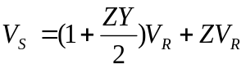 (3)
Sending side current (I_{S})
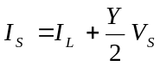 (4)
Substituting V_{S} and equation (3) into equation (4) will be obtained:
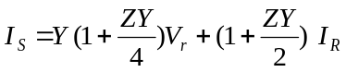 (5)
There are constants A, B C and D from equations (3), (4) and (5), namely:
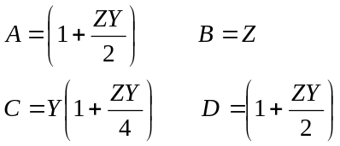 (6)
If written in the form of a matrix equation, it will be obtained:
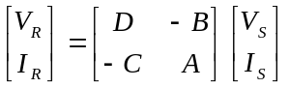 (7)

2.3. Media Content Validation.
After the simulation model based on Figure 2 is complete, media validation is carried out by experts, in this case 3 experts are needed, namely (1). Electricity expert; (2) Expert in the field of Information Technology and computers and (3) Expert in the field of Technology and Vocational Education. The three experts will analyze and validate based on their respective fields, as shown in figure 4.

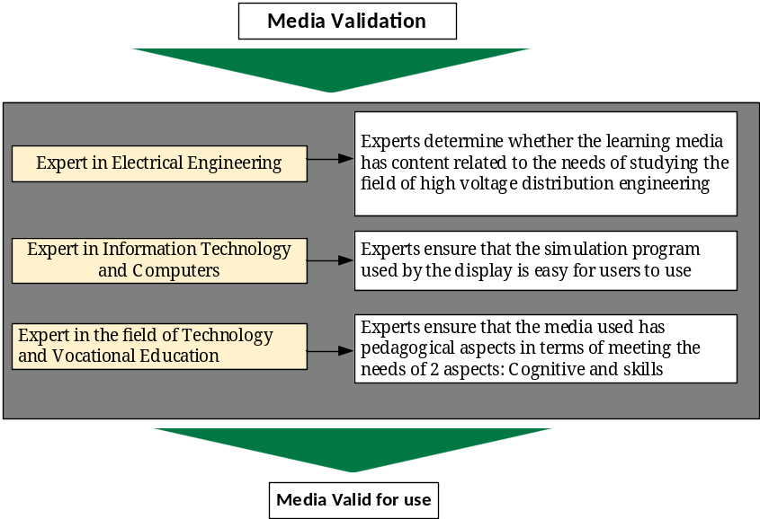
Figure 4. Media Validation by Experts
Media validation by 3 experts used two types of validity instruments used for validity testing, namely content validity with the Aiken'V approach used to analyze media content validity. is an approach formulated by Aiken for Content Validity Coefficient analysis based on the results of expert recommendations of 3 respondents regarding the media items proposed, in this case the extent to which media items in efforts to strengthen/optimize independent campus policies represent the measured needs of users.
In the simulation media, learning material for electrical power distribution systems is input. The material included is based on user needs. There are two types of instruments for collecting data on material needs used in this research, namely (a) questionnaires, and (b) interview/observation rubrics, as the main tool for observing research data. Questionnaires are used to search for information related to the specifications of the data being searched. The questionnaire prepared is used for study tracer, needs assessment and research product assessment, with the substance of the questions in the questionnaire in accordance with the required data collection. The assessment questionnaire from respondents was prepared using Linkert scale assessment criteria. The statements described in the questionnaire to respondents are arranged with scores and selection of descriptions of the contents of the questionnaire according to the criteria of need, shown in table 1.
Table 1. Assessment Questionnaire Likert Scale Table
Skor | deskripsi
5 | Very (Good/precise/systematic/consistent/adequate/interesting)*
4 | Good/precise/systematic/consistent/adequate/interesting *
3 | Sufficient ((Inadequate (Good/precise/systematic/consistent/adequate/interesting)*
2 | Less (Good/precise/systematic/consistent/adequate/interesting)*
1 | Very Poor (Good/precise/systematic/consistent/adequate/interesting)*
Note: the * mark is a selection according to the criteria for the content of the questionnaire questions.

2.4. Data for Effectiveness and Practicality Testing
The data used to test the effectiveness of the program is user data, namely study programs, lecturers and students who utilize the consortium program, with simulation products, Semester Learning Plans where activities are tested in several subjects in the field of electrical power systems engineering, the subjects chosen include namely Electric Power Transmission.
The effectiveness test formulation is shown in table 2.

Table 2. Effectiveness Test Equation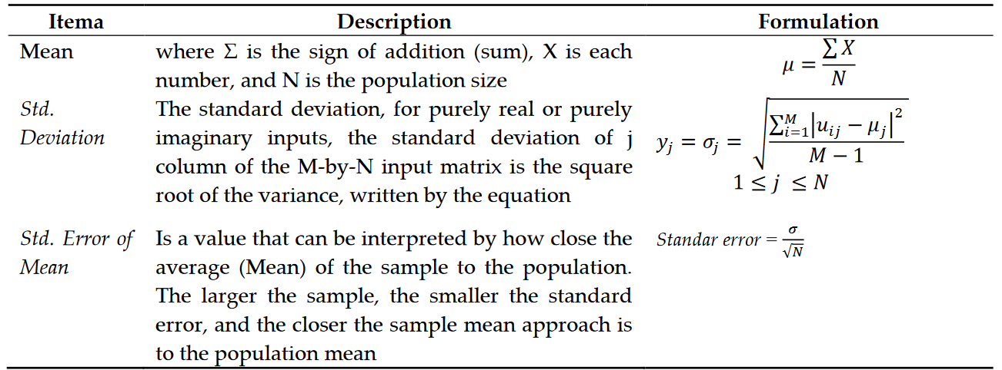
Effectiveness test analysis with the type of research used is pre-experimental quantitative research using one group pretest-posttest design (Sugiyono, 2017). The design that will be used in this research can be seen in table 3.

Table 3. The research design is one group pretest-posttest design
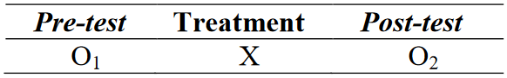
Data analysis carried out in this research included descriptive analysis and inferential analysis
includes the N-gain test, normality test, homogeneity test, and T-test (Paired Samples T-test). Descriptive analysis to describe the results of the learning process based on the data obtained. Scores from the response questionnaire on the use of electric power system simulation media using descriptive statistics. The following is the formula used to convert:
$Score/Value=\frac{Total Values ​​obtained}{Maximum Value}$ (8)
The percentage score obtained will be converted into a qualitative value using four criteria. Assessment classification guidelines are in table 4.
Table 4. Qualitative criteria for effectiveness testing
Value Interval | Criteria
81,25% < x ≤100% | Very good
62,50%< x ≤ 81,25% | Good
43,75%< x ≤ 62,50% | Not good
25%< x ≤ 43,75% | Very Not Good

Data for trial analysis was obtained from users (study programs, lecturers and students) with intervals for assessing the practicality of involving practitioners in collaboration are given in table 5.
Table 5. Classification of Practicality Levels of Research Models and Products
Nilai (%) | Kategori
80 < P ≤ 100 | Very Practical
60 < P ≤ 80 | Practical
40 < P ≤ 60 | Quite Practical
20 < P ≤ 40 | Less Practical
P ≤ 20 | Impractical

Analysis of the practicality of the media was carried out by simulation using Simulink Matlab. Measurement. Block diagram of practicality analysis process. As shown in figure 5.
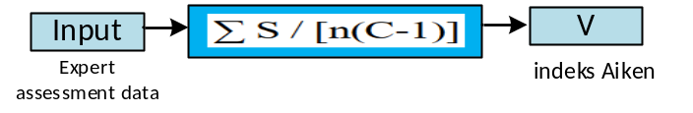
Figure 5. Media Practicality Analysis Model Block by Experts
Figure 4 shows the analysis model to be applied to Simulink Matlab, S is the difference between R and Lo (S=R-Lo), where S is minus the score given by the expert, while Lo is the lowest assessment score and R is the score given by the expert, for n is the number of validators. All parameters based on the equation in image block number 4 are used to determine the V (Aiken index) value.

- FINDINGS AND DISCUSSION

3.1. Effectiveness Test Analysis in the control class and experimental class
Data analysis: To determine the level of effectiveness of simulation media in learning electrical power systems which involve tri-partite collaboration in media development, it can be seen through the results of trials through pretests and posttests in the control class which applies power point media and the experimental class which applies simulation media. Analysis of differences in learning outcomes in the control class and experimental class was carried out with the help of simulation media using Simulink, as shown in figure 6.

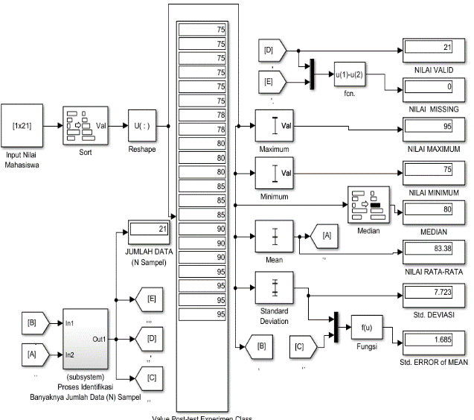
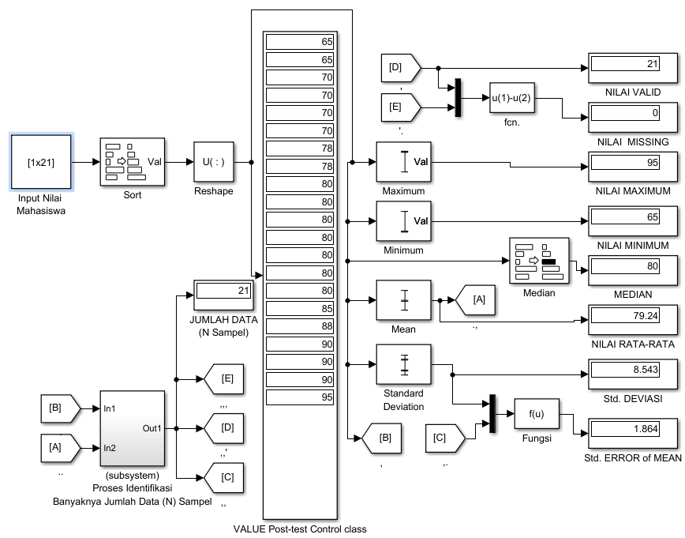
(a) (b)
Figure 6. Post-test simulation results show differences between the experimental class and the control class from the analysis test (a). Simulation of learning outcomes in the control class using video tutorial media in learning (b) Learning outcomes of the experimental class using tri-partite collaboration in developing simulation media

From the simulation results in Figure 5, data is obtained that the pre-test score is clearly control 65, while the post-test result is 75.8. In the control class, learning was treated with simulation tools using power points. Meanwhile, in the experimental class, the pre-test score was 66.5, while the post-test score was 83.38. The experimental class was treated with simulation media with tripartite cooperation. The plot of differences in learning outcomes based on tests in the control class and experimental class is shown in figure 7.
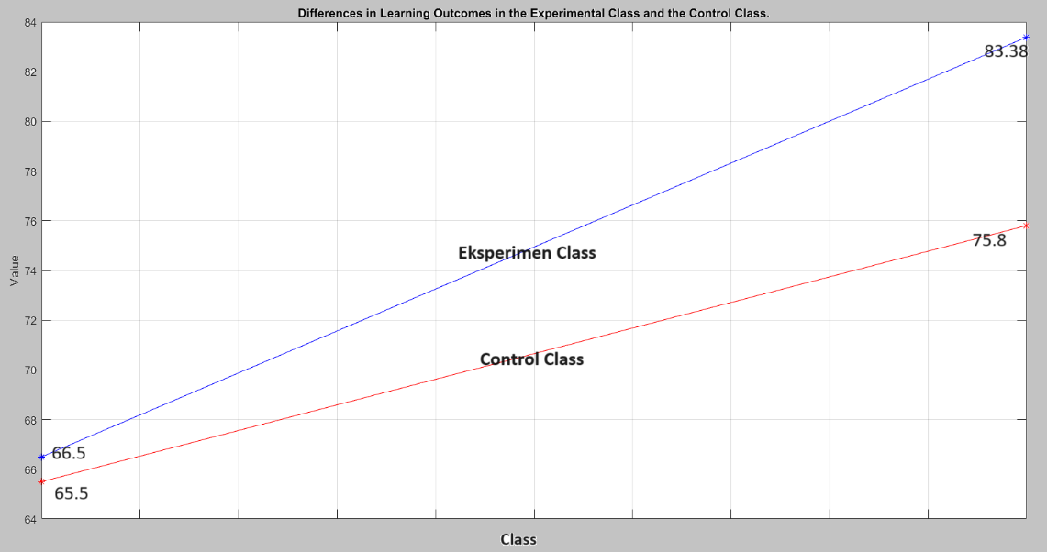
Figure 7. Graph of Differences in Learning Outcomes in the Experimental Class and the Control Class
Figure 7 shows the differences in learning outcomes in the control class and the experimental class. From the results of the simulation analysis of simulation media research trials with tripartite collaboration in learning about electrical power transmission, it is effective in improving learning outcomes.
The t-test is used to see the differences in a sample from two groups of data that receive different treatments or measurements. The results of the analysis using SPSS software obtained information about whether or not there were differences between the two groups in both the experimental class and the control class. In this research, the difference test uses the Mann-Whitney approach, if the significance value is <0.05 then the hypothesis or Ha is "accepted" while if the significance is >0.05 then Ha is "rejected". The process for determining the significance value is carried out with the help of SPSS software and the characteristics of the significance parameters in the results of running SPSS can be seen from the Asymp.sig (2-tailed) result data, meaning that the value shown in Asymp.sig(2-tailed) is to provide information that Ha is "accepted" or Ha is "rejected".
The t-test process of the post-test results of the control class and experimental class was carried out with the help of SPSS IBM 2.2 software, with the t-test results shown in table 6.
Table 6. Table Uji-t
One-Sample Test
 | Test Value = 0
 | t | df | Sig. (2-tailed) | Mean Difference | 95% Confidence Interval of the Difference
 |  |  |  |  | Lower | Upper
Nilai | 38.421 | 63 | .000 | 63.59259 | 59.4119 | 65.7733
From table 6, it can be seen that the value in the Asymp.sig(2-tailed) column is 0.00, indicating a significance value of <0.05, meaning that there is a difference in learning outcomes between the experimental class and the control class.
From the limited class effectiveness test for the control class and experimental class each had changes in student learning outcomes. In the control class, the expanded test using Power Point media showed changes in the average learning outcomes with the average value of the results between the pre-test and post-test in the control class with quite significant differences compared to the experimental class which was tested using tripartite collaboration-based simulations. In line with studies from research (Haerun. 2023) through studying the influence of collaborative learning using the ANOVA test, it is also known that the effect of implementing collaborative learning has an influence on learning outcomes through students' creativity and critical thinking, with a total influence of 77.9% for creativity and critical thinking. amounting to 27.1%.

3.2. Simulation Media Practicality Test Analysis Results
The practicality test was analyzed based on the results of user opinions (21 students in the experimental class) who used simulation media based on tripartite collaboration. 4 aspects in assessing media, namely (1) Media appearance, (2) Data entry on media (3) Ease of use of media and (4) Helpdesk (assistance) on media. Practicality analysis uses the help of Matlab simulation, as shown in figure 8.
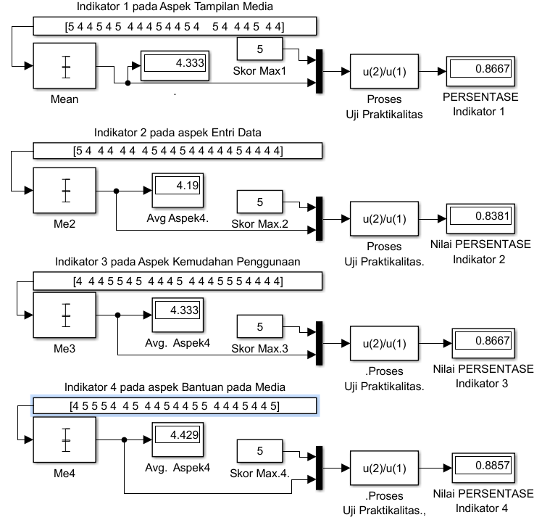
Figure 8. Media Practicality Test Simulation Results by Users.
From Figure 7, you can see the results of practicality in four aspects. Practicality was tested using the maximum value approach compared with the average value of the respondents' assessments. In the display aspect of the test media it was 86.67%, in the data entry aspect it was 83.81%, ease of use was 86.67% and in the media helpdesk aspect it was 88.57%. Of the four aspects, the practicality value is >80%, indicating that the media is very practical for use by users (students).

CONCLUSION
The tests and analyzes that have been carried out for the development of tripartite collaboration model simulation media can be concluded:
- Producing products based on the characteristics of user needs in the field of electric power transmission lines can improve learning outcomes in the knowledge aspect of the field of electric power distribution
- The results of the practicality test on the media show that the media is very practical to use and meets the learning needs of the field of electrical engineering
- The products produced in the research have been tested for their practicality. From the results of product practicality tests from the development of the PACTA model, it is stated that model books, module books, student manuals and lecturer manuals are easy for users to use in TDL learning.
- Testing of 2 classes that were treated with different learning models, the control class was treated with power point media and the experimental class was given simulation media based on tripartite collaboration. From the results of the comparison of the two classes, it can be seen that the cognitive aspect learning results through the post-test, the assessment results on the affective and psychomotor aspects in the experimental class have higher scores compared to the control class, so it can be stated that the simulation media product was developed involving industry practitioners. and academics have a better level of effectiveness in improving learning outcomes in the field of electrical power transmission compared to the model applied in the control class.

Acknowledgments: This paper was produced from the results of research funded by a Product Research Grant from PNBP funding managed by LPPM UNIMED in 2023

REFERENCES

Agus Junaidi & Rahmaniar (2022). Effectiveness of Learning Electric Power System Transmission using Higher Other Thinking Skill based Simulation, Al-Ishlah: Jurnal Pendidikan http://journal.staihubbulwathan.id/index.php/alishlah Vol.14, 3 (September, 2022), pp. 4105-4116 ISSN: 2087-9490 EISSN: 2597-940X, DOI: 10.35445/alishlah.v14i3.1227. 4105-4116.

Ahmad Sonhadji, K. Hasan, 2015, Cooperative Model of Industrial Work Practice for Vocational Teacher Education, The 3rd UPI International Conference on Technical and Vocational Education and Training, 2015, pp. 15-18.

Arweni Puspita Sari, Mardiana Ahmad, Prastawa Budi, Sutinah Made, Andi Nilawati Usman, Syafruddin Syarif, Jufriadi (2023), Effect of the Cooperative Learning Model through E-Module regarding Third Stage of Labor Care on the Increase in Knowledge, Skills and Learning Motivation among Midwifery D-III Students, Poltekita: Jurnal Ilmu Kesehatan, Vol.16 No.4: Hal. 416-421.

Ayu Fitrianingsih, Cahyo Hasanudin, Nofia Fitriyana, Abather Saadoon (2023), Developing Website-based Learning Media to Improve Students’ 5Cs Skills, Al-Ishlah: Jurnal Pendidikan Vol.15, 4 ISSN: 2087-9490 EISSN: 2597-940X, DOI: 10.35445/alishlah.v15i4.4504, pp. 4772-4780

Considine, M., Lanuru, M., Bahruddin, B., Vaughan, F., Alam, J.F., Mangilep, M.A.A., Ikasari S.N., Ramli, R.N.H. (2022), ‘Membangun hubungan yang lebih kuat antara universitas dan industri: Studi kasus di Universitas Hasanuddin’, the Australia-Indonesia Centre.

Haerun Nisa, Muhammad Isnaini, Linda Sekar Utami, Islahudin Islahudin,(2023) Collaborative Learning Effect on Improving Students’ Creativity and Critical Thinking in the Independent Curriculum, Al-Ishlah: Jurnal Pendidikan Vol.15 (3) ISSN: 2087-9490 EISSN: 2597-940X, DOI: 10.35445/alishlah.v15i3.3538, pp. 4038-4048.

Junaidi A, Adi Sastra T., Abdul Hakim B., Marwan Afandi, Janner Simarmata, Wanapri Pangaribuan (2020). Effectiveness And Practicality Cai Based Simulation For Learning Media of Short Circuit Current, Journal of Theoretical and Applied Information Technology, Vol.100 (15). 4732-4743.

Keputusan Menteri Pendidikan, Kebudayaan, Riset, dan Teknologi Republik Indonesia Nomor 210/M/2023 tentang Indikator Kinerja Utama (IKU) Perguruan Tinggi dan Lembaga Layanan Pendidikan Tinggi di Kementerian Pendidikan, Kebudayaan, Riset, dan Teknologi Menteri Pendidikan, Kebudayaan, Rissi, Dan Teknologi Republik Indonesia.

Kemenristek DIKTI (2019). Report Rekomendasi Rakernas Kemenristekdikti”, Semarang, 2019

Michal Hrivnák and Jana Jarábková, (2022) Drivers of Academic Engagement and University–Industry Collaboration in Conditions of Slovakia, MDPI, Basel, Switzerland, https://doi.org/10.3390/admsci12040128, pp. 1-21.

Rahmaniar, Ganefri, Abd. Hamid K, Nizwardi Jalinus, Jalius Jama (2019). Modelling and Simulation: an Injection Model Approach to Controlling Dynamic Stability Based on Unified Power Flow Controller. Journal of Theoretical and Applied Information Technology, Vol.97. (20) 2334-2345.

Q. Wang, Z. Tang, I. Knezevic, J. Yu and G. Karady (2016). Power system protection education and digital relay training based on a physical platform, North American Power Symposium (NAPS), Denver, doi: 10.1109/NAPS.2016.7747884. 1-5.

