Unveiling perspectives: Pre-service physics teachers and their views on STEM-EDP project in tackling water turbidity
Atin Nuryadin¹, Lambang Subagiyo², Nurul F. Sulaeman³, Muliati Syam⁴
¹ Physics Education Study Program, Mulawarman University, Samarinda, Indonesia 75123; atin.nuryadin@fkip.unmul.ac.id
² Physics Education Study Program, Mulawarman University, Samarinda, Indonesia 75123; subagiyo@fkip.unmul.ac.id
³ Physics Education Study Program, Mulawarman University, Samarinda, Indonesia 75123; nurul.sulaeman@fkip.unmul.ac.id
⁴ Physics Education Study Program, Mulawarman University, Samarinda, Indonesia 75123; muliati.syam@fkip.unmul.ac.id

ARTICLE INFO |  | ABSTRACT
Keywords:  pre-service physics teachers;  STEM-EDP;  water turbidity |  | Water turbidity, caused by human activities like mining and agriculture, refers to the cloudiness of water due to particles mixing with it. This increased turbidity can lead to reduced ecosystem productivity, habitat degradation, changes in water color, lower oxygen levels, and health risks. To address this issue, students need to be educated on water conservation and how to mitigate turbidity. This study explores the perceptions of pre-service physics teachers regarding how STEM integrated with the Engineering Design Process (STEM-EDP) can help solve water turbidity problems. A STEM-EDP activity was designed through a worksheet for four meetings, with 39 students divided into 13 groups. They were tasked with designing and building a water turbidity measurement and filtration device using common materials, following the same process used by engineers and scientists. At the end of the project, an open-ended question was used to gauge the students’ perspectives on how STEM-EDP facilitated the completion of the project. The results showed that pre-service teachers believed STEM-EDP helped them address water turbidity effectively. Their responses highlighted how the process encouraged critical and creative thinking, teamwork, communication, problem-solving, and the application of STEM principles in real-world contexts. This hands-on STEM activity not only helped students solve water turbidity issues but also inspired them to design engaging and meaningful learning activities for their future students.
Article history:
Received 2021-08-14
Revised 2021-11-12
Accepted 2022-01-17
 |  | This is an open access article under the CC BY-NC-SA license.
Corresponding Author:
Atin Nuryadin
Physics Education Study Program, Mulawarman University, Samarinda, Indonesia 75123; atin.nuryadin@fkip.unmul.ac.id
- INTRODUCTION
Turbidity is an important indicator of water quality, and surface water in Indonesia, particularly in rivers, is usually highly turbid during the rainy season (Azis, Yusuf, Faisal, & Suradi, 2015). In general, turbidity refers to cloudiness or haziness in water that is primarily due to human activity in certain industries, such as mining and agriculture, which cause particles to mix with water and move together. Turbidity in water can change the color of the water, reduce the oxygen concentration in the water, and impose health risks on aquatic ecosystems (Subagiyo, Nuryadin, Sulaeman, & Widyastuti, 2019; Yen & Rohasliney, 2013). As a result, it is everyone's responsibility to preserve clean water. In education, it is imperative that students are educated about water issues and turbidity in order to ensure water conservation in the future. This topic is also part of the science education curriculum for the high school level. For this reason, it is important to use the right teaching method when teaching environmental issues in a class.
A study has found that a project-based learning model based on contextual problems can improve students’ ability to solve environmental issues (Retnowati, Istiana, & Nadiroh, 2020). The project-based learning method focuses on enabling learners to build knowledge through the completion of meaningful projects and the development of real-world products. However, as learning nowadays needs to change with the trend in the globalization era, project-based learning needs to be integrated with Science, Technology, Engineering, and Mathematics (STEM) education (Roslina, Samsudin, & Liliawati, 2022). In STEM, authentic projects fuel students' curiosity and generate excitement and a sense of empathy by allowing them to engage in real-life problems. STEM with project-based learning model can help students to develop high-order thinking skills in solving real-life problems (Oyewo, Ramaila, & Mavuru, 2022). Typically, STEM teaching is implemented using the engineering design process (EDP) as an instructional framework (Siew, 2017). Many studies have proved that EDP improves student achievement, especially in terms of students' mastery of science, their interests in science, and their attitudes towards it, as well as improving technical skills (engineering and technology) (Nurtanto, Pardjono, Widarto, & Ramdani, 2020). In EDP, students are guided through the same process as engineers, scientists, or mathematicians would use to solve a problem. STEM with the EDP model (STEM-EDP) is intended to help students solve open problems, develop creativity, formulate solutions, make decisions, and consider alternative solutions to meet various challenges. However, in order to create an effective STEM-EDP implementation, teachers must be properly trained and experienced in conducting STEM-EDP learning (Sulaeman, Efwinda, & Putra, 2022). Therefore, experiencing real learning with STEM-EDP in the classroom is crucial for the implementation of STEM-EDP in learning before pre-service teachers become real educators in the future.
The preparation of teachers is an important component of STEM-EDP learning (Margot & Kettler, 2019). In particular, it is the teachers who are responsible for implementing or integrating STEM-EDP in the classroom. Hence, preparing pre-service teachers at the university level is essential in order to achieve a successful STEM-EDP implementation at school. Further, to motivate teachers to implement STEM-EDP learning in class and ensure that the implementation of STEM-EDP is meaningful, pre-service teachers must first understand the benefits students receive from integrating STEM-EDP learning into their classrooms. Based on the aforementioned explanation, it is clear that teachers need to be prepared with the knowledge, skills, and experience needed to implement STEM-EDP learning while still in university. Then, as an initial stage, this study tried to find out and describe pre-service teachers' perceptions of how STEM-EDP learning could help students to complete projects on water turbidity reduction.
- METHODS
This study is qualitative descriptive research. The samples in this study, which consisted of 39 pre-service teachers from two classes of the Integrated Science course, were divided into 13 groups. They were given four meeting projects to design and build a water turbidity meter and water filter using commonly available materials through a developed STEM-EDP worksheet. The worksheet development process has been explained in a previous study (Nuryadin, Sulaeman, Subagiyo, Sholeh, & Andrianto, 2023). The STEM component of science focused on the concept of scattering, absorption, and light reflection in the development of a water turbidity meter, and particle transport on filtration. As for the Technology component, the smartphone application of the lux meter was used for developing the turbidity meter, and the internet was used for browsing information about the mechanisms of turbidity measurement and water filtration. The Engineering component involved planning and designing a turbidity meter and a water filtration system at a low cost. Additionally, the Mathematics component was applied to plot graphs and calculate the water debit and manufacturing cost.
Pre-service teachers complete the project via the EDP procedure on the developed worksheet. The EDP procedure of the worksheet consisted of Define, Learn, Plan, Try, Test, and Decide. In Define stage, pre-service teachers identified the client’s needs relating to water issues and their constraints through given problem letters on the worksheet. After that, in Learn stage, they conducted a literature study to find information about water turbidity and filtration, and then looked for solution methods to solve water turbidity issues. Designing and developing the turbidity meter and water filter was conducted in the Plan stage. In the Try stage, they tested and evaluated the developed water turbidity meter and water filter. In the Test stage, they redesigned the developed turbidity meter and water filter as needed based on the evaluation in the previous stage. Finally, in the Decide stage, the pre-service teacher presented their designs to the whole group and decided which kind of design was proper for the turbidity meter and water filter. At the end of the project, an open-ended question was used to clarify the students' perspectives on how STEM-EDP helped them complete worksheet projects. The analysis of pre-service teachers’ answers to the question was performed through keywords, word co-occurrence network, and answer highlight analyses.
- FINDINGS AND DISCUSSION
The purpose of this study was to investigate how pre-service physics teachers think STEM-EDP can help students complete projects on water turbidity problems. In order to identify which concepts are prominent in the pre-service teachers' answers, a keyword analysis was conducted (DePaolo & Wilkinson, 2014). Figure 1 shows the word cloud constructed by students' answers to a given question related to how STEM-EDP helped them to complete the projects. In all the answers, the most commonly used keywords are water, STEM-EDP, project, approach, turbidity, and problems. These are related to the explanation of the activity that they have conducted on the answers, which is project-based learning with STEM-EDP on water turbidity problems. Since the STEM approach was used in the project, the words technology, science, mathematics, and engineering are also found in high frequencies in their answers. Moreover, the word queries helped, make, solving, designing, and measuring can be recognized as the basic keywords of the analysis, synthesis, and evaluation level of thinking skills (Lamoste, Lagunzad, & Distor, 2020; Valdev Singh & Shaari, 2019). It means that the STEM-EDP project tended to make pre-service teachers use higher-order thinking, which involves the development of critical thinking and problem-solving abilities.
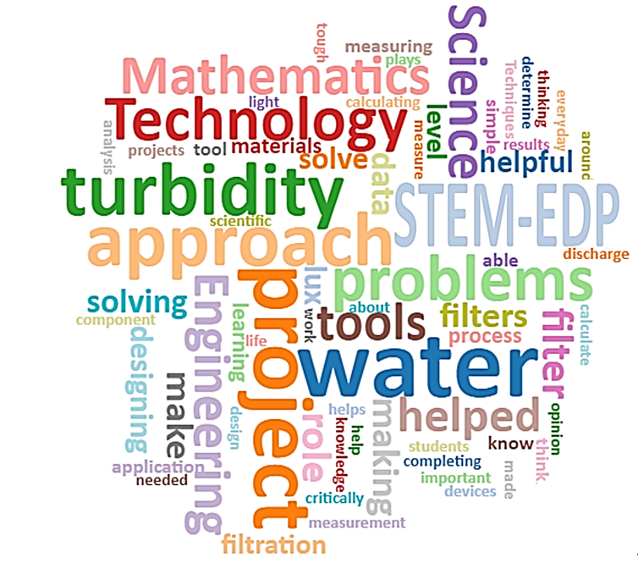
Figure 1. Keyword analysis of pre-service teachers' answers.
To analyze the potential relationships between words in a text, word co-occurrence network analysis was used in this study. The word co-occurrence analysis of 39 students' answers to the question with nouns and adjectives with a minimum TF (term frequency) of 50 can be seen in Figure 2. The size of the nodes indicates the frequency of words, the thickness of the paths indicates the strength of the connection between word pairs, and the color indicates the presence of word communities determined by the random walk method (Tussyadiah, 2016). The words that appear with the highest frequency in the network are the same as the results of the keyword analysis in Figure 1. It is noteworthy that the network represents isolated word communities with weak connections among them. There are two large word communities that can be seen in Figure 2. The first one is dominated by words that describe how pre-service teachers feel about the STEM-EDP role in the project. The majority of pre-service teachers felt that the STEM-EDP approach was very helpful in solving given problems and completing the projects. The second large word community is related to the description of the problems and projects they have done, which is to make a water filter and a turbidity meter using a lux meter application on a smartphone. Some isolated word communities revolve around the components of STEM (science, technology, engineering, and mathematics) and processes of the project (making filtration device, making measurement tool, and calculating water discharge). The existence of STEM components in their answers indicates that pre-service teachers realized the integration of the STEM elements during completing the project. The other isolated communities related to how STEM-EDP helped them to solve given problems on the projects, such as by enabling critical thinking, relating problems with everyday problems, and combining STEM components.
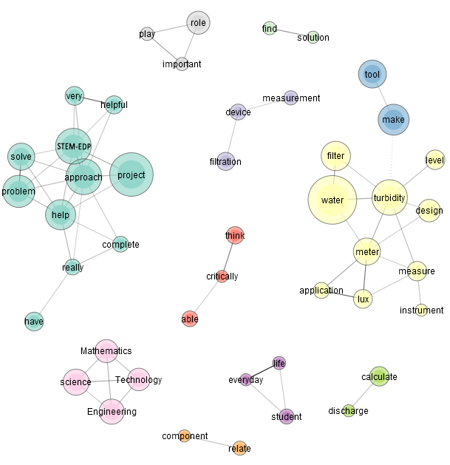
Figure 2. Word co-occurrence network of pre-service teachers' answers.
The answers from pre-service teachers to the given question are analyzed to bring more light to the discussion. The analysis categorized answers into several highlights. The answer highlights and their examples are presented in Table 1. In the table, the answers are grouped into six highlights: critical thinking, creative thinking, collaboration, communication, STEM integration, and solving real-life problems.
Based on Table 1, some students (e.g., students 16 and 19) argued that the STEM-EDP helped them to think critically in solving existing problems related to water turbidity. On the project worksheet, students were given a letter about problems being experienced by campus related to water turbidity. The client in the letter asked students to design and create a turbidity meter and water filter. In the design process, students need to identify the stated problem clearly, research the problem, generate a solution based on physics concepts, develop a prototype, and evaluate the prototype based on feedback from team members (Carfagni, Fiorineschi, Furferi, Governi, & Rotini, 2020). This process automatically guided pre-service teachers to think critically in completing the water turbidity project. Students 6 and 7 felt that completing the project with STEM-EDP required them to think creatively. In the problem letter, pre-service teachers were encouraged to think creatively and innovatively in order to design effective water turbidity meters and water filter equipment. They also have to design and create solutions to make a product safer or more cost-effective, as required in the problem letter. Moreover, it was found that project-oriented problem-based learning related to real-world problems could promote students' creativity (Chang et al., 2022). From the answers of students 32 and 35, it can be concluded that the developed STEM-EDP helped them to complete the project because they worked collaboratively in a group. Working in a group exposes students to continuous interaction, which can enhance their learning experience by building a sense of trust and dependence on their fellow members to perform tasks together efficiently and effectively (Ibrahim & Rashid, 2022). Furthermore, students 19 and 11 thought that the communication aspect helped them to perform the project, where this aspect was enabled by conducting the project in a team.
Table 1. Highlights of pre-service teachers' answers on how STEM-EDP could help students to complete projects on water turbidity problems.
Answer Highlight | Excerpt | Student Code
Critical Thinking | In this project, we were required to think critically to solve existing problems. | 16
 | The role of STEM-EDP in our project was to train our skills in thinking critically about a problem, especially when measuring the turbidity level of water. | 19
Creative Thinking | Making these tools can encourage our way of thinking creatively and innovatively, where we can develop procedures independently or in groups, solve problems that occur in the process of making tools, and can also utilize surrounding materials to create useful tools. | 6
 | With the STEM-EDP approach, we completed a water filter project with a creative way of thinking (…). | 7
Collaboration | STEM-EDP shapes learning experiences that are active in collaboration (…) | 32
 | During the project, we worked together in groups to complete the project according to the determined specifications but at affordable prices. | 35
Communication | STEM-EDP helped and trained us in solving problems, making decisions, and being able to communicate in groups (…). | 19
 | This STEM-EDP approach can also form (…) communicative thinking attitudes. | 11
STEM Integration | This STEM-EDP approach helped us in solving problems in designing turbidity measuring instruments and water filters because this approach interconnects and integrates STEM-EDP elements (…) | 13
 | The STEM-EDP approach helped us complete this project because it could direct us in searching for solutions used in our project through the integration of science, technology, engineering, and mathematics. | 23
Solving Real-Life Problems | The STEM-EDP approach in this project led us to know that simple tools around can help purify water (…). Through the STEM-EDP approach, we can also solve problems around our campus with environmentally friendly objects around us. | 7

Critical thinking, creativity, collaboration, and communication skills are considered the 4Cs of the 21st century, and these skills are needed in order to succeed in the modern work environment (Thornhill-Miller et al., 2023). Based on the answer highlighted in Table 1, the 4Cs skills were developed in pre-service teachers in the STEM-EDP-based project, which ultimately assisted them in successfully completing the project. As demonstrated in a previous study, STEM education was found to be beneficial to the development of 21st-century skills among pre-service science teachers (Hacıoğlu, 2021).
Besides the development of 4Cs skills, pre-service teachers also highlight the integration of STEM components, such as students 13 and 23. They felt that STEM guided them in finding solutions to the project problems through the integration of science, technology, engineering, and mathematics. A significant benefit of this integration is that pre-service teachers have the opportunity to make sense of an integrated world rather than learning and practicing fragmentary concepts (English, 2016). Furthermore, students 7 and 13 pointed out that STEM-EDP helped them complete the project because the problems offered related to problems in their real life. Pre-service teachers were exposed to real-world scenarios in STEM in order to demonstrate how they can apply their subject matter to their daily life. Using contextual problems as a means of learning motivates pre-service teachers to connect knowledge to application in the real world (Ilyas & Liu, 2020). By providing this type of lesson, students will gain a greater appreciation for what they are learning and feel more invested in their project.
- CONCLUSION
The exploration of pre-service physics teachers' perceptions of how STEM-EDP helps students to complete projects on water turbidity problems was done in this study. Based on the analysis, pre-service physics teachers felt that the STEM-EDP helped them to solve the water turbidity issues presented in the project worksheet. STEM-EDP promotes the use of higher-order thinking, which involves problem-solving and critical thinking skills among pre-service teachers. It appears from the pre-service teachers' answers that they realized the importance of integrating STEM elements during project completion. Participants indicated that STEM-EDP provided them with opportunities to think critically and creatively, collaborate in groups and communicate effectively, solve their actual problems, and use STEM components to propose solutions to water turbidity problems. By engaging in this STEM hands-on activity, pre-service physics teachers can learn how to design meaningful learning activities for their future students.
Acknowledgments: The authors express their gratitude to the support of the Ministry of Education, Culture, Research, and Technology, the Republic of Indonesia, for providing funding for this study.
Conflicts of Interest: The authors declare no conflict of interest.

REFERENCES
Azis, A., Yusuf, H., Faisal, Z., & Suradi, M. (2015). Water turbidity impact on discharge decrease of groundwater recharge in recharge reservoir. Procedia Engineering, 125, 199–206. https://doi.org/10.1016/j.proeng.2015.11.029
Carfagni, M., Fiorineschi, L., Furferi, R., Governi, L., & Rotini, F. (2020). Usefulness of prototypes in conceptual design: students’ view. International Journal on Interactive Design and Manufacturing (IJIDeM), 14(4), 1305–1319. https://doi.org/10.1007/s12008-020-00697-2
Chang, T.-S., Wang, H.-C., Haynes, A. M., Song, M.-M., Lai, S.-Y., & Hsieh, S.-H. (2022). Enhancing student creativity through an interdisciplinary, project-oriented problem-based learning undergraduate curriculum. Thinking Skills and Creativity, 46, 101173. https://doi.org/10.1016/j.tsc.2022.101173
DePaolo, C. A., & Wilkinson, K. (2014). Get your head into the clouds: Using word clouds for analyzing qualitative assessment data. TechTrends, 58(3), 38–44. https://doi.org/10.1007/s11528-014-0750-9
English, L. D. (2016). STEM education K-12: perspectives on integration. International Journal of STEM Education, 3(1), 3. https://doi.org/10.1186/s40594-016-0036-1
Hacıoğlu, Y. (2021). (2021). The effect of STEM education on 21st century skills: Preservice science teachers’ evaluations. Journal of STEAM Education, 4(2), 140–167. Retrieved from https://dergipark.org.tr/tr/download/article-file/1693716
Ibrahim, D. S., & Rashid, A. M. (2022). Effect of project-based learning towards collaboration among students in the design and technology subject. World Journal of Education, 12(3), 1. https://doi.org/10.5430/wje.v12n3p1
Ilyas, I., & Liu, A. N. A. M. (2020). The effect of based e-learning contextual approach on student learning motivation. Jurnal Penelitian Pendidikan IPA, 6(2), 184–189. https://doi.org/10.29303/jppipa.v6i2.425
Lamoste, L. D., Lagunzad, C. G. B., & Distor, J. O. P. (2020). apabilities of augmented reality in teaching and learning: Students ’perception. APCoRE Journal Proceeding, (May), 114–119. Pasay City, Philippines: Asia Pasific Consosrtium of Researchers and Educators, Inc. Retrieved from https://www.apcore-inc.org/apcore-journal-of-proceedings
Margot, K. C., & Kettler, T. (2019). Teachers’ perception of STEM integration and education: A systematic literature review. International Journal of STEM Education, 6(2). https://doi.org/10.1186/s40594-018-0151-2
Nurtanto, M., Pardjono, P., Widarto, W., & Ramdani, S. D. (2020). The effect of STEM-EDP in professional learning on automotive engineering competence in vocational high school. Journal for the Education of Gifted Young Scientists, 8(2), 633–649. https://doi.org/10.17478/jegys.645047
Nuryadin, A., Sulaeman, N., Subagiyo, L., Sholeh, M., & Andrianto, E. (2023). Developing worksheets using engineering design process to promote sustainable development goals for pre-service physics teacher. Jurnal Ilmiah Pendidikan Fisika, 7(1), 183. https://doi.org/10.20527/jipf.v7i1.7775
Oyewo, O. A., Ramaila, S., & Mavuru, L. (2022). Harnessing project-based learning to enhance STEM students’ critical thinking skills using water treatment activity. Education Sciences, 12(11), 780. https://doi.org/10.3390/educsci12110780
Retnowati, R., Istiana, R., & Nadiroh, N. (2020). Developing project-based learning related to local wisdom in improving students’ problem-solving skills. JETL (Journal of Education, Teaching and Learning), 5(1), 137. https://doi.org/10.26737/jetl.v5i1.1035
Roslina, Samsudin, A., & Liliawati, W. (2022). Effectiveness of project based learning integrated STEM in physics education (STEM-PjBL). Phenomenon, 12(1), 120–139.
Siew, N. M. (2017). Integrating STEM in an engineering design process: The learning experience. The Eurasia Proceedings of Educational & Social Sciences (EPESS), 6(4), 128–141. Retrieved from http://library.uprm.edu:2404/ehost/detail/detail?vid=4&sid=2263ee5a-20f2-4b8c-af4e-6a8f58b789e9@sessionmgr101&hid=126&bdata=JnNpdGU9ZWhvc3QtbGl2ZSZzY29wZT1zaXRl#AN=118132072&db=a9h
Subagiyo, L., Nuryadin, A., Sulaeman, N. F., & Widyastuti, R. (2019). Water quality status of Kalimantan water bodies based on the pollution index. Pollution Research, 38(3), 536–543.
Sulaeman, N., Efwinda, S., & Putra, P. D. A. (2022). Teacher readiness in STEM education: Voices of Indonesian physics teachers. Journal of Technology and Science Education, 12(1), 68. https://doi.org/10.3926/jotse.1191
Thornhill-Miller, B., Camarda, A., Mercier, M., Burkhardt, J.-M., Morisseau, T., Bourgeois-Bougrine, S., … Lubart, T. (2023). Creativity, critical thinking, communication, and collaboration: Assessment, certification, and promotion of 21st century kills for the future of work and education. Journal of Intelligence, 11(3), 54. https://doi.org/10.3390/jintelligence11030054
Tussyadiah, I. P. (2016). Strategic self-presentation in the sharing economy: Implications for host branding. Information and Communication Technologies in Tourism 2016, (January 2016), 695–708. Cham: Springer International Publishing. https://doi.org/10.1007/978-3-319-28231-2_50
Valdev Singh, R. K., & Shaari, A. H. (2019). The analysis of higher-order thinking skills in english reading comprehension tests in Malaysia. Malaysian Journal of Society and Space, 15(1), 12–26. https://doi.org/10.17576/geo-2019-1501-02
Yen, T. P., & Rohasliney, H. (2013). Status of water quality subject to sand mining in the Kelantan River, Kelantan. Tropical Life Sciences Research, 24(1), 19–34.

