Development of a Virtual Chemistry Practicum Platform: Challenges and Solutions

ARTICLE INFO |  | ABSTRACT
Keywords:  Online-based chemistry laboratory, ADDIE model, validity and practicality, chemistry practicum, physics education |  | Development research or R&D (Research and Development) is carried out with the aim of finding out the challenges and solutions for the development of online-based chemistry laboratory equipment for physics education study program students who meet valid, practical, and effective criteria. The research method used was developed with the ADDIE model. The research subjects in this study consist of two, namely the main subject and the trial subject. The main subject consists of 2 expert lecturers who are the product validator team. The test subjects consisted of 22 basic chemistry practitioners of the physics education study program of UIN Alauddin Makassar.  The results showed that the validity value obtained for the media was 0.57. The value is within the valid category range. This indicates that the development of an online-based chemistry laboratory device is valid and feasible. The level of practicality of the media is based on the results of responses and observations using student guides. The conclusions of the research obtained show that basic chemistry practicum to student responses is at 100% very practical. Based on this data, it can be concluded that the development of online-based chemistry laboratory devices has a valid and practical category. The implication of this research is that the developed online-based chemistry laboratory device provides convenience to assistants and laboratory heads in laboratory devices and makes it easier for students to collect assignments, an easy-to-access guide. In addition, the developed online-based chemistry laboratory device can also be used in physics practicum.
Article history:
Received 2021-08-14 2021
Accepted
Article history:  Received 2021-08-14 2021  Accepted |  | This is an open access article under the CC BY-NC-SA license.
Corresponding Author :
Muhammad Qaddafi
State Islamic University Alauddin Makassar; muhammad.qaddafi@uin-alauddin.ac.id
- INTRODUCTION
Laboratory practical work provides a unique learning context that allows students to actively engage in exploration and investigation, similar to the activities carried out by scientists (Domin, 2007). To implement learning in laboratories, it is important to support it with adequate facilities. The National Education Standards Agency (BSNP) has established standards for laboratory facilities and infrastructure related to the determination of various types of laboratory facilities at universities (Anggereni et al., 2021).
Chemistry, as part of science, is a discipline that relies on experimental methods, where its development and application require high standards in conducting experiments. Chemistry experiments or laboratory work contribute to helping students develop technical skills such as equipment and material handling, observation, data collection, data analysis, interpretation of observational results, problem-solving, teamwork, experimental design, and communication skills (Bennett & O’Neale, 1998).
One of the main approaches is the use of virtual laboratories as an alternative to traditional laboratory practicals. Research conducted by (Winkelmann et al., 2017) shows that immersive environments such as Second Life can be used effectively to conduct chemistry experiments, making it easier for students to access and understand complex chemical concepts. Research by (Bazie et al., 2024) demonstrates that online laboratories significantly contribute to the academic achievement of undergraduate chemistry students, proving that this approach can enhance learning outcomes compared to traditional lecture methods.
The development of chemistry education has faced various challenges, particularly in terms of limited access and limited resources for conducting laboratory practicals. In this context, the application of advanced technologies, such as augmented reality (AR), offers a potential solution to improve students' understanding of complex chemistry concepts. Research by (Nazar et al., 2024) indicates that AR can enrich learning experiences in a more interactive and dynamic way, providing students with opportunities to understand chemical properties in a more in-depth context. However, to effectively utilize this technology, it is important to provide training for educators, as emphasized by (Price et al., 2021) (Xue &amp; Keat, 2024), who highlight the importance of online learning communities in supporting the use of guided inquiry-based teaching methods.
In addition, laboratory administration also plays a crucial role in supporting the operations of virtual laboratories. (Yuliastrin et al., 2023) (Chamorro-Atalaya et al., 2023) emphasize the importance of technology in laboratory management to ensure operational efficiency, while (Kardiyem et al., 2025) highlight the role of student involvement and real-world experience in evaluating the success of virtual laboratories.
The use of a hybrid approach, which combines face-to-face and digital learning, also offers significant flexibility, allowing for the accommodation of various student learning styles (Masril et al., 2024). In addition, gamification (Wahyudi et al., 2023) can accelerate cognitive engagement and increase student motivation in learning chemistry.
The importance of continuous training for educators, the implementation of TPACK (Kartimi et al., 2021), and improving accessibility to science education are key to maximizing the potential of this technology, especially for students from economically disadvantaged backgrounds (Nicho et al., 2024). As such, the implementation of virtual laboratories, AR, and other digital education technologies has the potential to transform the face of chemistry education, opening up opportunities for more inclusive and innovative learning.
Many students experience difficulties in terms of knowledge and skills related to the use of equipment and procedures for conducting experiments, and assistants find it difficult to assess their performance. The Laboratory Head has not been able to provide adequate guidance on the proper use of equipment due to time and resource constraints. Additionally, there are limitations in the content presented in the practical guide and assessment materials, such as unattractive device designs, content that primarily explains theory without demonstrating practical steps in experiments, and manual attendance and assessment processes using paper, among others. This makes it possible for students to still lack understanding of what is conveyed in the practical devices, and assistants find it difficult to conduct assessments. This may occur because the design of the practical devices and the assessment for basic chemistry are still unappealing to students. As a result, the main issues students face when participating in basic chemistry practical activities are a lack of knowledge regarding the proper use of equipment, procedural guidelines for practical activities, and the need for improved explanations regarding the meaning and purpose of each activity, particularly during the mixing process in basic chemistry practical activities.
For this reason, innovation is needed in the form of visual guidelines that illustrate the procedures for conducting each experiment. To this end, utilizing advances in digital technology, a visual-based guide will be developed with the help of a website. An interactive multimedia-based tool is a guide that includes explanations of the steps involved in the data collection process for experiments, accompanied by visual guides in the form of animated images that can be replicated by students. Additionally, students can directly input values and take attendance within the same website, thereby simplifying the practical work for both students and assistants.
Based on the above explanation, the researcher intends to develop a Virtual Chemistry Practicum Platform, Challenges and Solutions for Physics Education Students, which includes the validity and practicality of the developed product.
- METHODS
This study uses research and development (R&D) to develop chemical laboratory equipment. This model consists of four simplified main steps, namely preliminary study, development, field testing, and dissemination. However, in this study, the dissemination stage was not carried out as part of the final activity. The preliminary study stage was conducted through literature studies and field studies. Field studies were conducted to identify existing potential and problems in the field, as well as to collect data from direct sources. The development stage involved determining the research objectives, determining the subjects to be studied, identifying the parties involved in the research, determining the work procedures, developing the product, and conducting validation. The field testing stage consists of product readability testing and field trials. During field trials, revisions are made based on the results of the trials to produce the desired final product. The research procedure flowchart has been modified from the Borg and Gall (1983) research model.
The ADDIE (Analysis, Design, Development, Implementation, and Evaluation) research design is the development model used in this study. One of the reasons the researchers used the ADDIE model in this study is that it has logical steps that are easy to learn. In addition, the development model used in this study involves assessment by experts or validators during its development.
The ADDIE model stages have been revised step by step to suit the creation of a valid and practical laboratory website. One of the most efficient tools currently available for product production is still the ADDIE process. ADDIE is simply a procedure that helps create educational products and other learning resources by providing a reference framework for complex situations. According to (Cahyadi, 2019), the stages of the ADDIE model in this study are as follows.
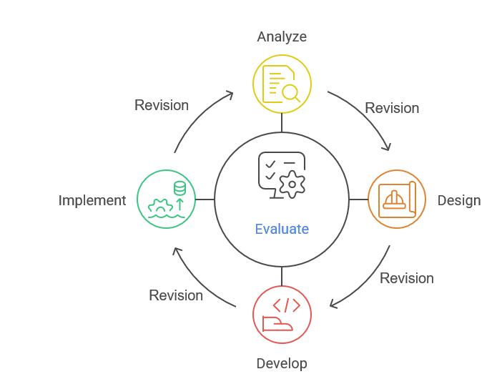
Figure 1. Steps in the ADDIE Model Development

At each stage, the model can be revised and evaluated repeatedly to ensure a reliable and useful final product. The ADDIE development model is considered suitable for product development on this basis. The ADDIE development model only reaches the evaluation stage, where evaluation is sourced from criticism and input from experts to help refine the product being developed.
Data collection refers to various methods used to gather, compile, extract, or collect research data. We are familiar with methods such as interviews, observation, testing questionnaires, archives, and documents. Good data is data that corresponds to reality and is consistent, stable, or reliable.
The validation sheet used is a device validation sheet that has been adapted and modified according to development needs. The questionnaire on responses to basic online-based chemistry devices was filled out by the head of the laboratory, assistants, and practicum students. The data from the practicum students was obtained using a questionnaire. The purpose of this questionnaire was to obtain feedback on the developed media product and to evaluate the practicality of the product as a learning medium. The data obtained from this questionnaire will be used as a basis for improving and enhancing the quality of the developed learning media.
The data collected through the validation questionnaire, observation sheets, and response questionnaires were then analyzed quantitatively to evaluate the validity and practicality of the developed media. The data obtained from the validation results by the experts will be analyzed to determine the validity and suitability of the learning media that has been created.
- Validity Data t Analysis of Online-Based Chemistry Laboratory Equipment
The validity of a product can refer to two things, namely whether the product developed is in accordance with theory and whether there is internal consistency in each of its components. The data obtained from expert validation was analyzed using Gregory's analysis.
The criteria used to determine that a device has an adequate degree of validity are that the content validity coefficient value for all aspects is at least in the sufficiently valid category and that the validity value for each aspect is at least in the valid category. If this is not the case, revisions need to be made based on the validator's suggestions or by reviewing the aspects that were assessed as lacking. Next, revalidation is conducted, followed by reanalysis. This process is repeated until the minimum M value is within the valid category (Retnawati, 2016b)
- Practicality analysis of the Online-Based Chemistry Laboratory Device
The analysis of the practicality of Online-Based Chemistry Laboratory Equipment was conducted by considering two components, namely (1) student and lecturer responses, and (2) observations of the learning process implementation.

Table 1: Practicality Categories of Learning Media
Formula | Average Score | Classification
$$X>\overline{Xi}+1,8×sbi$$ | > 7 | Very good
$$Xi+0,6×sbi<X≤\overline{Xi}+1,8×sbi$$ | &gt; 64.56 – 79.68 | Good
$$Xi-0,6×sbi<X≤\overline{Xi}+0,6×sbi$$ | >49.44 – 64.56 | Fair
$$Xi+1,8×sbi<X≤\overline{Xi}-0,6×sbi$$ | >34.32 – 49.44 | Poor
$$X≤\overline{Xi}-1,8×sbi$$ | ≤ 34.32 | Very low

- FINDINGS AND DISCUSSION
This study used the ADDIE development model, which includes five stages: Analysis, Design, Development, Implementation, and Evaluation. The aim of this study was to produce an online chemistry laboratory tool that meets validity and practicality criteria. This study used the ADDIE development model, which includes five stages: Analysis, Design, Development, Implementation, and Evaluation.
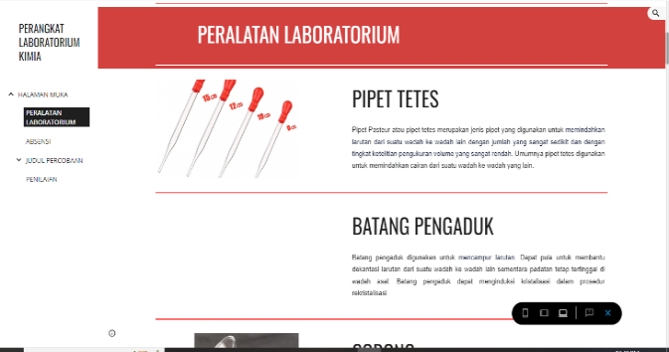
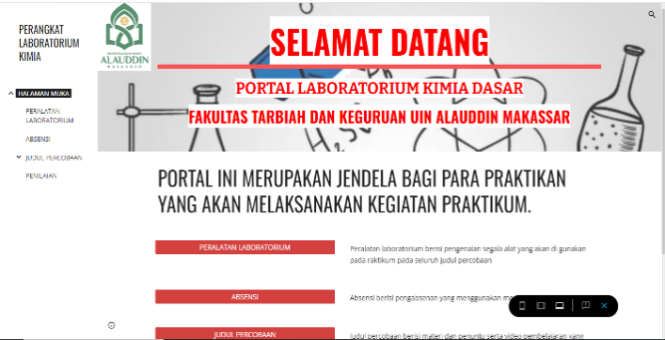
The online-based chemistry laboratory device produced for the first time was called prototype 1, which was then validated by two validators by reviewing the appearance, language, and content of the online-based chemistry laboratory that had been created. Based on the analysis of the product validation results, the average validity score for the development of the online-based chemistry laboratory device was 1. Based on the validity criteria, this value is categorized as high validity, consistent with the theory (Retnawati, 2016b) which states that if the agreement index is less than 0.4, the validity is considered low; between 0.4 and 0.8, it is considered moderate (mediocre); and if it is greater than 0.8, it is considered high.
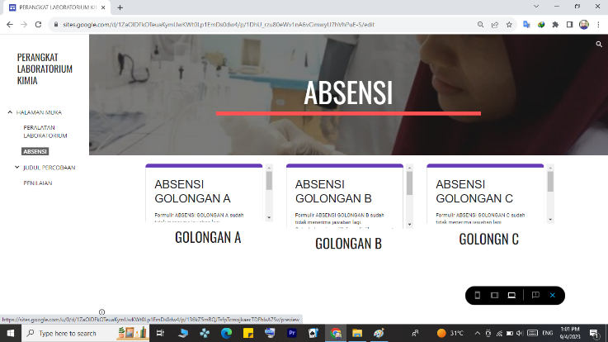
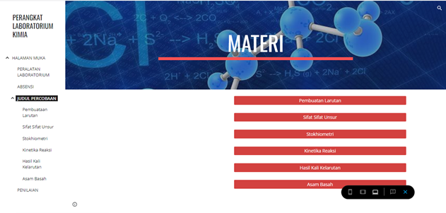
Figure 1. Home page of Figure 2. Laboratory equipment
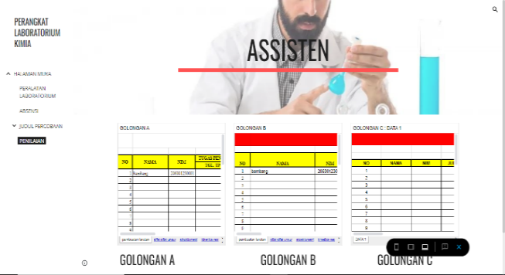
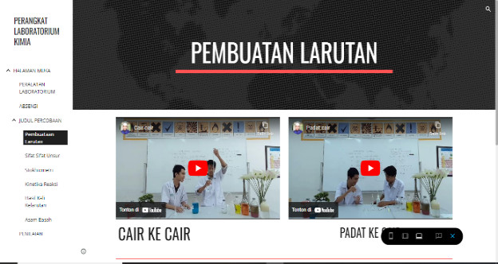
Figure 3 Attendance Figure 4. Experiment Title
Figure 5. Experiment Subtitle Figure 6. Evaluation

The development of an online-based chemical laboratory device received an average score of 3.4 from validator 1 and an average score of 3.1 from validator 2. From the average scores of both validators, the relevance level in the appearance aspect was strong with a relevance index of D. Based on the results of the validity analysis of the appearance aspect in stage 2, the validity score for the development of the online-based chemical laboratory device was 1.
When reviewed from all aspects, it can be concluded that the development of an online-based chemical laboratory device for measurement material in stage 2 meets the criteria for high validity.

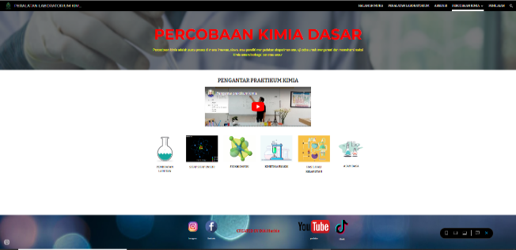
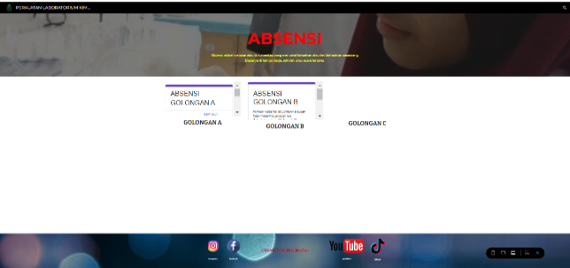
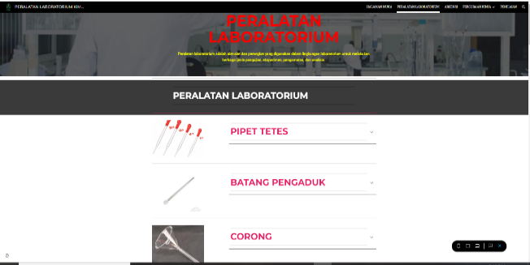
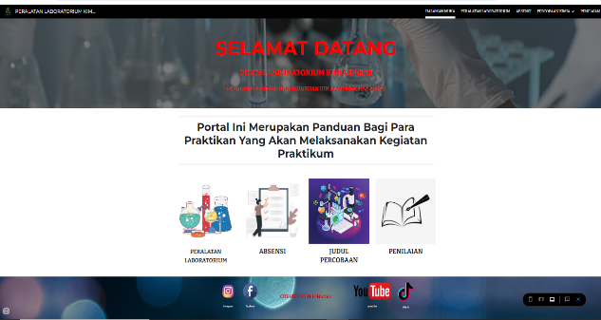
Figure 7. Front Page of Prototype 2 Figure 8. Laboratory equipment prototype 2

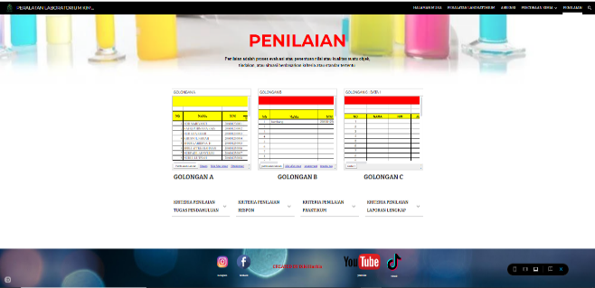
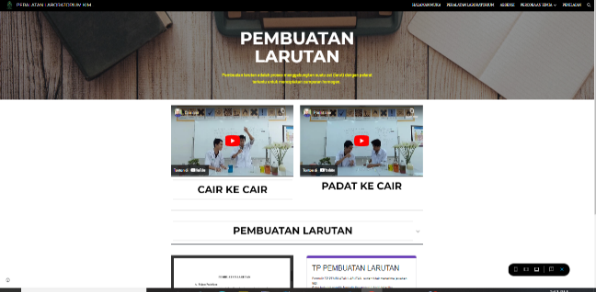
Figure 9 Attendance Prototype 2 Figure 10. Title of Prototype 2 experiment
Figure 11 Subtitle of Experiment Prototype 2 Figure 12 Evaluation of Prototype 2

The practicality level of the online-based chemistry laboratory equipment that has been developed was measured using research instruments in the form of teacher response questionnaires and student response questionnaires. Based on the data, considering the "very practical" responses from students, the percentage of student responses to the online-based chemistry laboratory equipment was 100%. According to existing theory, if 100% of all students who were the subjects of the experiment answered with criteria of good or very good, or the average score was in the good category.
Table 2: Results of the practicality of online-based chemistry laboratory equipment
No | Range | Frequency | P = F/n × 100% | Class
1 | x > 3.4 | 2 | 1 | Very Practical
2 | 2.8 ≤ 3.4 | 0 | 0 | Practical
3 | 2.2 ≤ 2.8 | 0 | 0 | Fairly Practical
4 | 1.6 ≤ 2.2 | 0 | 0 | Less Practical
5 | x ≤ 1.6 | 0 | 0 | Very impractical
Total |  | 2 | 1

The practicality level of the online-based chemistry laboratory equipment that has been developed was measured using research instruments in the form of teacher response questionnaires and student response questionnaires. The questionnaires were administered to 6 assistants and 22 students. The results of the responses from the chemistry assistants and students are as follows.

Figure 13. Graph of the practicality results of chemical laboratory equipment

Online-based Chemistry Laboratory Equipment is designed to assist laboratory heads, assistants, and practitioners in conducting practical experiments. Online-based Chemistry Laboratories can be used in practical experiments after undergoing a validation process. Online-Based Chemistry Laboratory Equipment and instruments are considered valid if expert and practitioner evaluations indicate that the development of the equipment is based on strong theoretical foundations and exhibits internal consistency, meaning there is a clear interconnection between the components of the developed equipment.
The validity of this Online-Based Chemistry Laboratory device was obtained based on the results of an assessment analysis by two validators. The validation was carried out in two stages until a final prototype was obtained for testing. The first stage was carried out by validator to determine the level of validity of the Online-Based Chemistry Laboratory in all aspects measured (language, appearance, and content).
The language aspect includes the appropriateness of the language used in accordance with English language rules and the selection of appropriate sentences. From a language perspective, the product is deemed suitable for use. This is because the grammar used in the Online-Based Chemistry Laboratory is in accordance with Indonesian language rules. In addition, the language used in the Online-Based Chemistry Laboratory is simple and easy to understand for users.
The appearance aspect covers the appearance components on the layer, presentation, and accessibility of the assessment website developed. From the visual aspect, the product is deemed suitable for use with minor revisions. This is because the assessment website has an appealing visual design in terms of color selection, layout, and font choice, which are easy for users to read. However, there is a need to add appropriate color combinations and include illustrative images on the initial display of the website.
The content aspect covers the suitability of the assessment website for use as a laboratory tool in practical work. The components are appropriate for practical work and include aspects of knowledge, attitude, and effectiveness. From the content aspect, the product is deemed suitable for use with minor revisions. This is because the components of the assessment website are consistent with the components of the chemistry practical, but adjustments are needed in some assessment components (Alfian et al., 2025).
According to (Kusumastuti et al., 2025; Saputra, 2018), the practicality of instruments is assessed to determine the quality and practicality of the developed instruments so that the product is useful for laboratories. This is because the development of laboratory equipment is an effort to develop laboratory equipment based on needs analysis into new products that are tested for effectiveness first, resulting in products that are functional and useful for the community. (Sinaga, 2018) states that practicality refers to the ease with which laboratory devices can be prepared, used, results obtained, and stored.
Practicality (Rahmayani & Atmazaki, 2025) can be determined from the response to the use of the learning media. This response can be obtained from a response questionnaire distributed to students and/or educators who use the media. A medium is practical if it contributes to the following aspects. 1) The transmission of learning information can be more standardized. 2) Makes learning more interesting. 3) Learning is increasingly applied to make learning theory more interactive. 4) The time required for learning can be shortened. 5) The quality of learning needs to be improved. 6) The learning process can be done anytime and anywhere you want. 7) It can enhance students' positive attitudes toward learning materials and the learning process. 8) There is a positive shift in the role of teachers. The guidelines are considered practical if at least 70% of all students fall into the positive category or, in this case, at least into the good category.
In some aspects of practicality assessment, several students gave points because there were several factors that the researchers eventually corrected, so that the researchers were able to achieve maximum scores in several aspects, such as in the language section (Edwin et al., 2025). There were some sentences that were difficult for some practicum participants to understand, so the researcher revised the language in those sections to make them clearer for the participants. In the display section, some participants recommended improvements to the YouTube, TikTok, Instagram, and Facebook logos, which were too large and caused some participants to be distracted by the large logos. The researcher eventually reduced the size of the logos and slightly revised the logos at the bottom of the website. At the beginning of the release, an error occurred in the assessment section, preventing participants from accessing the assessment mode. As a result, participants could not view their scores on the website. The researcher subsequently fixed the issue and improved the overall appearance.
- CONCLUSION
The conclusion of this study is that the validity level of the Online-Based Chemistry Laboratory Device developed after revision obtained a Gregory Index of V=1, indicating that it is highly valid and suitable for use. Thus, the Online-Based Chemistry Laboratory Device meets the validity criteria. The practicality level of the Online-Based Chemistry Laboratory Device developed was found to be practical, with 100% of students stating that it was very practical.
The implications of this study are that the Online-Based Chemistry Laboratory Equipment developed provides convenience to laboratory heads, assistants, and students in conducting laboratory experiments and facilitates students in submitting assignments, taking quizzes, and searching for materials. Additionally, the Online-Based Chemistry Laboratory Device developed can also be used in other laboratory experiments. Further research recommendations include conducting similar studies with an increased number of chemical experiment items and developing and disseminating the system on a larger scale.
Acknowledgement: We would like to thank the Rector of UIN Alauddin Makassar, South Sulawesi, Indonesia, for the permission given to carry out this research.
Author's Contribution: Muhammad Qaddafi: Writing – original draft, Oversight, Methodology, Funding acquisition, Data management, Conceptualization. Anas Irwan: Writing – review & editing, Visualization, Resources, Investigation, Data management. Santih Anggereni: Instrument design, data collection and analysis. Ali Umardani: Project Administration, Methodology, Investigation. All authors have read and approved the final manuscript.

REFERENCES
Alfian, A., Santoso, I., &amp; Saputra, D. S. (2025). Developing and Validating a Digital Literacy Assessment Tool for Indonesian Primary Education. AL-ISHLAH: Jurnal Pendidikan, 17(2). https://doi.org/10.35445/alishlah.v17i2.7741
Anggereni, S., Suhardiman, S., & Amaliah, R. (2021). Analysis of the availability of equipment, teaching materials, laboratory administration, and the implementation of practical activities in physics laboratories. Journal of Physics Education, 5(3), 414.
Bazie, H., Lemma, B., Workneh, A., & Estifanos, A. (2024). The Effect of Virtual Laboratories on the Academic Achievement of Undergraduate Chemistry Students: Quasi-Experimental Study. Jmir Formative Research. https://doi.org/10.2196/64476
Bennett, S. W., & O’Neale, K. (1998). Skills development and practical work in chemistry. University Chemistry Education, 2(2), 58–62.
Cahyadi, R. A. H. (2019). Development of teaching materials based on the ADDIE model. Halaqa: Islamic Education Journal, 3(1), 35–42.
Chamorro-Atalaya, O., Morales-Romero, G., Trinidad-Loli, N., Caycho-Salas, B., Guía-Altamirano, T., Auqui-Ramos, E., Rocca-Carvajal, Y., Arones, M., Arévalo-Tuesta, J. A., & Gonzales-Huaytahuilca, R. B. (2023). Gamification in Engineering Education During COVID-19: A Systematic Review on Design Considerations and Success Factors in Its Implementation. International Journal of Learning Teaching and Educational Research. https://doi.org/10.26803/ijlter.22.6.17
Domin, D. S. (2007). Students’ perceptions of when conceptual development occurs during laboratory instruction. Chemistry Education Research and Practice, 8(2), 140–152.
Edwin, M., Alwi, Z., & Izzah, I. (2025). Developing Interactive E-LKPD with Wizer.Me: A Needs Analysis for Enhancing Poetry Writing Skills in Junior High School Students in Palembang. AL-ISHLAH: Journal of Education, 17(2), 1989–2005. https://doi.org/10.35445/alishlah.v17i2.6811
Kardiyem, Bandi, B., Susilaningsih, S., & Setyowibowo, F. (2025). Measurement of the Feasibility of Virtual Laboratories for Teaching and Learning in the Fields of Economics, Management, Business, and Accounting Using a Systematic Literature Review. Multidisciplinary Reviews. https://doi.org/10.31893/multirev.2025227
Kartimi, K., Gloria, R., & Anugrah, I. R. (2021). Chemistry Online Distance Learning During the Covid-19 Outbreak: Do TPACK and Teachers’ Attitude Matter? Jurnal Pendidikan Ipa Indonesia. https://doi.org/10.15294/jpii.v10i2.28468
Kusumastuti, D. E., Mirnawati, M., Damastuti, E., Susanti, D. J., Ramli, T. J., & Rini, S. (2025). Development of Project-Based Learning Model Assisted by Mobility Orientation Technique Application (ATOM) for Students with Hearing Impairments. AL-ISHLAH: Journal of Education, 17(2), 2246–2260. https://doi.org/10.35445/alishlah.v17i2.6790
Masril, M., Jalinus, N., Ridwan, R., Ambiyar, A., Sukardi, S., & Irfan, D. (2024). Hybrid Learning Integrated Remote Laboratory: a Pedagogical Strategy for Future Practicum Learning. International Journal on Advanced Science Engineering and Information Technology. https://doi.org/10.18517/ijaseit.14.3.19760
Nazar, M., Zulfadli, Z., Rahmatillah, Puspita, K., Setiawaty, S., &amp; Sulastri, S. (2024). Development of Augmented Reality as a Learning Tool to Improve Student Ability in Comprehending Chemical Properties of the Elements. Chemistry Teacher International. https://doi.org/10.1515/cti-2023-0070
Nicho, M., Fakhry, H., Bataineh, E., &amp; Girija, S. (2024). A Strategic Evaluation of Educational Continuity for Accessibility During Uncertainty in an Educational Practicum. International Journal of Information and Communication Technology Education. https://doi.org/10.4018/ijicte.342111
Price, E., Lau, A. C., Goldberg, F., Turpen, C., Smith, P. S., Dancy, M., &amp; Robinson, S. (2021). Analyzing a Faculty Online Learning Community as a Mechanism for Supporting Faculty Implementation of a Guided-Inquiry Curriculum. International Journal of Stem Education. https://doi.org/10.1186/s40594-020-00268-7
Rahmayani, R. D., & Atmazaki, A. (2025). Development of Interactive E-LKPD Based on Live-Worksheets for Reading and Viewing Skills. AL-ISHLAH: Journal of Education, 17(1), 73–89. https://doi.org/10.35445/alishlah.v17i1.6451
Retnawati, H. (2016a). Quantitative Analysis of Research Instruments (A Guide for Researchers, Students, and Psychometricians). Parama Publishing.
Retnawati, Heri. (2016b). Quantitative Analysis of Research Instruments (A Guide for Researchers, Students, and Psychometricians). Parama Publishing.
Saputra, M. T. (2018). Development and Usability Analysis of a Manufacturing System Laboratory Website.
Sinaga, N. A. (2018). Development of a Web-Based Computer Laboratory Information System (Case Study of the Indonesian Business Polytechnic). Jurnal Tekinkom (Information and Computer Engineering Journal), 1(2), 55–61.
Wahyudi, W., Sri Verawati, N. N., Islahudin, I., & Agustina, S. Pd. P. (2023). Hybrid Ethno-Project Based Learning Integrated With Virtual Assistive Technology to Enhance Students’ Critical Thinking in Fundamental Physics Course. Tem Journal. https://doi.org/10.18421/tem124-11
Winkelmann, K., Keeney-Kennicutt, W., Fowler, D., & Macik, M. (2017). Development, Implementation, and Assessment of General Chemistry Lab Experiments Performed in the Virtual World of Second Life. Journal of Chemical Education. https://doi.org/10.1021/acs.jchemed.6b00733
Xue, Y., & Keat, O. B. (2024). A Review of Teaching Environment and Social Factors Influencing Engineering Innovation in Henan Vocational Students. Environment and Social Psychology. https://doi.org/10.59429/esp.v9i12.3182
Yuliastrin, A., Vebrianto, R., Berlian, M., & Thahir, M. (2023). Developing Media of Virtual Laboratory of Science: To Support as a Pioneer of Cyber-University. Contemporary Educational Technology. https://doi.org/10.30935/cedtech/13032

