Teachers' Challenges and Expectations for Artificial Intelligence-Based Geometry Learning at Tana Toraja Junior High School
Cheisar Manga Ranggayanan¹ , Evy Lalan Langi'²,Suri Toding Lembang³
¹ Universitas Kristen Indonesia Toraja; mangacheisar97@gmail.com
² Universitas Kristen Indonesia Toraja ; evylalanlangi@ukitoraja.ac.id
³ Universitas Kristen Indonesia Toraja; karitutusuri@gmail.com

ARTICLE INFO |  | ABSTRACT
Keywords:  Geometry;  Artificial Intelligence;  Challenges ;  Expectations. |  | This study aims to explore the challenges, readiness, and expectations of mathematics teachers towards Artificial Intelligence-based geometry learning in junior high schools. The approach used is qualitative with an exploratory phenomenological design. The research subjects consisted of junior high school mathematics teachers in Tana Toraja Regency who were selected through purposive sampling techniques. Data were obtained through in-depth interviews, non-participatory observations, and documentation studies, then analyzed using thematic analysis. The results of the study show that teachers have a positive perception of the application of AI because it is considered to be able to increase students' understanding and motivation to learn. However, limited facilities, digital infrastructure, and technological competence are the main obstacles. Teachers hope that there will be training and institutional support so that the integration of AI in learning can be carried out effectively and sustainably.
Article history:
Received 2021-08-14
Revised 2021-11-12
Accepted 2022-01-17
 |  | This is an open access article under the CC BY-NC-SA license.
Corresponding Author:
Cheisar Manga Ranggayanan
Universitas Kristen Indonesia Toraja ; mangacheisar97@gmail.com
- INTRODUCTION

Geometry learning at the junior high school level still faces various obstacles in fostering spatial thinking skills and spatial visualization skills in students. Most learners have difficulty in associating two-dimensional shapes with three-dimensional representations and understanding geometric transformations conceptually. This difficulty arises because the learning process tends to be abstract and centered on the role of the teacher, so that students do not get optimal opportunities to build their own knowledge . This situation emphasizes the need for a more interactive, contextual, and real-experience learning approach so that students can construct geometric understanding independently. (Putra & Ramadhani, 2022) Conventional approaches such as lectures and exercises on the whiteboard have proven to be not significant in improving an in-depth understanding of geometry concepts. The learning media used is generally passive and has not been adjusted to the needs and diverse learning styles. According to , students with low spatial ability need visual and interactive methods in order to be able to understand the relationship between the elements of building space concretely. Therefore, adaptive learning innovations are needed by integrating elements of visualization and interactivity in the learning process, especially through the use of artificial intelligence-based digital technology. (Riyanto et al. , 2023) Advances in AI technology provide a great opportunity to overcome these obstacles by presenting a learning system that is personalized and adaptive. This technology allows for automatic feedback, adjustment of difficulty levels according to students' abilities, and the provision of interactive three-dimensional visualizations. Hwang and Chang (2021) stated that the application of AI in mathematics learning can increase student motivation and engagement as learning experiences become more responsive to individual needs. However, the application of this technology in secondary schools in Indonesia is still limited. Many mathematics teachers show interest in the use of AI, but are still constrained by technical competence and lack of institutional support in the integration process. (Suharsono & Ningsih, 2024) This situation shows the need for an in-depth study related to the level of readiness, perception, and needs of teachers in adopting AI-based learning. Obstacles such as limited infrastructure, lack of professional training, and lack of policy support remain major challenges. Meanwhile, national policies through the Independent Curriculum have emphasized the importance of digital transformation and strengthening computational thinking skills. However, it noted that most schools are still in the early stages of adopting smart technology, which shows a gap between policy and implementation on the ground. (Rahmawati & Sari, 2023) Santoso & Utami (2022) Taking into account these conditions, this study is intended to examine the challenges, readiness, and expectations of mathematics teachers towards the application of Artificial Intelligence-based geometry learning at the junior high school level. This research is expected to be able to make a theoretical contribution to the development of the study of AI integration in mathematics education from the perspective of teachers as the main agents of learning innovation. In addition, practically the results of this research can be used as a reference in designing teacher training programs, developing contextual learning models, and formulating policies for the implementation of educational technology that are relevant to the context of Indonesian education in the digital era.
- METHODS
This study applies a qualitative approach with an exploratory phenomenological design, which aims to explore in depth the experiences, views, and expectations of mathematics teachers towards the use of Artificial Intelligence in geometry learning. This design was chosen so that the researcher can understand the subjective meaning of the teachers' real experiences without the presence of variable manipulation or experimental treatment. This research is naturalistic and interpretive, with the researcher playing a direct role as the main instrument that collects, interprets, and understands data based on the social and professional context of the participants. (Creswell & Poth, 2018; Sugiyono, 2022) The research location is in Tana Toraja Regency, South Sulawesi Province, which represents the context of semi-urban education with diverse levels of technology utilization. The selection of this region is based on its characteristics that illustrate the dynamics of digital transformation of education outside metropolitan areas. The research will take place throughout 2025 and includes the preparation stage, data collection, and analysis of findings.
The research participants were junior high school mathematics teachers in Tana Toraja Regency who were selected using the purposive sampling method. The selection criteria include:
- teachers who have known or have an interest in AI-based technology.
- have a minimum of three years of teaching experience.
- Volunteer to participate in interviews and observations.
The number of participants is determined based on the principle of data saturation, which is when the information obtained has been repeated and no new relevant findings have been found. (Creswell & Poth, 2018)
The research instrument consists of the researcher as the main instrument (human instrument) supported by semi-structured interview guidelines, observation sheets, and document analysis guidelines. The questions in the interview guidelines are prepared based on several dimensions, namely teacher readiness, knowledge of AI, experience in technology application, availability of supporting facilities, digital competence, as well as obstacles and expectations for artificial intelligence-based learning. The reliability of the instrument is strengthened through expert (Rahmawati & Sari, 2023) judgment and member checking to align with the research focus.
The data collection process was carried out through in-depth interviews as well as non-participatory observations. Semi-structured interviews of 45–60 minutes were used to explore teachers' views on the application of AI in geometry learning. Observation is applied to understand teaching practices in the classroom, while documentation studies include analysis of Learning Implementation Plans (RPPs), syllabus, and digital media used by teachers. All data collection activities are carried out under natural conditions to maintain the authenticity of information. (Scott, 2022)
The stages of data analysis are carried out thematically using a phenomenological approach according to , including the transcription process, data reduction, coding, categorization, and identification of main themes. To improve systematization and transparency, the analysis process is assisted by NVivo 15 software. This tool is used to perform keyword-based automatic coding, compile thematic categories, and display inter-theme relationships through coding matrix and thematic mapping. Analysis is inductive in order to capture patterns of meaning that describe the teacher's authentic experience. Data validity is maintained through triangulation of sources and methods, member checking, and trail audits to ensure consistency and traceability of all stages of research. Creswell (2018) (Lincoln & Guba, 1985)
- FINDINGS AND DISCUSSION

The thematic analysis carried out with the help of NVivo 15 software identified four main themes that describe the views, obstacles, and aspirations of junior high school mathematics teachers towards the development of geometry learning based on Artificial Intelligence. The four themes include: Teacher Perception, AI Implementation, Teacher Readiness, and Development Expectations.
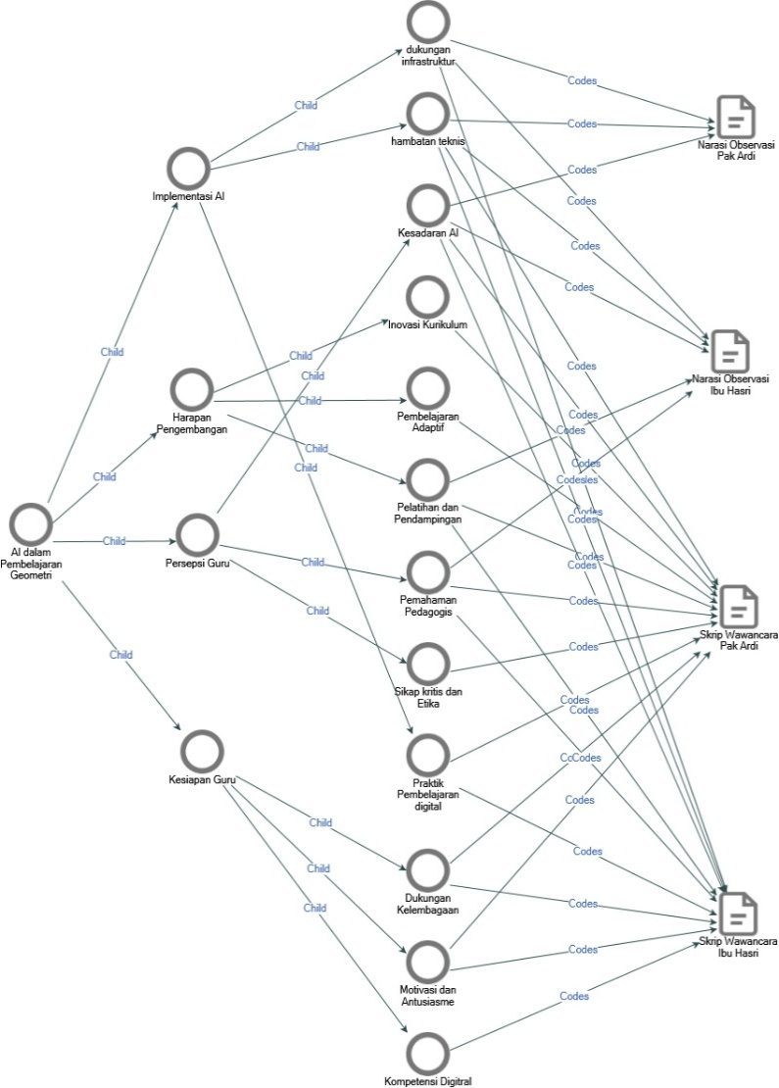
Picture 1. Thematic map of Teacher Identification of the Application of AI in Geometry Learning
Image Output : NVivo15
Overall, the results of the study show that teachers' conceptual understanding of AI is still relatively shallow. Many teachers view AI as just an automation tool, not as a pedagogical instrument capable of supporting data-driven adaptive learning. The low conceptual literacy has an impact on the limited ability of teachers to optimize the potential of AI to strengthen the effectiveness of geometry learning. These findings are in line with the view that the successful integration of AI requires a deep understanding of the pedagogical function of the technology, not just technical mastery. Hwang & Chang (2021)
Infrastructure and digital competency factors are also significant obstacles in the application of AI in schools. Limited computer devices, unstable internet connections, and lack of technical assistance make it difficult for teachers to use AI-based learning media. This condition supports the results of research that shows that teachers' readiness for technology is greatly influenced by the support of facilities and the role of educational institutions. Suharsono & Ningsih (2024)
Despite facing various obstacles, teachers consider that AI has great potential in strengthening students' visualization and spatial understanding skills. This technology is considered to be able to facilitate the exploration of building spaces through three-dimensional simulations and interactive learning experiences. This view is in line with findings that show that Lee et al. (2020) AI-based intelligent tutoring systems can increase students' motivation and conceptual understanding of mathematics learning. However, some teachers are still concerned about the social and ethical implications of using AI, such as the reduced role of humans in teaching and the issue of student data privacy, as stated by . Payadnya et al. (2025)
This research also emphasizes the importance of institutional support and education policies in encouraging the success of AI integration. Many teachers said that until now there has been no official training or policy guidelines from schools or related agencies. This lack of structural support hinders teachers' readiness and confidence in adopting technology-based innovations, supporting the view that the effectiveness of the application of educational technology is greatly influenced by school management. Supadi et al. (2025)
These findings show that teacher readiness is a crucial factor in the application of AI in mathematics learning, as explained by Teacher Readiness Theory (Rahmawati & Sari, 2023) . In this context, aspects of teacher readiness that include the cognitive, affective, and instrumental domains have not developed proportionally. Teachers have high enthusiasm, but their technical abilities and institutional support are still limited. This is in line with the Technology Acceptance Model (TAM) (Davis, 1989) framework, where the perception of the benefits of AI is relatively high, but the perception of its ease of use is still low due to limited resources and lack of training.
Theoretically, the results of this study expand the application of Teacher Readiness Theory and TAM in the context of mathematics learning, especially in the field of geometry that requires the ability to visualize and explore spatiality. Meanwhile, from the practical side, this study emphasizes the need for a gradual implementation strategy that includes increasing teacher capacity, strengthening digital infrastructure, and providing continuous professional training. Governments and educational institutions are expected to build policies that support collaboration between teachers and technology developers, as suggested by . Santoso & Utami (2022)
Table 1. Teachers' Thematic Analysis of the Use of AI in Geometry Learning
 | Narrative of Ibu Hasri's Observation | Pak Ardi's Observation Narrative | Interview Script of Mrs. Hasri | Interview Script of Pak Ardi
AI in Geometry Learning | Yes | Yes | Yes | Yes
Teacher's Perception | Yes | Yes | Yes | Yes
Critical Attitude and Ethics | Yes | Yes | Yes | Yes
Pedagogical Understanding | Yes | Yes | Yes | Yes
AI Awareness | Yes | Yes | Yes | Yes
Teacher Readiness | Yes | Yes | Yes | Yes
Motivation and Enthusiasm | Yes | Yes | Yes | Yes
Digitral Competencies | Yes | Yes | Yes | Yes
Institutional Support | Yes | Yes | Yes | Yes
AI Implementation | Yes | Yes | Yes | Yes
Digital Learning Practices | Yes | Yes | Yes | Yes
Technical barriers | Yes | Yes | Yes | Yes
infrastructure support | Yes | Yes | Yes | Yes
Development Expectations | Yes | Yes | Yes | Yes
Adaptive Learning | Yes | Yes | Yes | Yes
Training and Mentoring | Yes | Yes | Yes | Yes
Curriculum Innovation | Yes | Yes | Yes | Yes
Output Table : NVivo15
The limitations of this study lie in the narrow geographical range and the relatively small number of participants, so the generalization of the results needs to be done carefully. Advanced research can use a mixed methods or research and development (R&D) approach to develop and test AI-based geometry learning models directly in various school contexts.
Overall, the results of this study show that the success of the integration of Artificial Intelligence in geometry learning in Indonesia is highly dependent on the pedagogical readiness of teachers, the availability of adequate infrastructure, and policy support that is adaptive to digital changes in the world of education.
- CONCLUSION

This study shows that the application of Artificial Intelligence-based geometry learning at the junior high school level still faces a number of obstacles stemming from a lack of conceptual understanding, limited technological infrastructure, and a lack of teachers' digital competence. Although most teachers have a positive view and high interest in the use of AI, their level of conceptual literacy and pedagogical ability to optimize the technology is still relatively low. The thematic analysis using NVivo 15 identified four main themes, namely Teacher Perception, AI Implementation, Teacher Readiness, and Development Expectations. Overall, the four themes reflect that the level of teachers' readiness for the application of AI is not evenly distributed. From the theoretical side, the results of this study strengthen the relevance of Teacher Readiness Theory and Technology Acceptance Model (TAM) in the realm of mathematics education in Indonesia. Teachers' readiness to adopt technology depends not only on technical skills, but also on psychological factors and institutional support that affect teachers' perceptions of the benefits and ease of use of AI. These findings confirm that the successful integration of AI in geometry learning requires a balance between digital competence, pedagogical readiness, and institutional policies that support the shift towards technology-based learning.Practically, this study highlights the importance of implementing teacher professional development programs that focus on improving digital literacy, designing adaptive learning, and applying AI in subject-specific contexts such as geometry. Governments and educational institutions need to build collaborative synergy between teachers, technology developers, and policymakers so that the implementation of AI-based innovations can take place effectively, sustainably, and according to the local context. In addition, the results of this research can be the basis for the formulation of digital education policies that are more adaptive to the needs of secondary schools in Indonesia.Scientifically, this research contributes through the development of a conceptual framework that integrates the dimensions of teacher readiness and technology acceptance in one holistic analysis model. This study expands the understanding of the integration of AI in mathematics learning from the perspective of teachers as the main agents of change, and provides an empirical basis for the development of more visual, adaptive, and data-driven geometry learning models.

For future research, it is recommended to conduct a more comprehensive exploration using a mixed methods or research and development (R&D) approach to design and test the effectiveness of AI-based geometry learning models directly in the classroom environment. Follow-up studies also need to pay attention to other contextual factors, such as school culture, regional policies, and students' perceptions of the use of AI, so that the implementation strategies developed can adjust to the real conditions of education in various regions of Indonesia
- REFERENCES

Creswell, J. W. (2018). Qualitative inquiry and research design: Choosing among five approaches (4th ed.). SAGE Publications.
Creswell, J. W., & Poth, C. N. (2018). Qualitative inquiry and research design: Choosing among five approaches (5th ed.). SAGE Publications.
Davis, F. D. (1989). Perceived usefulness, perceived ease of use, and user acceptance of information technology. MIS Quarterly, 13(3), 319–340. https://doi.org/10.2307/249008
Hwang, G. J., & Chang, S. C. (2021). A review of opportunities and challenges of artificial intelligence in education. Educational Technology & Society, 24(1), 1–18.
Lee, J., Park, Y., & Kim, S. (2020). AI-based intelligent tutoring system for mathematics learning: A case study. Computers & Education, 151, 103857. https://doi.org/10.1016/j.compedu.2020.103857
Lincoln, Y. S., & Guba, E. G. (1985). Naturalistic inquiry. SAGE Publications.
Payadnya, I. P. A., Putri, N. M., & Suwija, N. (2025). Teachers' perceptions of the application of AI in mathematics learning in Southeast Asia. Asian Journal of Technology and Education, 6(1), 22–34.
Putra, D. A., & Ramadhani, R. (2022). Analysis of the difficulties of junior high school students in understanding the concept of spatial geometry. Journal of Nusantara Mathematics Education, 8(1), 55–68.
Rahmawati, N., & Sari, D. P. (2023). Teacher readiness in the implementation of artificial intelligence-based learning: A theoretical and empirical review. Indonesian Journal of Educational Technology, 11(2), 87–99.
Riyanto, A., Pratama, Y., & Lestari, F. (2023). The influence of spatial ability on the understanding of geometry of junior high school students. Indonesian Journal of Mathematics Education, 7(1), 12–25.
Santoso, H., & Utami, D. (2022). Implementation of the independent curriculum policy in supporting the digital transformation of education. Journal of Educational Management, 17(3), 144–158.
Sugiyono. (2022). Qualitative, quantitative, and R&D research methods. Alphabet.
Suharsono, A., & Ningsih, S. (2024). Teachers' perception of artificial intelligence-based learning in secondary school. Journal of Learning Innovation, 10(2), 80–92.
Supadi, S., Hasbullah, & Leonard, L. (2025). School management's support for the effectiveness of technology-based mathematics learning. Journal of Education and Technology Management, 13(1), 50–61.

