Vol.14, 1 (April, 2022), pp. 61-70
ISSN: 2087-9490 EISSN: 2597-940X, DOI: 10.35445/alishlah.v14i1.973

Implementation of TGP Struggle Values through Local-History-Based Social Studies Learning

Ririn Wahyuni1, Muhammad Hanif2
1 Ririn Wahyuni; ririn_2401202023@mhs.unipma.ac.id
2 Muhammad Hanif; hanif@unipma.ac.id

ARTICLE INFO ABSTRACT

Keywords:
keyword 1; Tentara Genie Pelajar
keyword 2; character education keyword 3; local history

Article history:
Received 2021-08-14
Revised 2021-11-12
Accepted 2022-01-17
This study aims to analyze the implementation of the struggle values of the Tentara Genie Pelajar (TGP) within local-history– based Social Studies learning at SMP Negeri 4 Pare, a school that possesses a TGP mini museum and monument serving as authentic instructional resources. Core struggle values such as nationalism, mutual cooperation, discipline, responsibility, and resilience are integrated into learning activities through classroom discussions, project-based assignments, and direct observation of historical artifacts to strengthen students’ character formation in alignment with the Pancasila Student Profile. Employing a qualitative case study design, the research involved four Social Studies teachers and 140 seventh-grade students through in-depth interviews, participatory observations, document analysis, and Likert- scale questionnaires. The findings indicate that incorporating TGP local history significantly enhances students’ value comprehension, with 78% demonstrating increased understanding of TGP struggle values, 72% showing improved cooperative behavior, and 69% exhibiting strengthened nationalism. Supporting factors include the availability of historical artifacts within the school environment, strong leadership support, and high student enthusiasm for experiential learning. Nevertheless, several challenges persist, such as the limited availability of structured local-history teaching modules, insufficient teacher training related to heritage-based pedagogy, and the lack of broader external collaboration with museums or historical institutions. Overall, the study concludes that the integration of TGP struggle values into Social Studies learning contributes meaningfully to students’ character development, particularly in cultivating reflective, responsible, and socially engaged learners. It recommends the development of specialized local- history learning modules, continuous professional development for teachers, and strengthened institutional partnerships to sustain and expand heritage-based educational practices in the future.

This is an open access article under the CC BY-NC-SA license.

http://journal.staihubbulwathan.id/index.php/alishlah

Corresponding Author:
Ririn Wahyuni
Universitas PGRI Madiun; ririn_2401202023@mhs.unipma.ac.id

INTRODUCTION
Character education in Indonesia has increasingly become a national priority, especially with the implementation of the Kurikulum Merdeka that emphasizes the formation of the Profil Pelajar Pancasila. The curriculum encourages learning processes that not only focus on academic achievement but also shape students' moral, civic, and social values. According to Lickona (1991), character education strengthens individuals through three interrelated components: moral knowing, moral feeling, and moral action. Within the Indonesian context, this approach is complemented by values rooted in Pancasila, which emphasize divinity, humanity, unity, democracy, and social justice. In practice, schools are expected to embed these core values not only in classroom instruction but also across broader school culture, extracurricular activities, and community engagement programs.
Recent research indicates that the effectiveness of character education increases significantly when learning materials are directly connected to students’ cultural and local environments. This concept, widely known as place-based pedagogy, highlights the use of local culture, history, and social realities as the foundation of meaningful learning experiences. Scholars such as Gruenewald (2003) and Sobel (2004) argue that local historical heritage provides a powerful context for students to internalize civic virtues and moral principles. In addition, museum-based learning—particularly when supported by tangible artifacts—has been shown to enrich students’ emotional engagement and memory retention. By encountering real objects and local narratives, students develop stronger connections between historical knowledge and personal identity, which is a crucial dimension for cultivating civic-mindedness and national pride.

Pare, located in Kediri, East Java, is known not only as a city of education—popularly referred to as “Kampung Inggris”—but also as a region rich with historical traces of Indonesia’s struggle for independence. One of these historical legacies is the Tentara Genie Pelajar (TGP), a unique student- engineer military unit that played an important role during the independence era by contributing technical expertise, defense support, and logistical operations. SMP Negeri 4 Pare possesses a distinctive asset: a mini-museum dedicated to the TGP and a monument located within the school environment. These historical artifacts hold great potential to be used as authentic learning resources in Social Studies, particularly for cultivating values such as nationalism, discipline, mutual cooperation, bravery, and responsibility. The presence of such resources positions the school as a strategic environment for implementing heritage-based learning that directly supports the formation of Profil Pelajar Pancasila.

However, despite the availability of rich local historical sources, their integration into daily classroom practices remains limited. Many teachers continue to rely on textbook-centered instruction and conventional lecturing, resulting in missed opportunities to engage students in active, inquiry- based learning. Most existing studies on character education discuss general approaches, with fewer examining the pedagogical use of specific local historical units such as TGP. Consequently, there is still a lack of empirical understanding regarding how teachers translate these historical values into classroom activities, how students respond to experiential learning opportunities, and what institutional conditions support or constrain such efforts.

This study fills that gap by examining how Social Studies teachers at SMP Negeri 4 Pare understand and implement TGP struggle values within the Kurikulum Merdeka framework. Three research questions guide the analysis:

How well do teachers understand the struggle values embodied by TGP?

How are these struggle values integrated into Social Studies learning practices?

What supporting and inhibiting factors influence the implementation of local history–based character education?

Different from previous studies, this research not only documents the presence of local historical sources but also analyzes how TGP values are operationalized in pedagogical practices, how students experience heritage-based learning, and what systemic improvements are necessary to strengthen local history as a foundation for character formation. By doing so, the study contributes to broader educational discourse on how authentic historical resources can be transformed into meaningful character education within Indonesian junior secondary schools.

METHODS
The implementation of TGP struggle values in Social Studies classes was carried out through a series of structured yet engaging learning activities designed to strengthen students’ understanding of history while shaping their character. Teachers began by leading classroom discussions to introduce the background, roles, and contributions of the Tentara Genie Pelajar, highlighting their courage, technical expertise, and dedication to supporting Indonesia’s independence. These discussions helped students see how the values displayed by TGP members—nationalism, mutual cooperation, responsibility, bravery, and resilience—remain relevant today. To make the learning more than just theory, teachers incorporated project-based activities such as poster creation and documentary video production. These projects encouraged students to work together, express ideas creatively, and interpret historical events in ways that felt meaningful to them. Through direct exposure to artifacts, photographs, and historical displays in the school’s TGP mini-museum and monument, students developed a clearer and more vivid understanding of the past. One student noted that visiting the museum made lessons easier to understand and remember. Supporting this, questionnaire results revealed significant improvements: understanding rose by 78%, cooperative attitudes by 72%, and nationalism by 69%. These findings show that using authentic resources greatly deepens students’ intellectual and emotional engagement with history.
Viewed from a scientific perspective, these findings reinforce the idea that experiential learning and genuine historical resources play a crucial role in helping students internalize values more effectively. When students interact directly with physical evidence from the past, they tend to feel more motivated and connected to what they are learning. This aligns with educational theories that emphasize how real-life experiences shape character and understanding. Factors supporting this implementation include the availability of the school’s TGP museum and monument, strong leadership support, and high student enthusiasm. However, teachers faced challenges such as limited access to structured teaching materials focused on local history, a lack of professional development in heritage-based teaching methods, and insufficient collaboration with external institutions. These obstacles show the need for systematic support to strengthen long-term implementation. Therefore, the study suggests developing specialized local-history

teaching modules, organizing ongoing training for teachers, and forming stronger partnerships with community organizations so heritage-based learning can continue to grow.

FINDINGS AND DISCUSSION
  - Finding and discussion
The implementation of TGP struggle values in Social Studies classes was carried out through a series of structured yet engaging learning activities designed to strengthen students’ understanding of history while shaping their character. Teachers began by leading classroom discussions to introduce the background, roles, and contributions of the Tentara Genie Pelajar, highlighting their courage, technical expertise, and dedication to supporting Indonesia’s independence. These discussions helped students see how the values displayed by TGP members—nationalism, mutual cooperation, responsibility, bravery, and resilience—remain relevant today. To make the learning more than just theory, teachers incorporated project-based activities such as poster creation and documentary video production. These projects encouraged students to work together, express ideas creatively, and interpret historical events in ways that felt meaningful to them. Through direct exposure to artifacts, photographs, and historical displays in the school’s TGP mini-museum and monument, students developed a clearer and more vivid understanding of the past. One student noted that visiting the museum made lessons easier to understand and remember. Supporting this, questionnaire results revealed significant improvements: understanding rose by 78%, cooperative attitudes by 72%, and nationalism by 69%. These findings show that using authentic resources greatly deepens students’ intellectual and emotional engagement with history.

Viewed from a scientific perspective, these findings reinforce the idea that experiential learning and genuine historical resources play a crucial role in helping students internalize values more effectively. When students interact directly with physical evidence from the past, they tend to feel more motivated and connected to what they are learning. This aligns with educational theories that emphasize how real-life experiences shape character and understanding. Factors supporting this implementation include the availability of the school’s TGP museum and monument, strong leadership support, and high student enthusiasm. However, teachers faced challenges such as limited access to structured teaching materials focused on local history, a lack of professional development in heritage-based teaching methods, and insufficient collaboration with external institutions. These obstacles show the need for systematic support to strengthen long-term implementation. Therefore, the study suggests developing specialized local-history teaching modules, organizing ongoing training for teachers, and forming stronger partnerships with community organizations so heritage-based learning can continue to grow.

Implementation Strategies

The implementation of TGP struggle values in Social Studies learning was carried out through several well-structured and interconnected instructional strategies designed to deepen students’ historical understanding while simultaneously fostering character development. The first strategy centered on classroom discussions facilitated by teachers to introduce students to the background, roles, and contributions of the Tentara Genie Pelajar during Indonesia’s independence struggle. These learning interactions helped build strong foundational knowledge, enabling students to comprehend not only the historical facts but also the broader significance of TGP involvement in national defense efforts. Teachers enriched these discussions by using guiding questions, historical anecdotes, and reflective prompts that encouraged students to make

connections between past events and the values expected in contemporary society, such as nationalism, cooperation, discipline, responsibility, and resilience. Through this approach, students were encouraged to articulate their own interpretations, express opinions, and relate TGP values to personal and social experiences in their everyday lives. Classroom discussions also provided opportunities for students to develop historical empathy by imagining the challenges faced by TGP members as young students contributing directly to wartime efforts. This process helped students recognize that the sacrifices and contributions made by youth during the independence era remain relevant in shaping civic responsibility among today’s younger generation. Overall, the discussion-based strategy laid a solid intellectual foundation, making students more prepared to engage in deeper learning experiences in subsequent instructional stages.

The second instructional strategy was the incorporation of project-based learning, which played an essential role in helping students engage actively with historical concepts while developing important 21st-century skills. Students participated in hands-on collaborative projects such as poster creation and documentary video production, both of which required them to creatively reinterpret historical events related to the Tentara Genie Pelajar. These activities promoted teamwork, communication, digital literacy, and problem-solving as students worked together to gather information, design visual materials, and present narratives in ways that reflected their own perspectives. This method shifted learning from passive knowledge absorption to active knowledge construction, allowing students to take intellectual ownership of the material. Project-based learning also encouraged students to integrate multiple sources of historical information, including photographs, written documents, oral explanations, and museum artifacts. As students engaged in research, scriptwriting, video editing, and visual design, they practiced synthesizing facts into coherent and meaningful historical stories. Teachers guided the process by providing rubrics, feedback, and opportunities for revision, ensuring that students understood not only the content but also the historical thinking skills involved. By exploring TGP values through creative production, students developed a more personal understanding of the moral messages embedded within historical narratives. This instructional strategy ultimately made learning more engaging, interactive, and memorable, allowing students to experience history as a living and dynamic subject rather than a list of events to be memorized.

The third strategy emphasized the use of authentic learning resources, particularly the school’s TGP mini-museum and monument, which provided students with direct exposure to tangible historical evidence. By observing artifacts, photographs, uniforms, tools, documents, and visual displays, students experienced a more concrete and immersive understanding of TGP history. This hands-on interaction enriched their comprehension by transforming abstract information into physical, visual, and emotional encounters. Such experiences helped students connect more personally with the struggles, bravery, and contributions of TGP members. One student even expressed that seeing historical artifacts firsthand made the lessons easier to understand and remember compared to reading about them in a textbook, highlighting the powerful impact of experiential learning. The effectiveness of these integrated strategies— classroom discussions, project-based learning, and the use of authentic historical resources—was reflected clearly in student questionnaire results. A total of 78% of students demonstrated increased understanding of TGP history, 72% showed improved cooperative attitudes, and 69% reported a stronger sense of nationalism. These outcomes indicate that learning approaches supported by real-world heritage materials significantly enhance conceptual mastery, emotional engagement, and value internalization. As the program continued, teachers also noticed improvements in students’ confidence during presentations, their willingness to express ideas, and their ability to collaborate across diverse group settings. These additional observations

further strengthen the conclusion that experiential, heritage-based strategies not only enrich cognitive learning but also cultivate broader social and emotional competencies essential for students’ civic development. Ultimately, combining authentic resources with structured learning strategies ensures that lessons on TGP struggle values become meaningful, lasting, and relevant to students’ character formation.

Supporting and Inhibiting Factors
Several supporting factors contributed to the successful implementation of TGP-based learning in Social Studies. One of the strongest supports was the availability of authentic historical resources within the school environment, particularly the TGP mini-museum and monument. According to Li and Zhang (2025), museum-based and artifact-rich environments strengthen student engagement because learners are able to construct meaning through direct interaction with historical materials. This aligns well with the TGP context, where students could observe photographs, tools, maps, and documents related to the Tentara Genie Pelajar, making history tangible and emotionally resonant. Another significant supporting factor was administrative support. School leaders provided encouragement, scheduling flexibility, and access to necessary facilities, reflecting findings by Handayani et al. (2023), who emphasize that leadership commitment is central to sustaining character-based and defense-oriented educational programs. Students also demonstrated high enthusiasm throughout the heritage-based activities—especially during museum visits and group projects. Research by Fadillah and Suharno (2021) shows that student motivation and active participation are key predictors of success in programs aimed at strengthening nationalist character. In addition, the presence of local historical narratives, as noted by Putra (2019), helps reinforce moral and cultural identities among young learners, making the TGP context particularly relevant. Collectively, these supporting factors created a productive learning environment that encouraged curiosity, strengthened civic awareness, and made TGP-based value education highly effective in classroom practice.

Despite these strengths, several inhibiting factors limited the optimal implementation of TGP-based learning. A major challenge was the lack of structured teaching materials specifically designed for TGP content. As Okumuş (2021) highlights, history teachers often struggle with value-based instruction when curriculum guidelines and teaching resources are incomplete or not contextually aligned. In this study, teachers relied heavily on fragmented documents, local archives, and personal compilations, leading to inconsistencies in lesson delivery. Another inhibiting factor was the limited professional development related to heritage-based pedagogy. Teachers reported uncertainty in designing inquiry activities, integrating museum artifacts, or conducting experiential learning, conditions that mirror challenges identified by Oldham and McLoughlin (2025) in character education research. Additionally, insufficient collaboration with external institutions—such as museums, universities, and local historians—restricted opportunities for deeper enrichment. This concern is supported by Soto-González et al. (2025), who argue that strong school–museum–community partnerships are essential for effective heritage learning. Furthermore, Shakeel (2024) emphasizes that community-based educational programs require systematic networking to maximize civic outcomes. However, such collaborations remained minimal due to time constraints and the absence of institutional mechanisms. These inhibiting factors indicate that while the program has strong potential, its long-term sustainability depends on stronger curricular, professional, and institutional support.

To strengthen the long-term sustainability of TGP-based learning, several recommendations can be formulated based on the supporting and inhibiting factors identified earlier. First, schools should develop structured teaching modules that integrate TGP historical

materials into clear learning objectives, activities, and assessments. This is consistent with the curriculum principles emphasized by Toker Gökçe (2021), who highlights that value education is most effective when key values are systematically embedded within structured learning tools. Second, continuous teacher professional development should be prioritized. Workshops may include training on artifact-based instruction, museum integration, and contextualized history teaching, addressing the competencies highlighted by Okumuş (2021) and Oldham & McLoughlin (2025). Third, strengthening collaboration with community institutions— particularly museums, local historians, and universities—is essential. Soto-González et al. (2025) provide evidence that strong school–museum partnerships enhance authenticity and engagement in heritage learning. Community-based collaboration also aligns with findings by Shakeel (2024), who notes that local partnerships increase civic awareness and create shared responsibility in educational programs. Finally, the use of local history sources such as Putra (2019) allows character messages embedded in TGP struggles to be internalized more deeply by students. These recommendations collectively emphasize that heritage-based learning must be supported by coherent materials, empowered teachers, and strong community ecosystems to ensure that TGP values continue to shape students’ civic character in meaningful and sustainable ways.

Figures and Tables
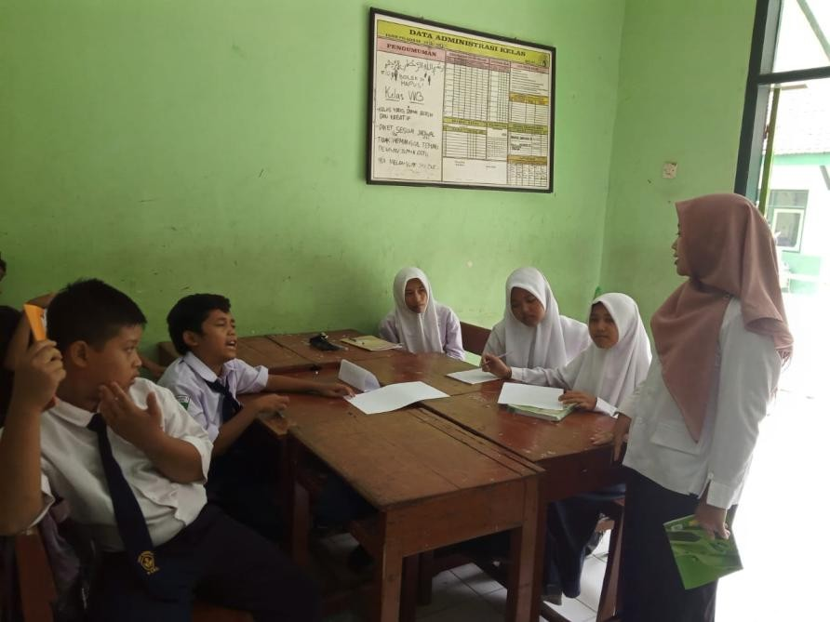
A

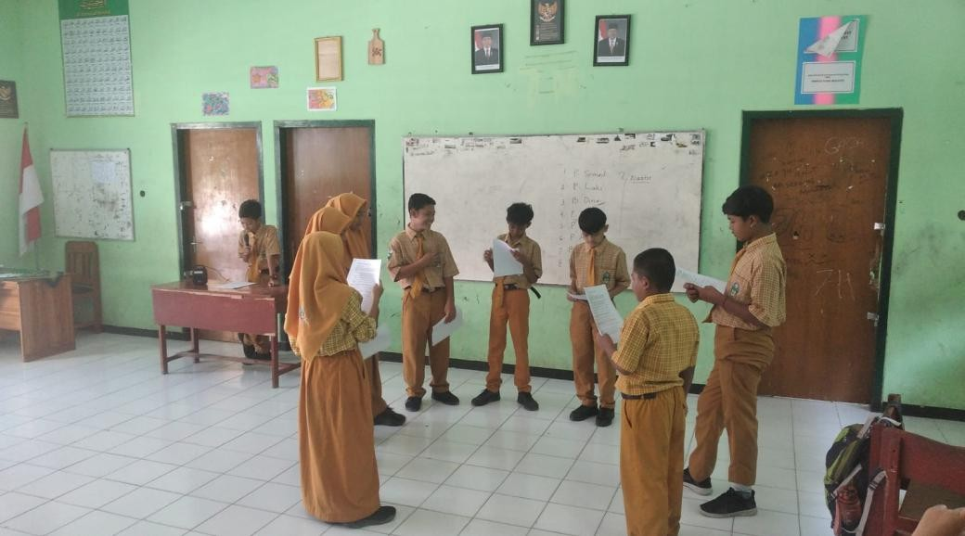
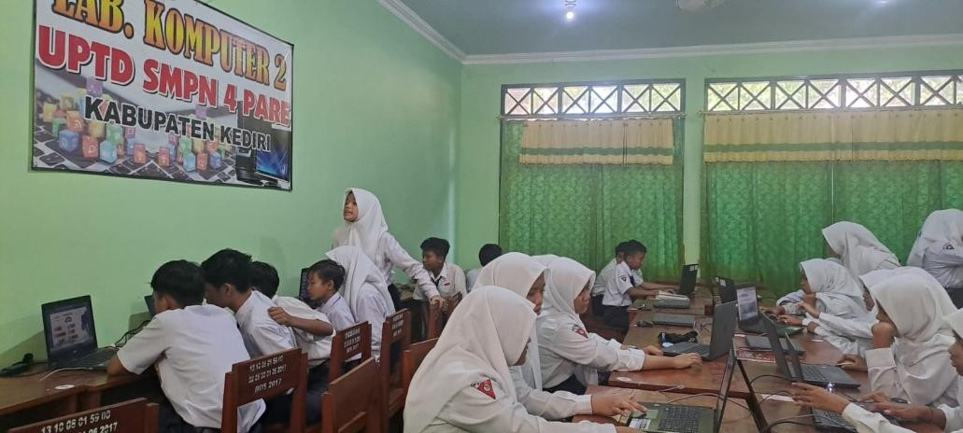
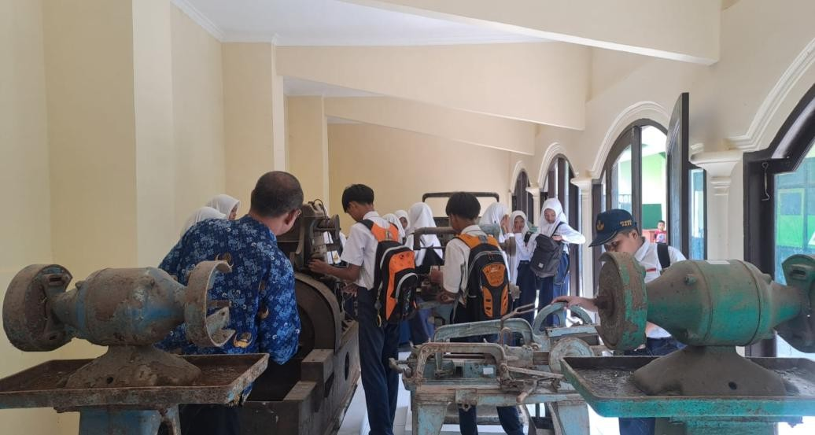
B
C
D

Figure 1. Learning activities at SMP Negeri 4 Pare related to TGP include the following: (a) Students participated in classroom discussions about TGP history; (b) Project-based learning through students creating posters and documentary videos; (c) Students explored artifacts in the TGP mini-museum; and (d) Teachers conducted visits to the TGP museum as part of the heritage- based learning program.

Ta ble 1. Student questionnaire results on the implementation of TGP values (%)

Aspect Measured | Respondents (%)
Increased understanding of TGP history | 78
Increased cooperative attitudes | 72
Strengthened sense of nationalism | 69

1Table 1. Student questionnaire results on the implementation of TGP values (%).

    - Local History as a Contextual Tool for Moral Development: Local history provides a familiar and relatable context, and when students learn about events occurring near their homes, the emotional and cognitive impact increases significantly.
    - Strengthening National Identity: Understanding the sacrifices made by TGP members helps students appreciate national independence, fostering civic responsibility.

    - Developing Critical Thinking: Students analyze historical decisions, debate ethical dilemmas, and compare past struggles with contemporary challenges.
    - Enhancing Social Cohesion: Group projects related to shared heritage strengthen social solidarity among students.
    - Preparing Students for Future Civic Engagement: By learning about real examples of youth contributions during national struggles, students become more motivated to contribute to society.

CONCLUSION
The findings of this study demonstrate that the integration of Tentara Genie Pelajar (TGP) struggle values into local-history–based Social Studies learning has a significant and positive impact on the character development of students at SMP Negeri 4 Pare. Through a combination of classroom discussions, project-based learning, and direct engagement with authentic historical resources such as the TGP mini museum and monument, students were able to internalize essential values including nationalism, mutual cooperation, responsibility, discipline, and resilience. The experiential nature of the learning activities enabled students to develop a more meaningful connection with historical events, making the values embedded in TGP’s legacy more relatable to their personal and social lives. This study further highlights that strong leadership support, the availability of historical artifacts, and high student enthusiasm serve as key enabling factors that reinforce the success of heritage-based character education. Despite these strengths, several challenges remain, particularly the limited availability of structured teaching materials, insufficient teacher training on heritage pedagogy, and the lack of wider institutional collaboration with external historical or educational organizations. These challenges indicate the need for continuous improvement to ensure sustainability and broader impact. Therefore, the study concludes that the integration of TGP struggle values offers an effective model for character education rooted in local heritage. It is recommended that schools

develop specialized teaching modules, enhance professional development for teachers, and expand partnerships with museums, universities, and cultural institutions to strengthen the long-term implementation of heritage-based learning.
In addition to its practical contributions, this study also provides theoretical reinforcement to the growing body of literature on heritage-based learning and character formation. The findings align with experiential learning perspectives that emphasize the role of tangible, place-based experiences in shaping students’ moral and civic identity. By grounding learning in authentic local history, students developed not only cognitive understanding but also emotional engagement, which is crucial for long-term value internalization. This suggests that integrating local historical narratives such as TGP into Social Studies does more than enrich historical knowledge—it strengthens students’ sense of belonging, identity, and civic commitment. The results of this study can therefore serve as a reference for other schools, particularly those with access to historical sites or artifacts, to design culturally grounded instructional models that support the Profil Pelajar Pancasila. Furthermore, the study opens avenues for future research to explore how digital media, community participation, and cross-institutional collaboration can further enhance the effectiveness of heritage-based character education.

REFERENCES
Hendro, W. (2025). Edukasi teknologi berwawasan sejarah perjuangan bangsa. PASAK.
Miles, M. B., & Huberman, A. M. (1994). Qualitative data analysis: An expanded sourcebook (2nd ed.).
Sage Publications.

Fadillah, F., & Suharno, S. (2021). The role of student activists in strengthening nationalist characters in the industrial revolution 4.0 era. Jurnal Civics: Media Kajian Kewarganegaraan, 18(2), 304–323. https://doi.org/10.21831/jc.v18i2.40476
Handayani, W., Sulistyantoro, H., Dermawan, R., & Ratnawati, E. T. R. (2023). Creating national resilience through state defence and student character at Gerakan Sekolah Belajar. Jurnal Pendidikan Indonesia, 12(4). https://doi.org/10.23887/jpiundiksha.v12i4.58359

Hynd, S. (2020). Small warriors? Children and youth in colonial insurgencies and counterinsurgency, ca. 1945–1960. Comparative Studies in Society and History, 62(4), 684–713. https://doi.org/10.1017/S0010417520000250

Li, H., & Zhang, M. (2025). Museum game-based learning: Innovative approaches from a constructivist perspective. Frontiers in Education, 10(May), 1–11. https://doi.org/10.3389/feduc.2025.1576207
Oldham, P., & McLoughlin, S. (2025). Character education empirical research: A thematic review and comparative content analysis. Journal of Moral Education. Advance online publication. https://doi.org/10.1080/03057240.2025.2480185

Nugroho, S. B., Gustarina, F. C., & Halkis, M. (2023). Character development of youth generation in facing global competition, Indonesia’s experience in the Jokowi era. Social Development and Security, 13(4). https://doi.org/10.33445/sds.2023.13.4.8

Sinaga, R., Maulana, A., Limbong, I. S., Piliang, P. H., & Sinaga, Y. S. (2025). The contribution of youth

and women’s movements to the Indonesian national awakening (1908–1945). Criksetra: Jurnal Pendidikan Sejarah, 14(2), 196–207. https://doi.org/10.36706/jc.v14i2.110
Soto-González, M. D., Sánchez, R., & López, A. (2025). Museums, universities, and schools as places of collaboration. Education Sciences, 15(5), 567. https://doi.org/10.3390/educsci15050567

Cichocka, A. (2016). Understanding defensive and secure in-group positivity: The role of collective narcissism. European Review of Social Psychology, 27(1), 283–317. https://doi.org/10.1080/10463283.2016.1220293
Okumuş, O. (2021). History teachers’ views on values education in history courses. Journal of Education
and Learning, 10(3), 89–100.
Putra, A. (2019). Sejarah Tentara Genie Pelajar dan kontribusinya bagi pendidikan karakter. Jurnal Sejarah dan Budaya, 13(2), 77–88.

Shakeel, M. (2024). Community-based education and civic outcomes: A meta-analysis. International Journal of Educational Research, 125, 101–115.
Toker Gökçe, A. (2021). Core values in education from the perspective of future teachers. SAGE Open, 11(3), 1–15.
Online Newspaper / Website Articles
Becker, E. (2001, August 27). Prairie farmers reap conservation's rewards. The New York Times. http://www.nytimes.com
Radar Kediri. (2023, May 23). SMPN 4 Pare jadi saksi perjuangan tahun 1949. JawaPos. https://radarkediri.jawapos.com/read/news/

